**The Sixthman, Always on Duty**

**J. Brian Starling, Dominion VA Power**

**Presented a the Georgia Tech Fault and Disturbance Analysis Conference, April 27-28, 2015**

**Background**

The retrieval, aggregation, and analysis of transient recording device records during an outage have added to the response time of utilities during transmission interruptions. Of the transmission outages which have occurred in the past five years on Dominion’s system requiring response, seventy-one percent of those have occurred during off business hours. To reduce this component of the response time, Dominion has implemented an internally developed system to automatically retrieve recording device records and generated locations from both Ethernet and phone connected stations both periodically and on demand. Once downloaded the records are processed to calculate the fault inception time, fault type, and estimated fault location. In addition to using the locations provided by recording equipment and protective relays, additional fault locations are calculated using four singled ended algorithms, falls (Fault and Lightning Location System), doubled ended algorithm using IEEE C37.114, comparisons using both single ended and doubled ended short circuit modeling programs, and traveling wave system timestamps. In locations where recording devices are not available, the system can use recorded data from remote locations to calculate a fault location. This information is then compiled, filtered for anomalies, displayed visually, and emailed directly to response personnel usually in less than five minutes.

**Current Process Model**

While it is known that each utility which owns and operates transmission assets has different policies and expectations of their fault location processes. A common underlying understanding of human intervention is usually required to retrieve and analyze this data. When an outage occurs after office hours when analysis personnel are at home, a typical response time can vary from 45 minutes to 3 hours depending on a variety of factors. With those factors in mind, the common process consists of the following steps.

1. A callout must be conducted for an analyst employee to respond.
2. The employee must either respond by traveling to the office or starting a remote connection when available, then authenticate to the network.
3. Once authenticated, the analyst must determine which devices contain relevant data, connect to those devices, and download the data.
4. Analysis of the retrieved data is performed, screening for erroneous locations, and providing the best location possible.
5. Transmittal of the location to interested parties.

**Enhanced Model**

Dominion operated on the above model or similar model for as long as fault location technology has existed. The only large change was the step forward from machines where data was retrieved on site versus remote communications. Many suggestions had been made in the past years to increase productivity; however none ever gained any significant traction within the company. Some of these suggestions included, automated retrieval of records and a semi-automatic data retrieval system. Dominion’s fault analysis department began implementing various stages of the new system from 2013 to the present. The results of the program have resulted in fewer callouts, quicker response times by field personnel, and quicker restoration of customers.

1. *Auto retrieval of event records*

One of the most time consuming processes, is retrieving data from the various fault location devices. If data resides on more than one device or in more than one location, current manual connections only allow for data to be retrieved from one device at a time. The concept of having a universal file downloader which works will all the vendor platforms and can connect to multiple devices simultaneously saves considerable time.

Dominion created a standalone FTP downloader system which can connect to each platform and download the files need, and ignore the ones which are not of interest. The downloader processes both Ethernet connected and dial up devices. Currently the system is running at 24 connections which are consistently scanning the fleet of almost 200 fault recorders for new records. The system connects to each device between 550 and 650 times a day depending on available bandwidth at the time. This equates to each device being scanned at least every 3 minutes if not faster. Because of long distance phone bill restrictions dial up machines are only scanned every 4 hours. However each machine can be polled on demand.

In the beginning only oscillography records were being return to local share drive and kept for 30 days locally. Since its inception, the downloader has been expanded to return other types of files such as fault summary files, device configuration information, and sequence of events files. The device configuration files keep an archive on themselves, for the situation in which something is inadvertently changed. A historical copy of the configuration is available if a restoration is required. In the event a configuration file is changed, the fault analysis group is notified via email on the download.

1. *Creation of the FA Management System*

After the downloader was created, a method to configure and control the downloader was needed. It was decided to create a web based interface, called FA Management, which would allow users to change the device polling configurations, view setup configurations on each machine, and poll every device on demand. The web based access interfaces with a SQL database which in turn controls and prioritizes the downloader programs.

The FA Management system has been expanded to included our fault recorder trouble ticket system, control the annunciator alarm board, configure the Travel Wave Fault locator system, and display dashboards for various metrics which are tracked internally. Having this data and system configuration available via a web interface allows us to control the system from anywhere, including the field during set up, from home, or in the office.

1. *Assembly and distribution of pre calculated fault location data*

After the downloader was vetted, a realization came about that Dominion had several methods of fault locations in different locations, but not available to any one person at the same time. Relay targets and locations were available from the SCADA system, fault recorder locations were located on a share drive at the office, travelling wave locations were available in a database at the office, and FALLS locations were available through an online data connection. Only 1 type of location was visible to the operators, which are locations computed by relays and are communicated back through SCADA. However, none of those locations are visible to the field personnel.

To expedite the process of retrieving and disseminating the pre calculated fault locations, two modules were added to the system. The first module maintains a relational database of which devices monitor which lines, by reading the most recent device configuration files downloaded from the actively polled devices. This module will then update the database based on the settings of the remote monitored devices. The module activates every 6 hours enabling the relationships database to be kept up to date automatically.

A second module was created and added to the existing program, which when a line operation was recorded, the system would automatically initiate polling of all fault devices which monitor the line, collect the pre calculated data, plot the data, and disseminate it to operations, field personnel, and other interested parties. The report contained, basic line information including line length, impedance parameters, responsible line crews, available fault locations from each terminal, correlated structures, lightning in the area, plotted images of the line and calculated fault locations.

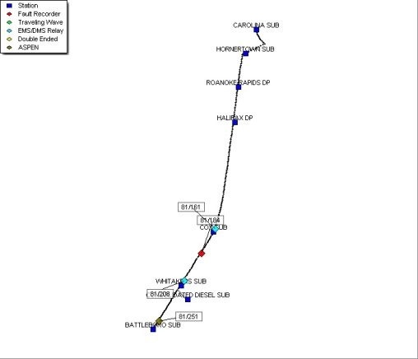

1. *Calculating fault inception times and automating single ended algorithms*

Determining the inception time of the fault is critical for performing lightning correlations. During a ± 1 second window around a fault inception time, Dominion has seen as many as 30 strokes over top of the line. By having a precise inception time, we can identify the exact stroke of interest and subsequent location of the fault.

While there are various methods to determine the fault inception time, Dominion chose to implement a combination approach to cover the multiple fault types which are experienced. The first approach attempted is the generated signal method. Using prefault values taken at the beginning of the fault record, a sample signal is generated which should match the sampled signal throughout the record. The point at which the signal deviates is considered the fault inception time. This method is applied to all three phase voltages, and the earliest time between the three phase voltages is selected.

In the image below, the red trace is an actual recorder voltage wave at the during a fault. The black trace is a simulated signal using prefault values, that will match the red trace until the fault occurs. Where the blue arrow is pointing shows the start of the deviation and hence the fault inception time.

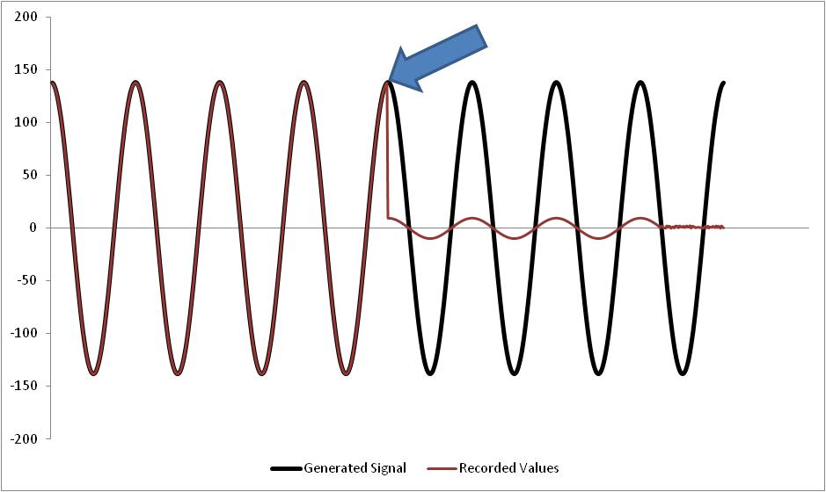

In the event that the phase voltages do not deviate from the generated signal voltage, an attempt is made to identify the point on the wave at which the residual current instantaneously increases to five times the prefault value. When a fault inception time still has not been identified the generated signal method is applied to all three phase currents, provided they have sufficient prefault quantity. Dominion has selected 100 Amps as the prefault threshold for this step.

If an inception time has not been computed or prefault values are not available, for example on a reclose, then the final step will be looking for an instantaneous current rise on the three phase currents to at least 5 times the second cycle in the record rms value. Using this method to derive a fault inception time, precise FALLS lightning correlations are now available without human intervention.

When a fault inception time has still not been identified the program will mark this line group as “No Faults Identifiable.”

1. *Calculating double ended algorithms and fault model comparisons*

Because the vendor locations were not being calculated and event channel data was previously loaded into memory to calculate the fault inception time, fault locations were calculated using the event records. Using the data already available, we calculated the fault locations using four different algorithms: the simple method, reactance method, Takagi method, and modified Takagi method. Those locations are placed into a fault summary file. Based on our initial reviews of the fault algorithms, the reactance method was chosen to be used in the outgoing reports. As more data becomes available, different algorithms may be set for specific lines.

Values are read at the first stable point in the faulted section of the record. An RMS point is considered stable when the RMS magnitudes of all 6 phasors: Va, Vb, Vc, Ia, Ib, and Ic, have not varied by more than ± 3% in the past cycle. The first stable point in the fault is then used to calculate magnitude and angle of the phasor. If a stable value cannot be detected, the phasors are calculated using the cycle of data 1.75 cycles from the fault inception time. A fault location is considered valid if it is between -2% and 200% of the line length. If the fault location is considered valid it is placed in the database and a graphical image of the phasors is created for use in the summary report. The RMS values for the selected cycle of data are stored in the database for use later.

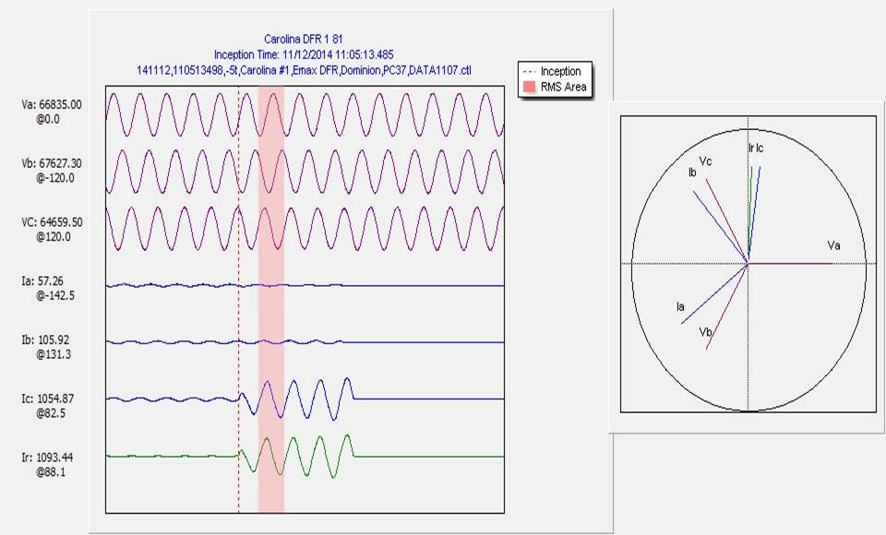

1. *Calculating double ended algorithms and fault model comparisons*

Many factors can play into single ended fault locations which can cause the location to be inaccurate. Some of these factors include; ground reactance, fault resistance, changing soil conditions, etc. The IEEE C37.114 double ended fault algorithm has the potential to eliminate most of these variables by using the negative sequence components of the fault from both ends of the transmission line. Dominion has had great success using this method to locate faults on long transmission lines where traditional single ended algorithms have been a challenge. When a fault is detected using the single ended algorithms, those phasor values are stored in the database. The program then checks for any additional faults already in the database on the same line at the exact times which are from the remote terminal. When the second terminal is processed is locates the data from the first terminal and uses it to perform the double ended algorithm using negative sequence. This works for phase to ground and phase to phase faults only. Three phase faults use the positive sequence component.

One additional method of fault locating used by analysis personnel is a comparison to the short circuit fault models. For other company purposes all of the fault current flows for phase to ground and three phase faults are stored in an SQL table. Two methods are used which depend on the amount of data available. If only 1 terminal’s data is available, a query is used to extract the location on the system which most closely matches the RMS phasors from the fault record. This is known as the single ended approach. If both the local and remote terminals’ RMS phasors are available a ratio is derived from the measured Iremote/Ilocal and the closest matching Iremote/Ilocal system location from the database is selected. This is known as the ratio method.

1. *Extended Lines Groups*

In a few remote places, fault recording technology is not available, or is not accessible by conventional communication means. This presented a challenge when the need arises to provide accurate fault locations on these lines. To overcome this challenge an idea was presented of using the recorded values available from the next bus back to compute locations. When a fault occurred, the recorders monitoring the adjoining lines will trigger and record the values. Those values then can be used to compute a fault impedance further away than their remote terminal. The known line impedance between the recorder and remote station is then subtracted from the computed fault impedance. Using this information, fault locations are performed automatically without having access to local recorded values.

1. *Fault Selection Criteria*

The program will attempt to identify any locations either self calculated or vendor provided which are not rational. To accomplish this, the program calculates a mean and standard deviation of all of the locations. Any locations which fall outside of +/- 1.85 times the standard deviation are marked as filtered and excluded from consideration. Using the recomputed standard deviation of the remaining fault locations a confidence interval is displayed to inform the end users on how reliable the data is. The following table shows Dominion’s confidence intervals.

|  |  |
| --- | --- |
| Standard Deviation | Confidence Level |
| ≤0.5 miles | High Confidence |
| >0.5 miles, but ≤1 miles | Confident |
| >1 miles, but ≤1.5 miles | Low Confidence |
| >1.5 miles | No Confidence |

With 7 different fault location methods now available, the question arose which one should be used as the target location. Using historical data regarding the accuracy of each method, the following priority list was developed.

1. FALLS Lightning Correlation
2. Travelling Wave System Location
3. Double Ended Fault Algorithm
4. Fault Recorder Single Ended Algorithm
5. Digital Relay SCADA location
6. Aspen Ratio Method
7. Aspen Single Ended Method

The program will select the first method which is available based on this generic list. Because certain lines have known limitations to which certain methods are not reliable, these line have a different specified order to select from. Examples of these known limitations are: ground sources in the middle of the line, in feed from other sources that cannot be accounted for, or non homogenous line constructions.

1. Program Output

|  |  |  |
| --- | --- | --- |
| cid:image001.jpg@01D04C1A.3FC17C90 | Line Operation Quick Summary for Line A. | Confidential |
| Tunis - Earleys (Main Line Length: 14.85 miles) |
| Operation Date/Time: 12/16/2014 15:45:07.899 |

|  |  |  |
| --- | --- | --- |
| Responsible Line Crew: Albemarle-Wmstn (ETLE2) | | |
| Supervisor: Vernon D 'Doug' Mitchell  [supervisor@dom.com](mailto:supervisor@dom.com)  (O)(252) 809-1234  (M)(252) 661-1234 | Manager: William Vernon 'Billy' Gatlin  [manager@dom.com](mailto:manager@dom.com)  (O)(434) 447-1234  (M)(804) 337-1234 | Director: Mark Steven Allen  [director@dom.com](mailto:director@dom.com)  (O)(804) 257-1234  (M)(804) 240-1234 |

|  |  |
| --- | --- |
| Fault Location Summary | |
| Tunis | Earleys |
| |  |  |  |  |  | | --- | --- | --- | --- | --- | | **Device** | **Date Time** | **Location** | **Structure** | **Targets** | | Tunis\Boykins DFR 1 | 12/16/2014 15:45:07.899 | 6.410 | 136/72 | BG* | | Tunis\Boykins DFR 1 (Double Ended) | 12/16/2014 15:45:07.899 | 7.579 | 136/85 | BG* | | Tunis\Boykins DFR 1 (ASPEN Single Ended) | 12/16/2014 15:45:07.899 | -27.500 |  | BG* |   (*) Post Processed Records | |  |  |  |  |  | | --- | --- | --- | --- | --- | | **Device** | **Date Time** | **Location** | **Structure** | **Targets** | | Earleys DFR 1 (ASPEN Single Ended) | 12/16/2014 15:45:07.901 | 7.992 | 136/75 | BG* | | Earleys DFR 1 | 12/16/2014 15:45:07.901 | 7.531 | 136/80 | BG* | | Earleys DFR 1 | 12/16/2014 15:45:07.907 | 7.4 | 136/82 | BG |   (*) Post Processed Records |

|  |  |  |
| --- | --- | --- |
| Fault Locations Convergence | | |
| **Fault Location Standard Deviation** | 0.43 miles | High Confidence |

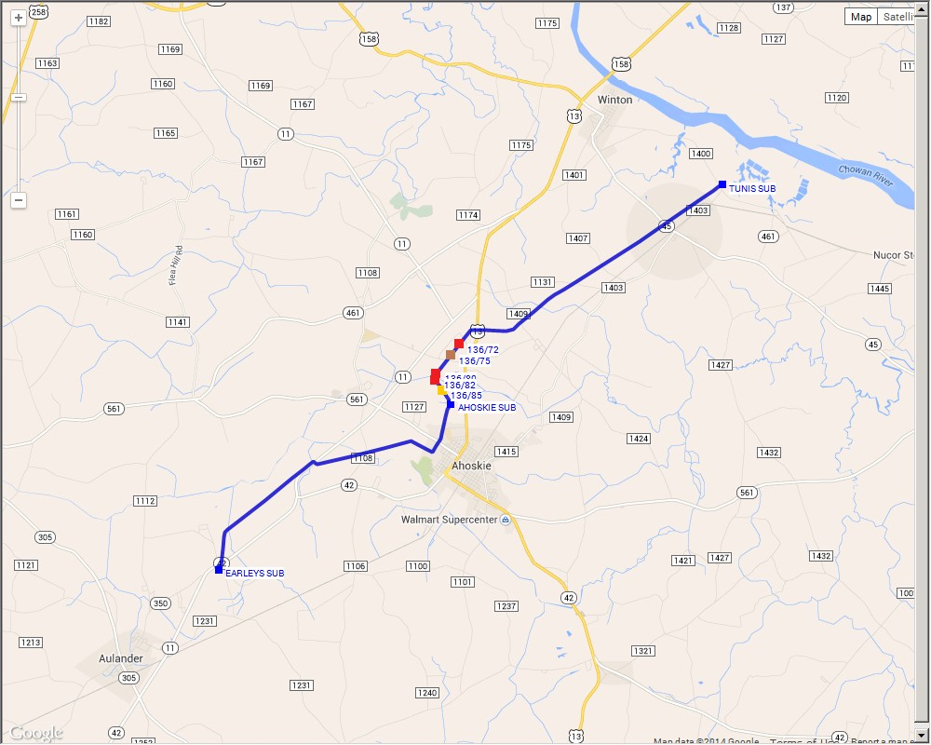

|  |  |
| --- | --- |
| cid:image002.jpg@01D04C1A.3FC17C90  Zoom on Fault View | cid:image003.jpg@01D04C1A.3FC17C90  Earth View |

|  |
| --- |
| **FALLS Locations** |
| **No Lightning Detected +/- 2 seconds.** |

|  |
| --- |
| cid:image004.jpg@01D04C1A.3FC17C90 |

|  |
| --- |
|  |

**Author Biography**



James B. Starling has worked at Dominion Virginia Power since 2003. He has a BS degree in Electrical Engineering from Virginia Commonwealth University. His experience includes testing, installing, and repairing relay systems and calculating line impedances and relay settings. He also has extensive experience analyzing and documenting transmission system operations. He is currently responsible for compliance reporting, misoperation investigations, and fault recorders. Brian is a Master Black Belt Six Sigma for helping reduced Dominion’s transmission operations by 22%.

**References**

[1] Evaluation of Travelling Wave Fault Locators at Dominion, FDAC 2012

[2] Double Ended Fault Location Application using IEEE Standard C37.114, FDAC 2013

[3] IEEE Std. C37.114-2004, Guide for Determining Fault Location (Transmission/Distribution)

[4] Validating Transmission Line Impedances Using Known Event Data, FDAC 2012.