[1]

230 kV Power System Cascade Event by a Single Phase Power Swing Phenomenon

Piñeros J. F., Llano J. F., Agudelo L.Y., Montaño, F. H., Gutiérrez G., Rivera T.

*Abstract*— The reliability of protection systems under asymmetrical power swings is an open topic for the protection engineers. This work presents the analysis and lessons learned from a real single phase power swing phenomenon in an area of the 230 kV transmission network of the Colombia power system. This phenomenon was caused by the asymmetrical connection to the power system of four power hydro generators in a 1200 MW power plant by the connection in the high side of their step up transformers only with the phase C to the power system because of a failure in the closing process of a disconnector at the power plant substation. A simplified simulation model in EMTP/ATP was used to study the oscillatory current phenomenon observed in the event. This phenomenon was caused by the asymmetrical operation of the generators with an alternative positive and negative electromagnetic torque resulting from a high negative sequence current flow into the generators due to the topology created by the double wire open fault condition. Performance evaluation of the protection system is shown which is considered from power system stability and equipment protection point of view.

*Index Terms*— Protection Schemes Performance, Asymmetrical Power Swing, Disturbance Analysis, EMTP/ATP Simulation, Synchronous machine abnormal asymmetrical operation,

# INTRODUCTION

P

ower swing is a three-phase oscillation phenomenon normally defined as a stable or unstable unbalance between the generations in the Bulk Electric System.

There is a challenge with the electrical protections if the power swing phenomenon has an only a single phase swing behavior. The performance of protections systems is uncertain because of the oscillatory currents can reach too high and too low values and the apparent impedance has unexpected changes. The ANSI 68 block function could be activated in single phase power swing conditions. Depending of the point of view of the operator (power system stability) or the owner (equipment protection) to block or not to block by the ANSI 68 function is still an interesting discussion in protection engineering.

This work presents a detailed real single phase power swing event analysis occurred after maintenances activities. It started with a pole discrepancy condition in a connection line of a hydro power plant because of a failure in the actuator mechanism of a disconnector. After a second restoration attempt process, a new condition of unbalance connection of the power generators at the hydro power plant led the power system to experiments a single phase power swing. This phenomenon was characterized by high current oscillations, causing variations of the apparent impedance detected by distance protections. As a final result the phenomenon observed in this event caused the disconnection of eight 230 kV transmission lines.

A preliminary analysis of the event is presented in the section II. This analysis considered the revision of available fault records with emphasis in the tripped protection functions (distance 21 and earth directional overcurrent 67N). The sequence of the power plant maneuvers after the end of the maintenance is also described as a fundamental issue of the event.

In the section III a further analysis is presented to explain the single phase power swing phenomenon as a result of an asymmetrical connection of four power generators and theirs transformers to the power system through phase C only. A simplify EMT simulation in EMTP/ATP is used to understand and to describe the internal phenomenon in the synchronous machines involved in this event.

Several findings, lesson learned and future work are described in section IV and section V. The main goal of this is looking for avoiding this kind of events in the future.

Finally, in section VI conclusions are presented summarizing all the experiences and lessons learned around a rare single power swing phenomenon. It contributes to protection engineers criterium discussion in order to improve protection systems reliability under the failure occurred in this event.

# Network and initial disturbance description

## System Summary

The Colombian System is composed by the following voltage levels 500 kV and 230 kV. The Fig. 1 shows the electrical area in the western of Colombian network with some substations in 230 kV named as Sub (Substation) GS, Sub TC, Sub CV, Sub LF, Sub CR and Sub GC. Substations TC, CV, LF and CR contain several transmission lines.

The substations CV and GC have hydro units about 1000 MW and 1200 MW, respectively. The power plant in substation GC is connected to the transmission system through two parallel transmission lines (1 and 2) of 0.5 kilometers, which connect substations GC and GS.

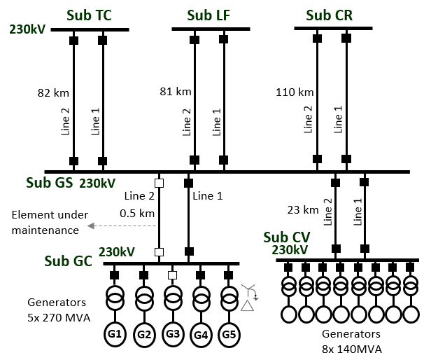

Fig. 1 Power system network – area of the event

## Event Description First Part

Previously to the ending of the maintenance activities in the line 2 Sub GS – Sub GC, the power plant in the substation GC was synchronized at the electrical system through the Line 1 with 470 MW with Units 1, 2, 4 and 5 in service (see Fig. 2).

During the restoration of the transmission line 2, the circuit breaker at substation GS was closed first. Then the circuit breaker at substation GC was closed. At the moment when the last circuit breaker was closed in this line, an unbalance current started flowing through the transmission lines 1 and 2 as a consequence of the open disconnector phases A and B in the disconnector Q1 (failure in closing process).

Fig. 2a and Fig. 2b show the sequence of restoration and the unbalance current condition between lines 1 and 2 when the line 2 was closed.

|  |  |
| --- | --- |
|  |  |
| (a) | (b) |

Fig. 2 Switching operations after maintenance - Line 2   
Sub GC – Sub GS

Consequently, the unbalance current condition between GS and GC substations was cleared by lines 1 and 2 pole discrepancy protection.

This disturbance caused the disconnection of all circuit breakers of the lines GS – Sub GC at 230 kV in substation GC and in the substation GS only the circuit breaker of the line 1. The circuit breaker of the line 2 close to the substation GS did not open because of this circuit breaker was the last in the closing process and the timing of the pole discrepancy function was not completed at this bay.

The Fig. 3 and Fig. 4 show the electrical variables and protection digital signals in the lines 1 and 2 Sub GS – Sub GC after the initial restoration closing of the line 2.

|  |
| --- |
|  |
| Fig. 3 Fault record - currents line bay 1 at Sub GS to Sub GC |
|  |
| Fig. 4 Fault record voltage and currents line bay 2 at Sub GC to Sub GS |

## Event Description Second Part

After the tripping of the lines 1 and 2 Sub GS – Sub GC, line 1 in both sides and line 2 only at substation GS, the hydro units at the substation GC were spinning with no load for 6 minutes.

Because of the line 2 Sub GS – Sub GC was still energized (no fault condition was identified at that moment), the operator of substation GC considered to do a new restoration attempt through the line 2 of this substation to recover the 470 MW which were disconnected from the power system.

The circuit breaker of the line 2 at the substation GC was closed and the disconnector Q1 next to this circuit breaker continued improperly closed. This new maneuver, as it is described in the Fig. 5, re-connected the power plant at substation GC (with 4 generators in service) to the power system through transmission line 2.

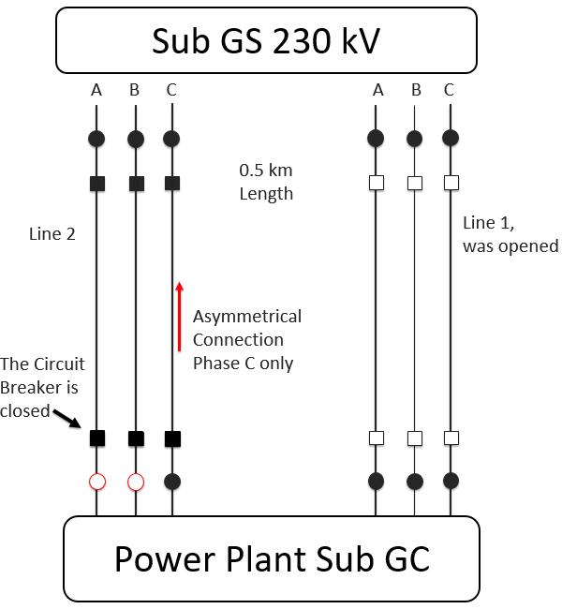

Fig. 5 Asymmetrical Closing of the Line 2 Sub GS – Sub GC

The asymmetrical connection only by phase C of the substation GC to the power system caused an electrical phenomenon in the Colombian power system identified as a single phase power swing.

Fault records of the transmission lines connected with substation GS showed high injection of oscillatory current in the phase C as it is shown in the Fig. 6 and the Fig. 7. The single power swing was detected by all protection elements located in the western Colombian power system.

|  |
| --- |
| Fig. 6 Fault records currents at the Line Bay 2 Sub GS to Sub CV - single phase power swing |
| Fig. 7 Fault record currents at the Line Bay 2 Sub GS to Sub LF - single phase power swing  After the single phase power swing created by the second restoration attempt of the line 2 at substation GC, the substations GS and GC were disconnected from the power system by protection trips of remote substation TC, LF, CR and CV. Functions operated were distance and earth directional overcurrent. |

## Preliminary Analysis First Part

The disconnector Q1 of the line 2 at substation GC presented a failure that unplugged the actuator mechanism of phase C from phase B, and in consequence, phases A and B were not able to close due to the closing mechanism when the closing command was executed.

The substation GC is a GIS type substation. In this substation the disconnector Q1 had only one phase position indicator and it was not possible in a visual way to realize for the operator the pole discrepancy condition after the closing command as is shown in Fig. 8.

The control system of the substation GC uses phase C to verify the position of disconnector Q1. According to the control of the substation the position of the disconnector Q1 signalized closed state.

With the conditions previously described the closing of the line 2 in an asymmetrical topology was not detected.

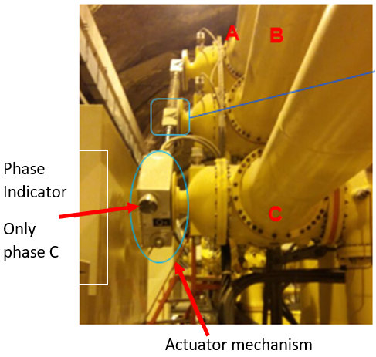

Fig. 8 Disconnector Q1 of Line 2 at substation GC

The tripping of the pole discrepancy function in lines 1 and 2 Sub GS – Sub GC was according to the protection settings considering the currents observed in the Fig. 3 and the Fig. 4. This function is based on unbalance current criterium. The setting at the moment of the event was based on current difference – 20% threshold and tripping after 2 seconds.

According with the real conditions presented in lines 1 and 2 Sub GS – Sub GC it was expected to trip only the line 1. The line 2 did not present a real pole discrepancy condition and it was an undesired trip.

According with the control system and its interlocks logics of substation GC, the closing process of line 2, with verification of phase C, could not be avoided.

## Preliminary Analysis Second Part

The summary of the openings caused by the single phase power swing phenomenon according to the revision of the Sequence of Events (SOE) and trip logs of the protection relays is described in the Fig. 9. It considers tripped protection functions and final opening times.

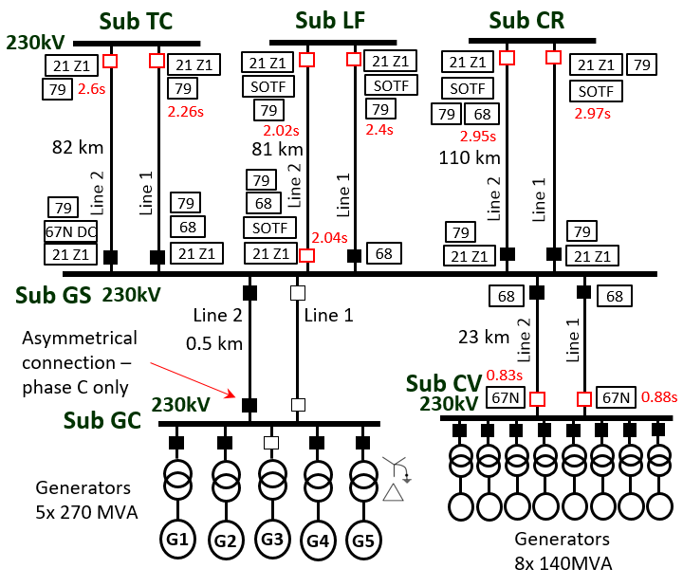

Fig. 9 Openings after the asymmetrical connection of power plant Sub GC to the Power System

Protection relays in the substation GC and the line 2 Sub GS – Sub GC did not trip and no fault records were available according to the information provided by the owner.

In this disturbance, most of the relays in this area of the power system identified the phase C oscillations with around 80% of the rated voltage and 430% of steady stable current (see Table 1). It caused that all the relays associated with the transmission lines in substation GS trip in order to clear this kind of fault called “double wire open circuit” which produced in this kind of topology a single phase power swing.

A key point in the information of this phenomenon is the current amplitude to estimate the current maximum value through the line 2 Sub GS – Sub GC, at the same instant time, measured by the phases C of all the transmission lines connected to the substation GS.

According to fault records the current through the line 2 Sub GS – Sub GC in the highest oscillation area was higher than 10kApeak as it is shown in Table 1.

Table 1 Current Amplitude at maximum peak instant phase C from Fault Records

|  |  |  |
| --- | --- | --- |
| **Lines** | **one line [kAp]** | **total [kAp]** |
| GS-CV | 4 | 8.0 |
| GS-TC | 1.3 | 2.7 |
| GS-LF | 1.0 | 2.0 |
| GS-CR | 1.0 | 2.0 |
| I Phasor Total ∑ | | **14.06** |

The Table 2 describes a summary of protection stages that tripped during this phenomenon. The typical setting used in Colombia and the most important findings of the event are also presented.

Table 2 Protection Function Operation and Findings

|  |  |  |
| --- | --- | --- |
| **Function** | **Typical setting** | **Findings** |
| Directional earth overcurrent  67N | I pickup: 120 A  Curve: Very inverse  Time Dial: 0.05  Intentional Time delay: 1 second | Several of these functions picked-up and remained unlatched because the phenomenon was oscillatory. Only two elements tripped for this function because its setting was different to typical recommend value (managed with dial setting as it was not available to set an additional timer of 1 second) |
| Distance  21 | This function detects a fault condition in the line with four zones, three forward zones and one reverse zone. | Most of these relays tripped by this function because this oscillatory phenomenon was identified as a single fault condition into zone 1 and it was a backup protection operation because of relays of lines 1 and 2 Sub GS - Sub GC 230 kV did not trip. |
| Reclose  79 | This function is set to single and three phase reclose after tripping of distance (zone 1) and overcurrent (Directional Comparison) operation | The most of relays reclose which trip to zone 1 distance function. |
| Power swing blocking  68 | This function is set to probide three phase power swing blocking for distance and overcurrent functions. | Some types of relays were undesirably blocked for some time for a single phase power swing. |

# Further Analysis

After the preliminary analysis of the single power swing phenomenon it was necessary to create a simulation model to clarify the following questions:

* Why the relays in the line 2 Sub GS – Sub GC did not trip during this phenomenon?
* Why was the asymmetrical current by the line 2 Sub GS – GC oscillatory with too high and too low (near to zero) values?
* Why was it possible to connect four generators at the same time to the power system?
* Why was the function 78 of the generators not tripped in this event?

To answer these questions a simplified model of the asymmetrical connection of the substations Sub GC with Sub GS was created in ATPDraw 6.1.

## EMTP/ATP Simulations

Fig. 10 shows the model considered to answer the previous question. This model was based on the key points describe below:

* Simulation of four hydro generators (270 MVA, 13.8 kV each one) using ATP type 58 (phase domain) Synchronous Machine model with a typical AVR and constant torque input with steps to simulate the disconnection and the re-connection condition.
* Simulation of the power system considering network equivalents in the substations CV, CR and TC.
* PI models for transmission lines modelling.

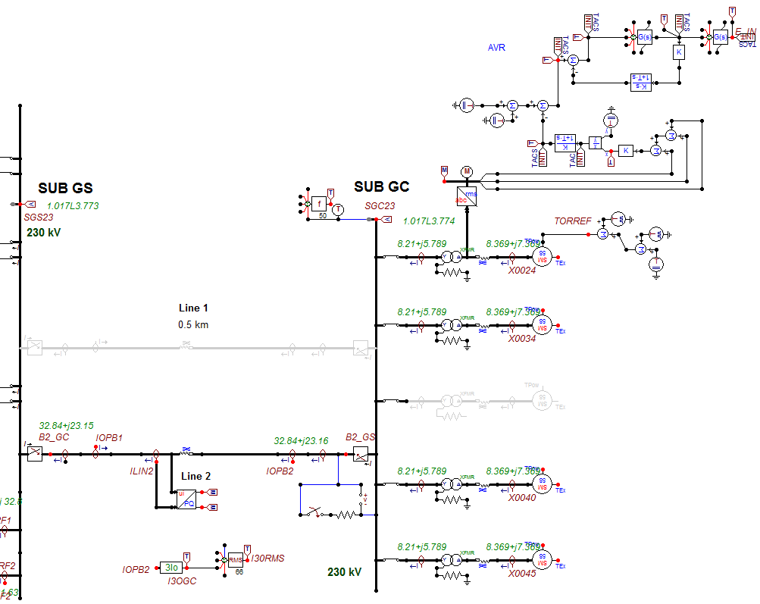

Fig. 10 ATPDraw simplified model to analyze the power swing phenomenon

Two simulation cases are presented in this paper and their considerations are shown in the Table 3. Both cases start with the opening (t = 0.2 s) of the line 2 Sub GS – Sub GC 230 kV at the side of the substation GC to simulate the temporal disconnection from the power system of the Generators 1, 2, 4 and 5 of the power plant at substation GC.

The active power initial conditions of the generators are below of the 5% of the rated power, it means not load conditions programmed for the generators. Which was the previous scenario to the asymmetrical phase C connection. Initial machine angle for both simulation was 31.3 degrees.

Table 3 Simulation Cases – Description at the line 2 of substation GC 230 kV

|  |  |  |
| --- | --- | --- |
| **Case** | **Synchronizing (phase C closing) Conditions** | **Description** |
| SimC1 | Voltage Angle difference below 50 degrees (48°) | Closing the phase C at t=1s of the Circuit Breaker. Internal generators maximum angle oscillation below of 50° |
| SimC2 | Voltage Angle difference over 50 degrees (123°) | Closing the phase C at t=2s of the Circuit Breaker. Internal generators maximum angle oscillation below of 150° |

Simulation results for case SimC1 of the key electrical variables are shown from the Fig. 11 to Fig. 15.

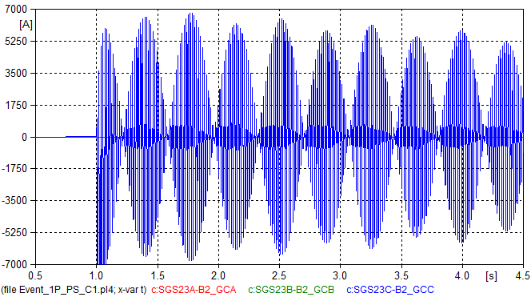

Fig. 11 Currents at line 2 Sub GC - Sub GS 230 kV – SimC1

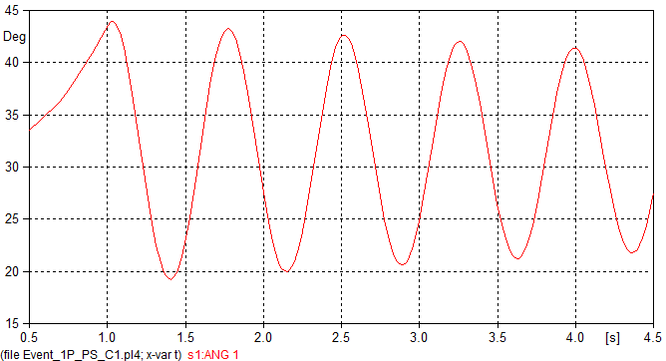

Fig. 12 Generator 1 Sub GC – Machine Angle – SimC1

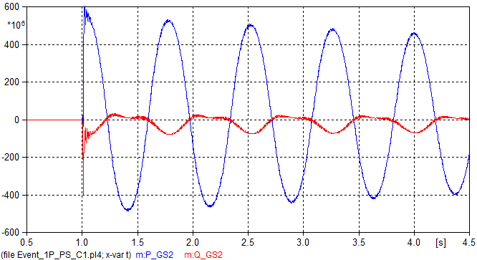

Fig. 13 Active (P_GS2) and Reactive ( Q_GS2) Power at line 2 Sub GC - Sub GS 230 kV – SimC1

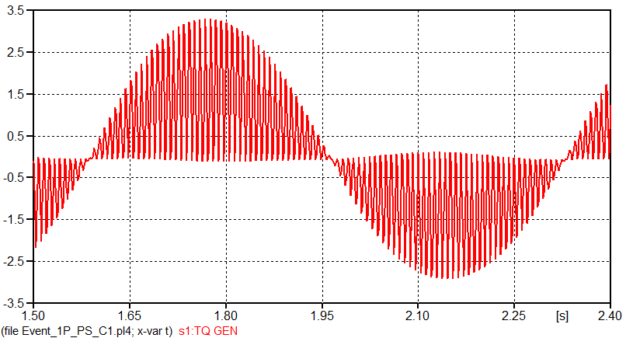

Fig. 14 Generator 1 Sub GC – Electromagnetic torque of the machine – SimC1

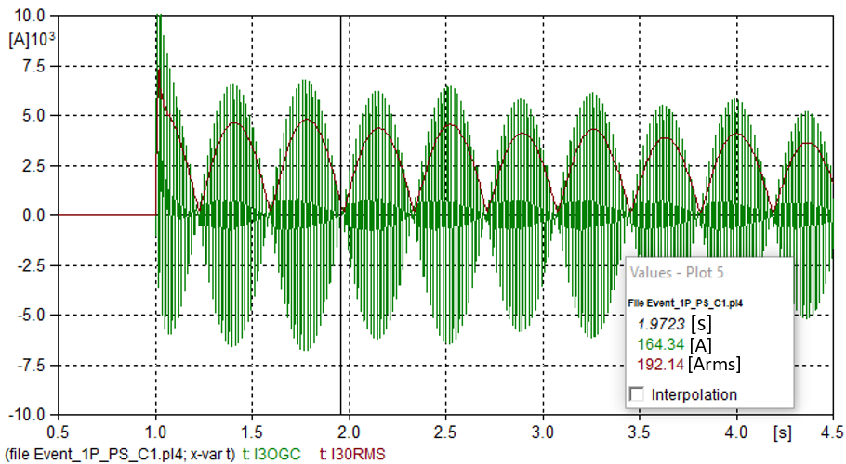

Fig. 15 Residual current waveform and rms value in line 2 Sub GS - Sub GS 230 kV – SimC1

Simulation results for case SimC2 of some of the key electrical variables are shown from the Fig. 16 to Fig. 19.

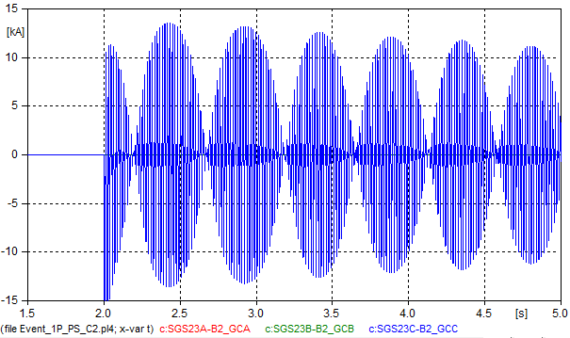

Fig. 16 Currents in line 2 Sub GC - Sub GS 230 kV – SimC2

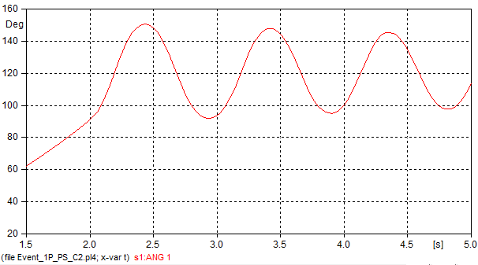

Fig. 17 Generator 1 Sub GC – Machine Angle – SimC2

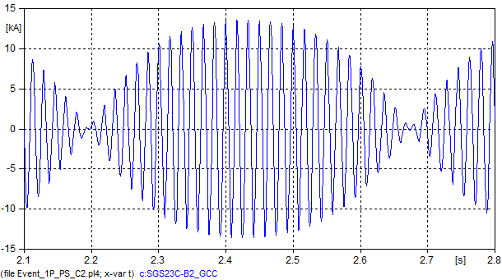

Fig. 18 Currents at line 2 Sub GS - Sub GC 230 kV waveform detail– SimC2

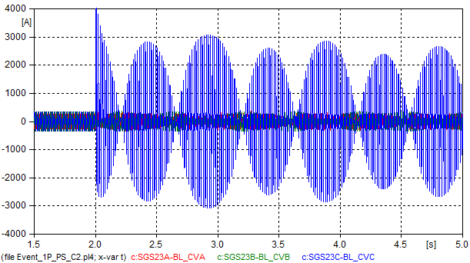

Fig. 19 Currents at line 2 Sub GS - Sub CV 230 kV– SimC2

## Simulation Results Analysis

The simulation results of the case SimC1 shows that:

* It was not required a high difference angle at the moment of the closing to generate high oscillatory currents at the line 2 Sub GS – Sub GC, as it is shown in Fig. 11.
* The four generators at substation GC experimented an active power swing operation mode (see Fig. 13) without a variation in the generator angle that suggested an out of step condition according to Fig. 12.
* The residual current through the line 2 Sub GS – Sub GC presented a very low rms value in the low area of the current oscillation as is shown in Fig. 15.
* The synchronizing conditions of the real event at the moment of the closing of the line 2 sub GS – Sub GC were worse than the conditions presented in the case SimC1 according to the value shown in Table 1 and compared with the maximum value in Fig. 11. This is coherent with the fact that the synchronization process was not done by the generator unit circuit breaker of every generator. Normally the synchronization parameters (angle, voltage and frequency delta ranges) for a transmission line bay synchronization process are less strict than the parameters for generators circuit breakers.
* According with the swing equation of the synchronous machine [3]:

$$J\frac{d^{2}θ}{dt^{2}}=τ_{m}-τ_{e}$$

the oscillation of the current was possible because of the oscillation between a positive and negative value of the electromagnetic torque of the generators at substation Sub GC (Fig. 14). The oscillation in the electromagnetic torque can be explained because of the asymmetrical connection in the 230 kV level. As it is shown in Fig. 20 the asymmetrical connection through phase C in the 230 kV caused in every generator, a negative sequence current component with the same magnitude that the positive sequence current in the generator. Considering that the negative current creates a counter torque in a negative sequence (the opposite of the generator’s rotor revolution) there were two components of the electromagnetic torque rotating in different directions and causing an oscillatory electromagnetic torque as it shown in the Fig. 14. Because of the oscillatory electromagnetic torque, the generators were operating in an alternating mode: as a generator and as a motor.

* The oscillation frequency observed in the real currents was around 2.94 Hz and according to the simulations the machines swing had a frequency of around 1.47 Hz (the half of the current oscillation). Simulations showed a good approximation with these frequencies and led to suggest that their values depend on the inertia of the generator and the angle zone of the machine at the asymmetrical switching instant.

According to the results of the simulation case SimC2, the conditions of the synchronization process of the four generators at substation GC through the line 2 sub GS – Sub GC occurred with an angle difference higher than 50 degrees.

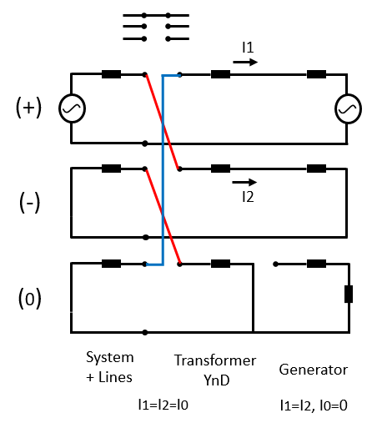

Fig. 20 Symmetrical Components Sequence Network Diagram of the double wire open failure

## Protection Systems Performance

The analysis of the asymmetrical connection occurred in this event shows that there was a double wire open failure, in consequence:

* Overcurrent relays at line 2 Sub GS – Sub GC experimented reset conditions because of the oscillation of the current and it explains the omission of the trip because of the lower current reached value was below of the pickup of these relays. The pickup was adjusted in a value higher than 300A and according with the rated current of the lines 4067 A.
* The generators involved in this event did not reach an out of step condition. The 78 function was not expected to trip.
* All the relays in the transmission lines between substation GS and substation CV, TC, LF and CR, operated as a backup of the failure occurred in the line 2 Sub GS – Sub GC.
* The protection schemes of the lines 1 and 2 Sub GS – Sub GC and of the power plant at substation GC did not provide enough reliability for the asymmetrical connection of the generators at substation GC.
* The activation of the blocking 68 function in this event is considered as an incorrect behavior taking into account that the phenomenon was not a three phase condition and there was a real fault in the power system at the line 2 Sub GS – GC.

# Findings and recommendations

After this disturbance a corrective maintenance was executed on disconnector Q1 at the substation GC to avoid recurrences. However, post disturbances analysis identified very important findings and recommendations to improve the protection systems performance:

* Implement in the Sequence of Events – SOE three pole signals position disconnector open-close.
* Implement the total stop in the hydro generator unit after no voltage detection in the two lines connecting substations GC and GS.
* Implement interlocks logic to avoid closing of the circuit breaker with at least one of the disconnector phases is open.
* Implement synchronization verification with as minimum two phases in all the line bays of the lines 1 and 2 Sub GC – Sub GS
* Analysis and implementation of new settings in the protection relays to improve protection schemes reliability in similar disturbances. One example is the analysis of the implementation of curve reset mode in the overcurrent protections of the lines to connect the power plants with the power system.

# Future work

Implement logics or use the capability of modern protection relays to identify in a generator a single phase power swing electrical phenomenon in order to avoid damage or life time reduction of the synchronous machines.

The methodology to set the power swing blocking protection function is being re-evaluated to determinate a more reliable setting and selection of a better electrical point where this function should trip or block.

# Conclusions

Philosophically protection relays must be designed only to identify three phase power swing electrical phenomena. Whereby, the single phase power swing phenomenon is not detecting for the conventional protection systems and the Colombian System Operator does not recommend implementing a blocking in the case of single phase power swing.

During a single phase power swing electrical phenomenon, some conventional relays presented blocking. It is recommended that relay manufacturers evaluate the performance of their protection equipment for single phase power swing. It is necessary to implement protection logics or protections functions settings to trip fast for this kind of phenomenon as a backup. However, the generator system protections must be designed to detect and clear any faults and abnormal conditions in the power plant with enough speed to avoid damages and life time reductions in the generators.

The single phase connection of a group power generator – transformer by the high voltage transformer side is highly risky for power systems and it must be avoid because of the high symmetrical oscillatory currents. These currents don’t allow to the conventional protection functions a fast detection. It leads that other protections system in the area of the event can trip.

The simplified EMT simulations allowed to identify and study in detail this kind of disturbances to provide the appropriate recommendations.

Acknowledgment

The authors make acknowledge the participants and companies involved in this event for their efforts to improve the reliability of the protection systems and the security of the power system through hard collaborative work to understand the phenomenon occurred in this event and the necessary actions to be taken.

References

1. XM, EMGESA, EEB, INTERCOLOMBIA, “Disturbance reports of the events 101,102”, Colombia, 2016.
2. C. Spagnolo, S. Nuzzo, G. Serra, C. Gerada, M. Galea, “Analysis of salient-pole synchronous generators operating in single-phase condition” IEEE Workshop on Electrical Machines Design, Control and Diagnosis (WEMDCD), 2017, 20-21 April 2017.
3. Kundur P, Power System Stability and Control, McGraw-Hill, 1994.
4. IEEE Std C37.104-2012 Guide for Automatic Reclosing of Circuit Breakers for AC Distribution and Transmission Lines.
5. H. K. Høidalen, ATPDraw Users’ *Manual – Reference Manual, Advance Manual*, version 5.6, 2009.

 **Juan F. Piñeros S.** received his B. Sc. in Electrical Engineering from National University of Colombia in 2008 and his M. Sc. in Engineering from Antioquia University of Colombia in 2016. Currently he is a Specialist in Reliability Performance Analysis at the Protection and Disturbance Analysis Team in XM S.A. E.S.P. Colombian Power System Operator and Market Administrator. He is an associate professor in the North University of Colombia in the Electrical Protections course and in Power System Simulation courses at the Antioquia University of Colombia.

**Javier F. Llano.** received his B. Sc. in Electrical Engineering from Antioquia University of Colombia in 2007 and his Technology in Information Systems of the ITM University of Colombia in 2003. He is M. Sc. (Candidate) in Engineering from UPB University of Colombia. Currently he is an Engineer of Reliability Performance Analysis at the Protection and Disturbance Analysis Team in XM S.A. E.S.P. Colombian Power System Operator and Market Administrator.

 **Laura Y. Agudelo**. received her B. Sc. And M Sc. in Electrical Engineering from Antioquia University of Colombia in 2007 and 2014, respectively. Currently she is an Engineer of Reliability Performance Analysis at the Protection and Disturbance Analysis Team in XM S.A. E.S.P. Colombian Power System Operator and Market Administrator.

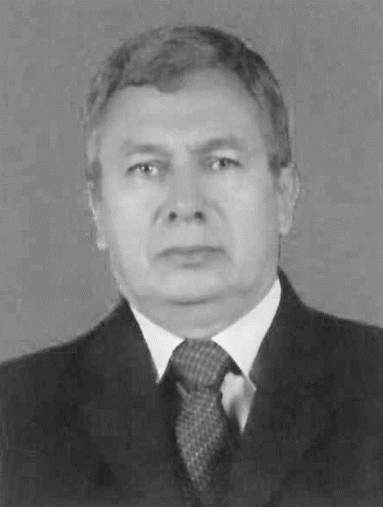**F. Humberto Montaño**. Electrical engineer graduated from the National University of Colombia in 1987, specialist in energy planning, graduated from the Autonomous University of Colombia in 1997, MSC Geophysics, graduated from the National University of Colombia in the year 2001. Currently working with Grupo Energía de Bogotá in the Operations Management, offering support in the planning of electrical power systems, regulatory framework of the electric sector in Colombia, operation assurance: analysis of events, processing of operation indicators, RCA analysis of special events and others.

 **German Gutierrez.** receive his B. Sc. in Electrical Engineering from National University of Colombia in 1997 and his M. Sc. in Engineering from Universidad Pontificia Bolivariana in 2016. Currently he is an Specialist in Protection systems and Disturbance Analysis in ISA-INTERCOLOMBIA S.A.



**Timo F. Rivera R.** received his B. Sc. in Electronical and Electrical Engineering from National University of Colombia in 2011 and 2012, respectively, and his Specialist degree in Industrial Process Automation from Los Andes University in 2015. Currently he is an Expert Professional at Electrical, I&C Division of the Technical Support Team in EMGESA S.A. E.S.P.

1. **Piñeros J.F., Llano J.F. and Agudelo L.Y**. are with XM S.A. E.S.P. Colombian Power System Operator and Market Administrator, Protection and Disturbance Analysis Team, e-mail: [jpineros@xm.com.co](mailto:jpineros@xm.com.co), [jfllano@xm.com.co](mailto:jfllano@xm.com.co), [lagudelo@xm.com.co](mailto:lagudelo@xm.com.co).

   **Montaño F. H**. is with Grupo de Energía de Bogotá, in the Operations Management department, email: [fmontano@geb.com.co](mailto:fmontano@geb.com.co).

   **Gutierrez G.** from ISA-INTERCOLOMBIA S.A. Specialist in protection systems and Disturbance Analysis, email: [gegutierrez@INTERCOLOMBIA.com.co](mailto:gegutierrez@INTERCOLOMBIA.com)

   **Rivera T.** is with EMGESA, Generator Company, I&C Division of the Technical Support Team, email: [timo.rivera@enel.com](mailto:timo.rivera@enel.com).