Fault investigation using data from PMU, DFR and Traveling-Wave fault locators: Experiences from Companhia Paranaense de Energia (COPEL) on combining these tools for optimal fault analysis

Gilmar F. Krefta  gilmar.krefta@copel.com | Carlos E. F. Pimentel  carlos.pimentel@ge.com
Lucas B. de Oliveira  lucas.oliveira@ge.com | Sergio L. Zimath  sergio.zimath@gmail.com
Copel Geração e Transmissão (GeT)  Phone: +554133313167  Rua Padre Agostinho, 2600, 80710-000  Curitiba, PR, Brazil | GE Grid Solutions  Phone: +554821080300  Office Park – SC-401, 4756, 88032-005  Florianopolis, SC, Brazil

ABSTRACT
Fault analysis in power systems is an important practice to identify latent issues, validate engineering design and premises and guarantee grid stability. Nonetheless, with the increasing complexity of the system due to the increasing interconnections, inclusion of Distributed Energy Resources (DER) and variable loads, this is not always an easy task. In this paper, we describe practical fault analysis examples from Companhia Paranaense de Energia (COPEL) using several monitoring technologies, such as Digital Fault Recorders (DFR), Phasor Measurement (PMU) and Traveling-Wave Fault Locator (TWFL) for optimal diagnose, highlighting the benefits of having multiple analytical resources available to the operators and power system engineers.
This paper also introduce the power system operated by COPEL, at the southern region of Brazil, and the tools available for power system monitoring and analysis, which comprehends DFRs in all substations from transmission system, dozens of TWFL, almost 40 PMU in all 230 and 525 kV power system and integration with meteorological data from geographical region where COPEL’s installations are located.
The examples presented feature data from the aforementioned tools and encompass different kind of events, such as systemic voltage dips, faults at transmission lines and diagnostics of logic errors in equipment operation. Finally, we deep-dive on the analysis of a given event to illustrate how the combination of tools available in COPEL is crucial for the understanding of the phenomenon, demonstrating that the analysis would be inconclusive if it weren’t for the concurrent tools.

KEYWORDS
DFR, TW, PMU, Fault Analisys, Wide Area Measurement Systems,Phasor Measurement,COPEL WAMS.

INTRODUCTION
Digital Fault Recorders (DFR), also known as oscillograph recorder, are devices used to monitor protection relays performance and fault values of voltage and current. Since the early days of the Electrical Power System, the Fault Recorders (FR) are devices entirely devoted to monitoring the operating conditions of the protection and the magnitudes of the signal of currents and voltages, during the incidence of faults or disturbances.
Initially, those devices were electromechanical, whose mechanisms magnetically triggered plumes, immersed in ink, which recorded the excursion of the current, voltage and the protection function signals on paper ribbons. As an example, one can cite the recorder Thomson, which was originally developed to perform the topography of the sea bed at the beginning of the year 1930 and subsequently was adapted to monitor the performance of the electrical power system during faults.
Figure 01 shows the register recorded by a Thomson recorder. This oscillography only shows if there is something under or above normal conditions related to the current or voltage signal and if any signal of protection was assigned, it did not report magnitudes.

Figure 01- Oscillography by electromechanical Thomson.
The evolution of the monitoring system occurred with the introduction of magnetic tape for recording disturbances, such as the Sangamo fault recorder. Up to this stage, the disturbance information contained in the registers arrived after days due to the need to carry the tapes or the envelopes with the printed records, from the substation to the office. In the analysis center, the printed records received identification and the tapes were then reproduced and the data analyzed.
Figure 02 shows a model of fault recorder that used magnetic tape for recording disturbances.

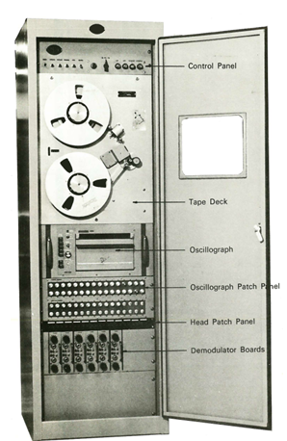
Figure 02-FR with magnetic tape for recording disturbances.

Figure 03 gives an example of register obtained by reproduction of the tape recorder. Now it is possible to know by the time code when it happened, and applying a scale, verify the magnitude of the fault voltage and current.
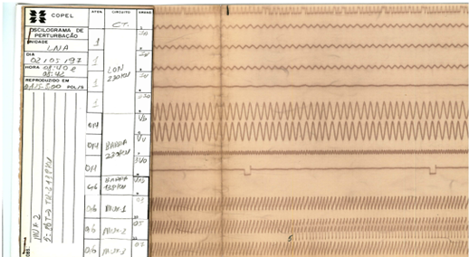
Figure 03- An example of register obtained by reproduction of the tape recorder.

With the advent of digital technology and the network communication, it was possible to set up an analysis center that would obtain the data generated by the digital disturbance recorders (RDPs) of the various substations, where these were applied, and thus allowing analysis of disturbances in a matter of minutes.
The dissemination of communication networks made disturbances of several monitored substations available to a central analysis manager almost in real time.
Figures 04 and 05 allows us to have an idea of the actual state of the art of the records obtained from DFR. With the aid of tools we can calculate vectors, magnitudes, angles, the sequence of currents and voltages, and so on. The sampling frequency currently available is in the order of 15kHz or higher. So we can analyze all kinds of harmonics presents in current and voltages faults and disturbances.
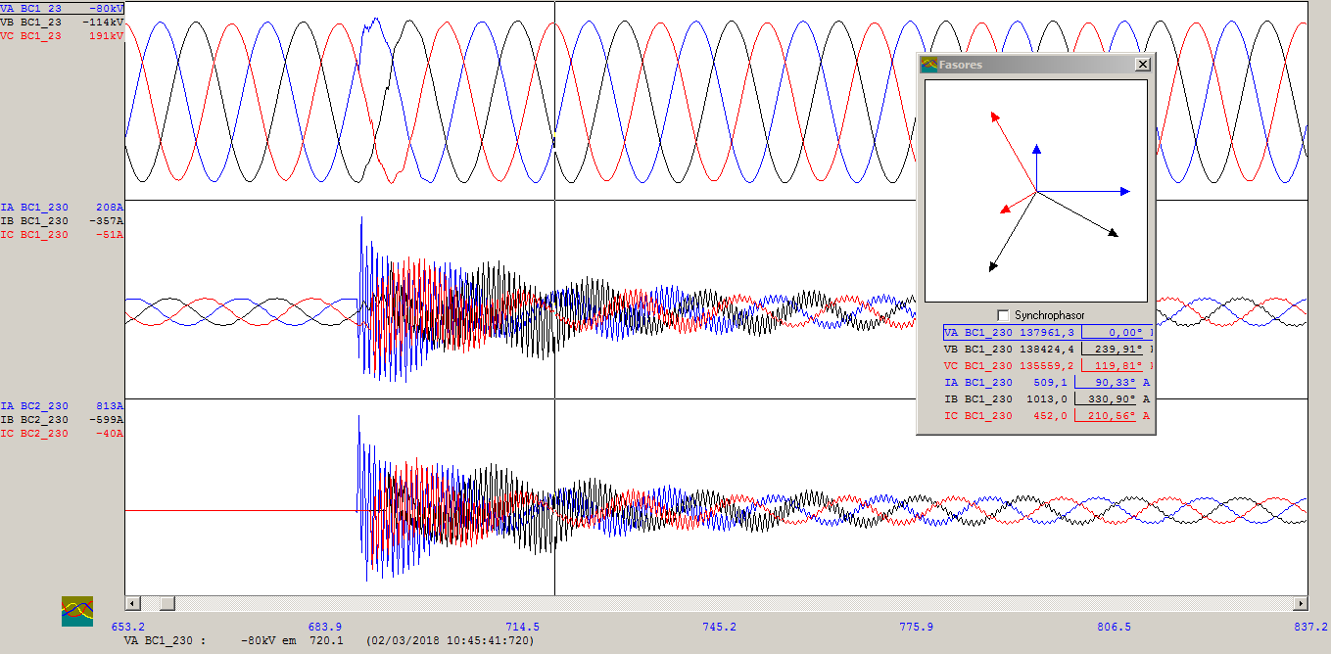
Figure 04- Inrush current of a capacitor bank of 230kV and 150Mvar.

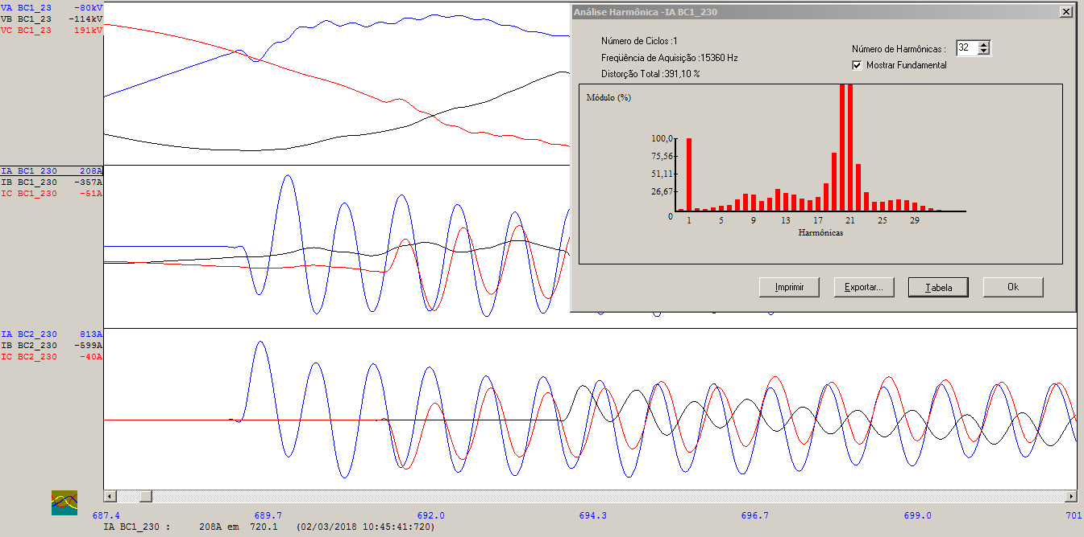
Figure 05- Inrush current harmonic analyzes of a capacitor bank 230kV and 150Mvar.
Faults in a given transmission line causes transients that travel along the line as a multiple frequency wave in a range of a few kilohertz up to several megahertz. These traveling waves are composed of a "wave front" usually with a short rise time and a long decrease time.
The propagation speed of the waves is close to the speed of light. These waves move away from the fault location towards both ends of the line. By determining the moment when the wave fronts pass through each end, it is possible to estimate the fault location as shown in figures 06, 07 and 08.
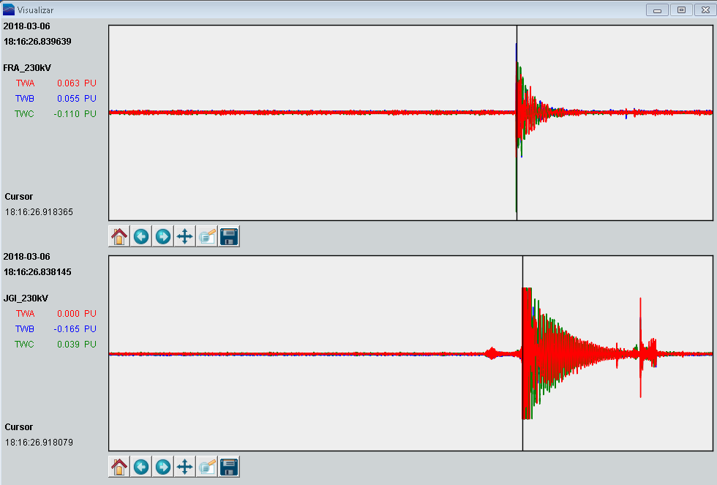
Figure 06 – Travelling wave captured by a DFR.

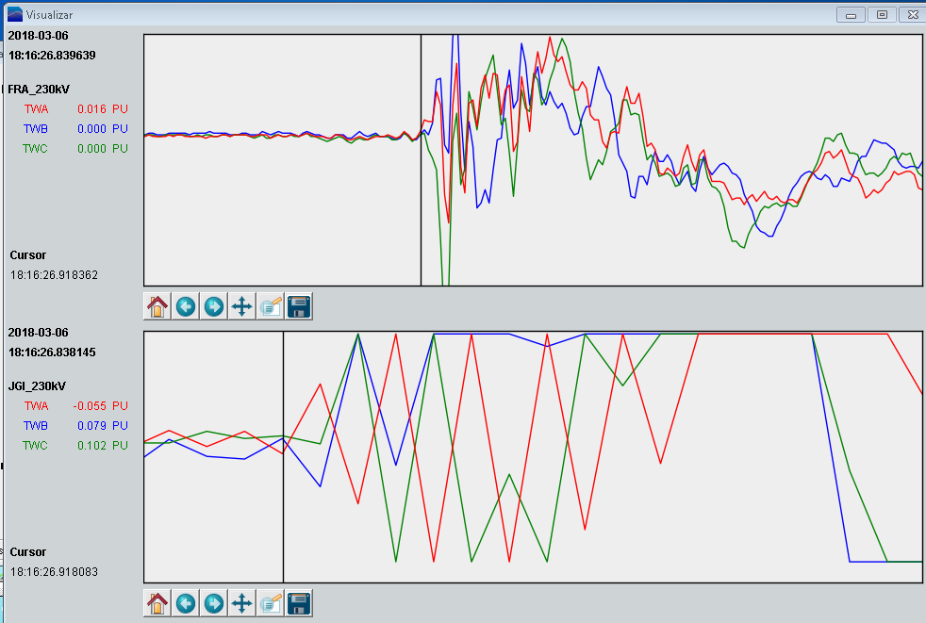
Figure 07 – Travel wave captured by a DFR amplified.

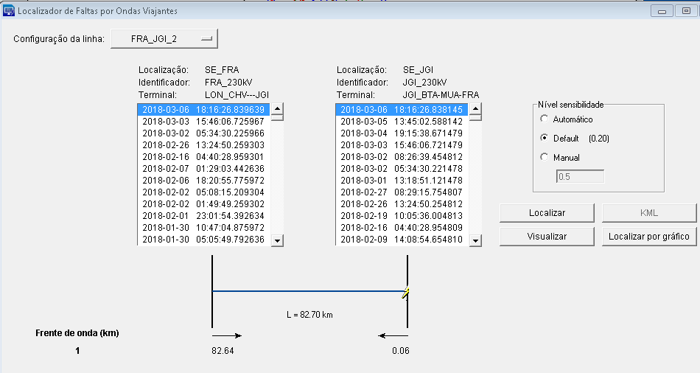
Figure 08 – Fault location applying Travel Wave captured by a DFR.
Protective relays, now also built with digital technology, have incorporated in addition to the protection functions the measurement, automation, communication channel and oscillography. The oscillography function, embedded in the relays of protection, did not eliminate the use of dedicated disturbance registers: in addition to the small data storage capacity of the protection relays compared to DFR, when these relays are damaged, the fault record is lost.
With scanned measurement data made available on Ethernet it was not difficult to add to the phasors a time stamp, common to all phasors originated at that time, by means of a standard time, as for example the obtained by the Global Positioning System (NVSTAR/GPS) or the Global Navigation Satellite System (GLONASS) or the overlap of the two systems. In this scenario, time-synchronized phasor measurement appeared as Phasor Measurement Unit (PMU).
The generation of several synchrophasial magnitudes in several substations of the electrical system makes it necessary to develop a Phasor Data Concentrator (PDC) that aggregates all synchrophasors at the same base time and treat these measures and then make them available to operators and system analysis personnel as software applications.
The increase in operating complexity of power systems has required constant improvement of its monitoring and control instruments, both real-time and offline. This demand has led to the development of innovative technologies, scenario in which stands the wide area measurements. Wide Area Measurement Systems (WAMS) formed basically by Phasor Measurement Units (PMU), communication channels and Phasor Data Concentrators (PDC).
The need of high-resolution continuous monitoring of the power system is being studied by COPEL in the last years, since power system and energy market is becoming more complex. Also, in Brazilian Interconnected Power System (BIPS), power system’s operation is led by National System Operator (Operador Nacional do Sistema – ONS). As ONS is responsible for all Brazilian system, this situation leads the transmission owners in Brazil to a challenge to monitor if their own system is being operated properly according to the equipment and installation.
For fault analysis, COPEL has traditionally used GPS-synchronized Digital Fault Recorders (DFR) and a management system for these records based on web interface. The usage of synchronized recorders is proven to be important as it is possible to aggregate at the same time different software and several waveforms to analyze faults and disturbances in the power system.

SYSTEM DESCRIPTION
Copel utility has generation, transmission and distribution systems and is located at Brazilian Southern. The Electrical Power System under operation of Copel, is composed by 55 substations with 10 transmission lines (TL) of 525kV, 67 TL of 230kV and 4 TL of 138kV. Also, there are six hydroelectric power plants above 100MVA, eight under 30 MVA, one thermal power plant above 100MVA and three wind farms. The length of Copel’s TLs varies from 0,6 km to 334,3km. Fault location by TW is available in all transmissions lines. Wide Area Monitoring System (WAMS) of Copel has 37 PMU distributed in all State of Paraná and is being added more 250 PMU.

Figures 09 and 10 shows the extension of the Copel Power system Operation.
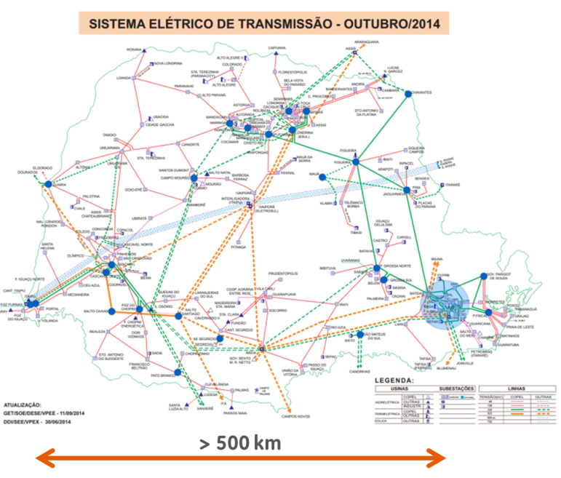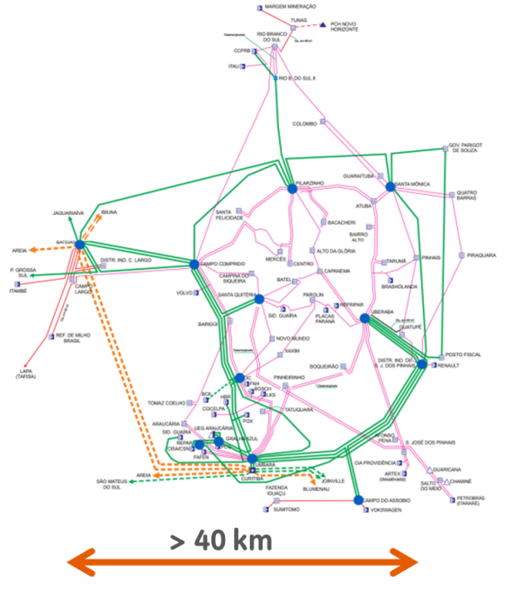
Figure 09. Paraná State system map and PMU locations. | Figure 10. Curitiba Metropolitan Region system map and PMU locations.
COPEL’s WAMS is a Wide Area Measurement System installed in mid-2015 and is being used by real-time operation team, for dynamic system observation. The system intends to support post-event analysis and engineering studies, providing information for post-event, system performance, generators response and dynamic intersystem oscillation analysis.
The WAMS with other tools such as oscillographs, TW fault location and sequence of events (SOE) all synchronized in a same time base allows a detailed analysis of a fault or disturbance in the electrical system, as shown in the example below.
The simple flowchart as shown below can be followed for a better understanding of the fault and preparation of the report.

Fault / Disturbance
Complex?
Use DFR
Create Report
Understand with PMUs
Have TWFL?
Locate accurate
N
Y
Y
N

disturbance and reestablishment of Ponta Grossa region BELONGING TO COPEL electric system .
With the help of the tools described above, we will try to clarify the occurrence and reestablishment of the electric system of the Ponta Grossa region due to the automatic shutdown of the 230 kV Areia-Ponta Grossa Norte (ARE / PGN 230 kV) and 230 kV Bateias-Ponta Grossa Sul (BTA / PGS 230 kV) and consequent load voltage sag at Ponta Grossa Sul 230 kV (SE PGS 230 kV) and Ponta Grossa Norte 230 kV (SE PGN 230 kV) substations, occurred on 10/17/2016 at 13:09 hours.
Figure 11 shows the geographical region of Ponta Grossa and the substations involved in the occurrence.

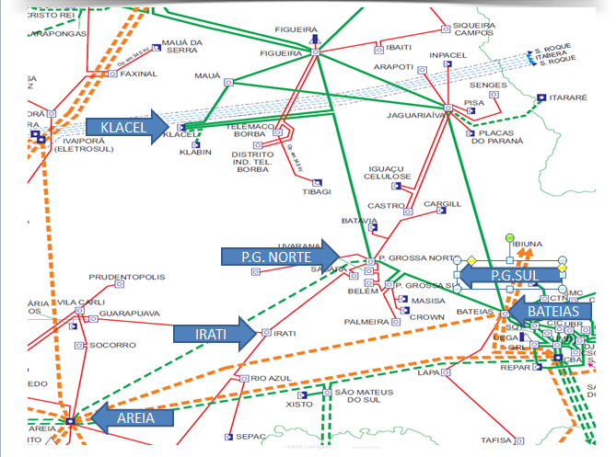
Figure 11 - Geographycal region of Ponta Grossa
Figure 12 shows the sources and substations involved in the disturbance and the normal operation system configuration in.
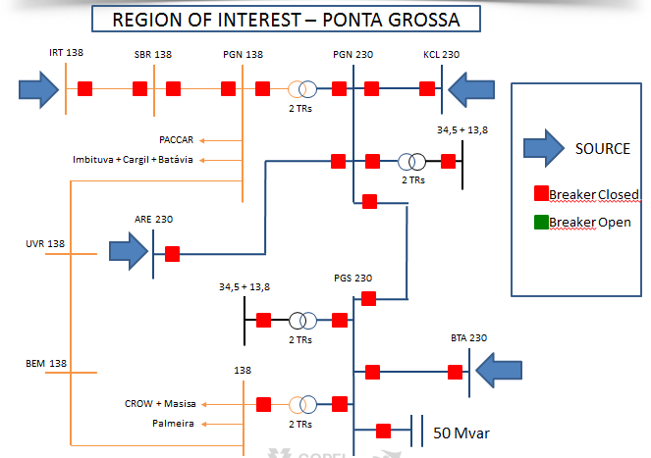
Figure 12 – Affected region electric diagram in normal operation.
Using data from Phasor Data Concentrator (PDC), figure 13 shows the voltage profile registered by Copel WAMS during the whole period of the fault and the system restoring attempts . The Sequence Of Events (SOE) was obtained from the Supervisory Control and Data Acquisition (SCADA) and according with the time breakers opening was possible to identify each step of the event in the voltage chart. So tone can see the exponential voltage sagging at the busbar 230kV of Ponta Grossa Sul being sustained by the connected bus bar capacitor feed by the 138kV system connected at busbar at the secondary of the two interconnecting transformer (230/138kV – 150 MVAR) after the opening of the 230kV TL Bateias/Ponta Grossa Sul. By this overview of the disturbance and others tools is possible to understand each single event.
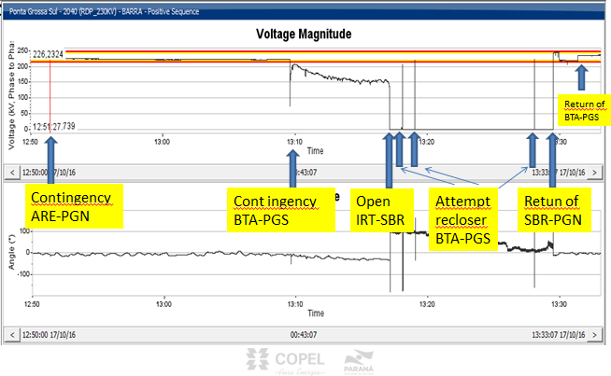 Figure 13 - Voltage profile registered by Copel (PDC) WAMS
At 2016/10/17 the Ponta Grossa system was operating without 230kV TL KCL/PGN. This transmission line was open and earthed without possibility of return to changing cables. So the system was sustained by 230kV TLs PGN/ARE and BTA/PGS. The system was connect to 138kV busbar side of PGN substation source. The figure 14 shows the diagram.
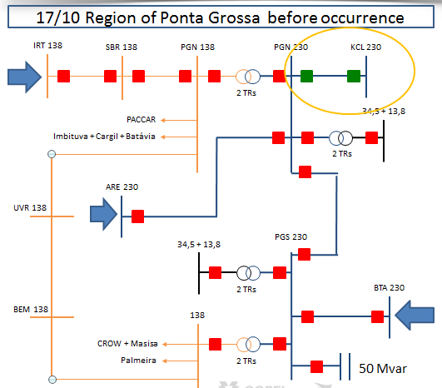
Figure 14- Ponta Grossa diagram before the ocurrency start.
At 12:51h of that day 230 kV TL ARE/PGN was opened because of disruption of the cable and produced an overload in the 230 kV TL BTA/PGN which increased the line sag causing the cable to touch a TL below tree. Maximum current allowed is from 439A to 583A and measured current at that moment was 410A. Later was checked creeping problems with this TL cable, as will be discussed latter.
Figures 15 and 16 show the diagram of the lines involved.

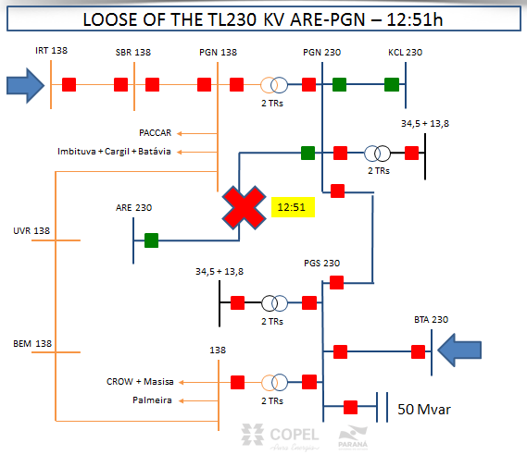
Figure 15 – The loose of the TL ARE/PGN 230kV at 12:51h.

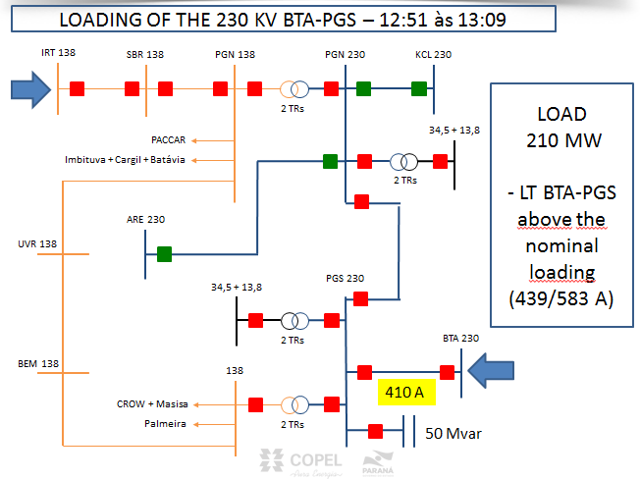
Figure 16 – The overload values of the TL 230kVBTA/PGS.
After the opening of all 230kV transmission lines, Ponta Grossa system was fed by 138kV system connected at the Ponta Grossa Norte substation busbar. The 138kV TL IRT/SBR did not bear this contingency and opened isolating the entire Ponta Grossa system.
One automatic reclose was attempt and three manual attempts were made to re-establish the 230kV TL BTA/PGS without success. The capacitor bank 230kV circuit breaker of PGS substation did not accept opening command and when the command of the 230 kV BTA circuit of PGS substation received the command to close, the protection relay of the line sent a trip to open because of the cold load capacitive inrrush as as shown at figure 17. Only when the PGS 230kV substation was energized by the 138kV busbar side the capacitor bank breaker accepted open command. Just after that, it was put in operation the 230kV TL BTA/PGS and Ponta Grossa system was restored.
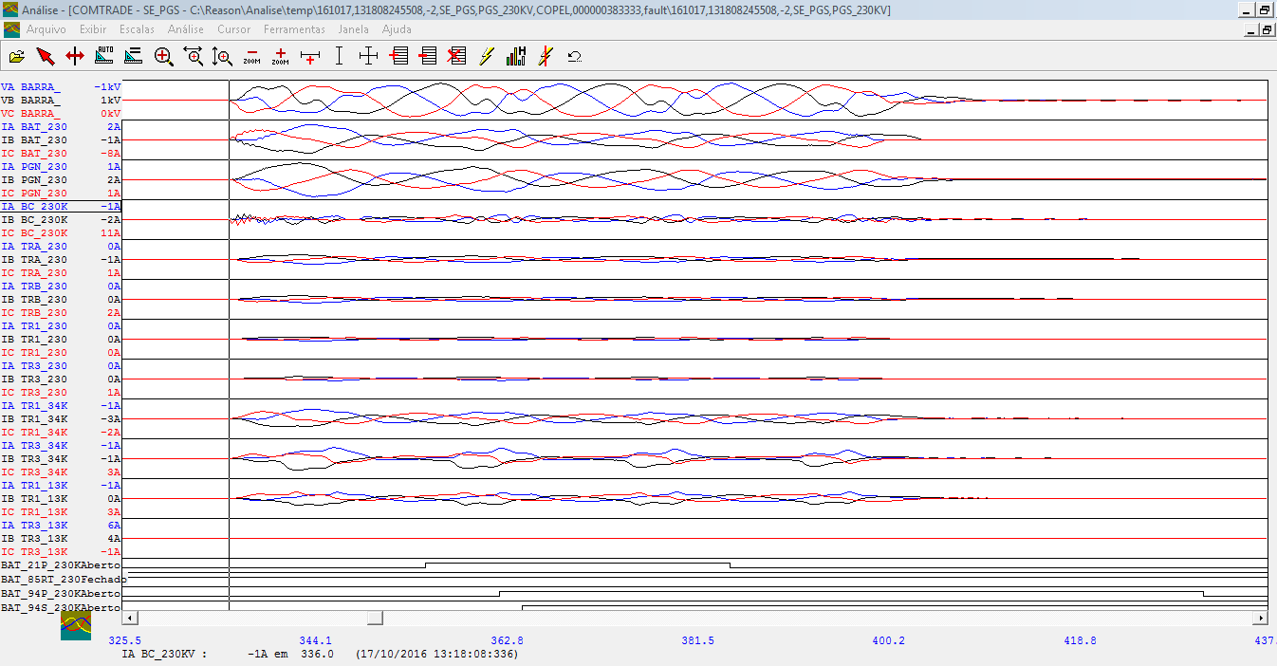
Figure 17 – The capacitive cold load inrush during the manual reclosing of the 230kV TL BTA/PGS at the 230kV PGS busbar.

Considerations
  - Failure of the automatic reclosing relay (79) of the 230 kV TL BTA/PGS after the first fault (13:09h)
The 230kV PGS circuit at 230kV BTA substation accepted the automatic command to close, sent by the 79. But the side at 230kV PGS substation did not. The conditions to reclose the breaker automatically of the side of 230kV PGS substation was according to the relay 79 setting, as shown in the table 01, i. e. with angle between +20 and -20 degrees and nominal voltage. The local system conditions as shown in figures 17 and 18 taken from the PDC historical data indicated that the relay 79 fail because of the difference between frequencies (DELTA F) was 57mHz, i. e., 0.7mHz above the 50mHz setting.
One of the advantages of the PMU applied to power system is to measure the real voltage angle of the system. The Copel WAMS refer to the measured angle of the 525kV BTA substation busbar. The most ordinary cause of fault attributed to relay 79 is the angular aperture of the system; here it was thought that the real cause was the frequency difference between the busbars.

Table 01 – Relay 79 settings
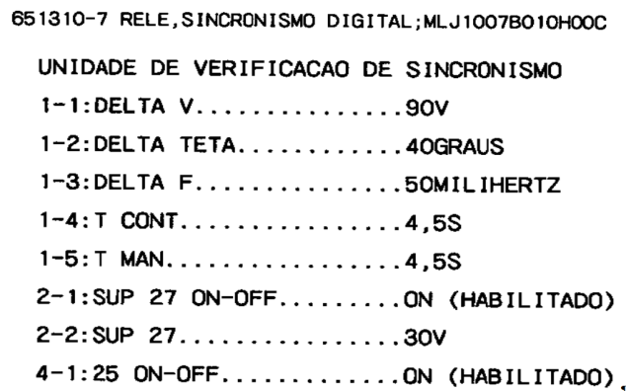
With the PMU aid, it was possible to determine the real conditions of the system at the moment when the 79 must had to command the breaker to close as as shown above.
- Synchronism conditions on BTA 230 kV substation as shown at figures 18 and 19:
f = 60.0113 Hz;
V = 242.94 kV;
φ = 2.35 degrees.
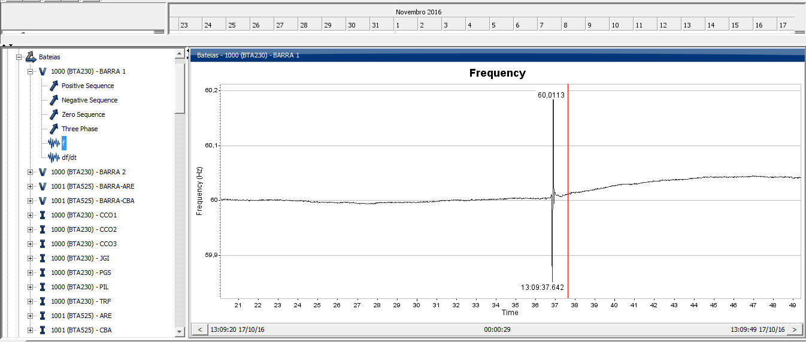
Figure 18 – Frequency at 230kV BTA substation.
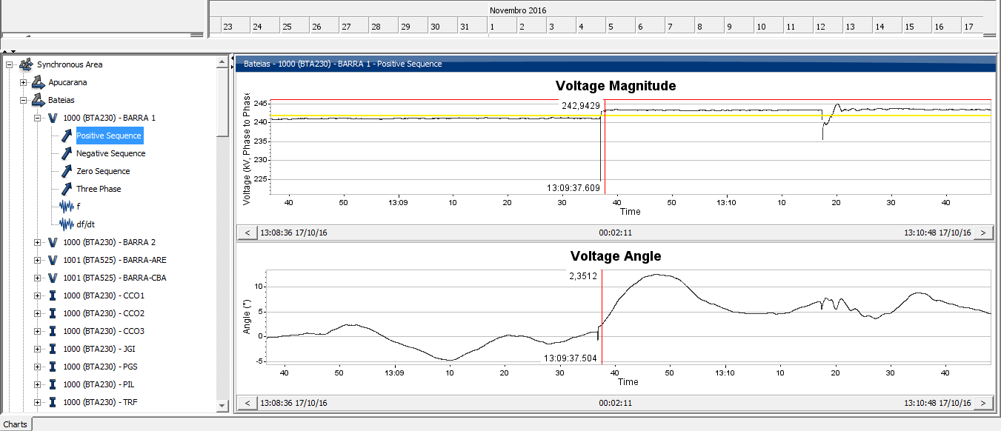
Figure 19 – Voltage and angle at 230kV BTA substation.
- Synchronism conditions on PGS 230 kV substation as shown at figures 20 and 21:
f = 60.0056 Hz;
V = 150.395 kV;
φ = -18.26 graus.
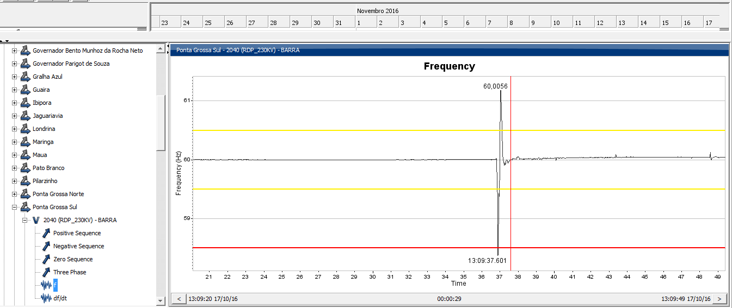
Figure 20 – Frequency at 230kV PGS substation.
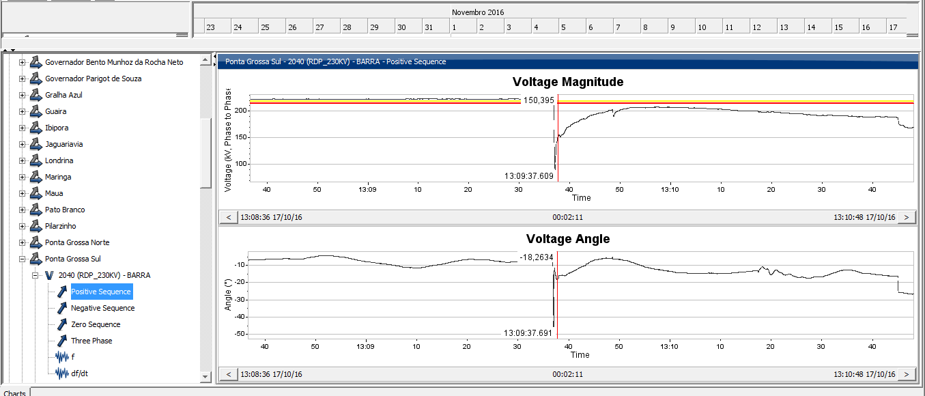
Figure 21 – Voltage and angle at 230kV PGS substation.
4.2 Fault location on 230 kV TL BTA/PGS at the first fault (13:09h)
The oscillography data, as shown in Figures 22 and 23 below, indicated that there was a phase B fault to earth on 230 kV TL BTA/PGS that occurred at 17.5 km using one side method and 20.76 km using the TW method distant from 230kV BTA substation on 2016/10/17 at 13: 09 h.
The fault was easily located at 20.34 km from the 230 kV BTA substation and was caused by a tree under the transmission line.

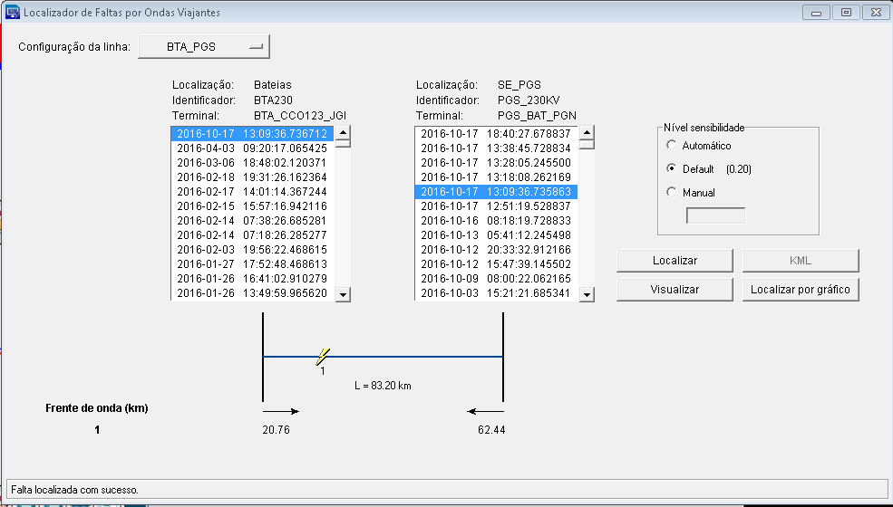
Figure 22 – Fault location by TW method.
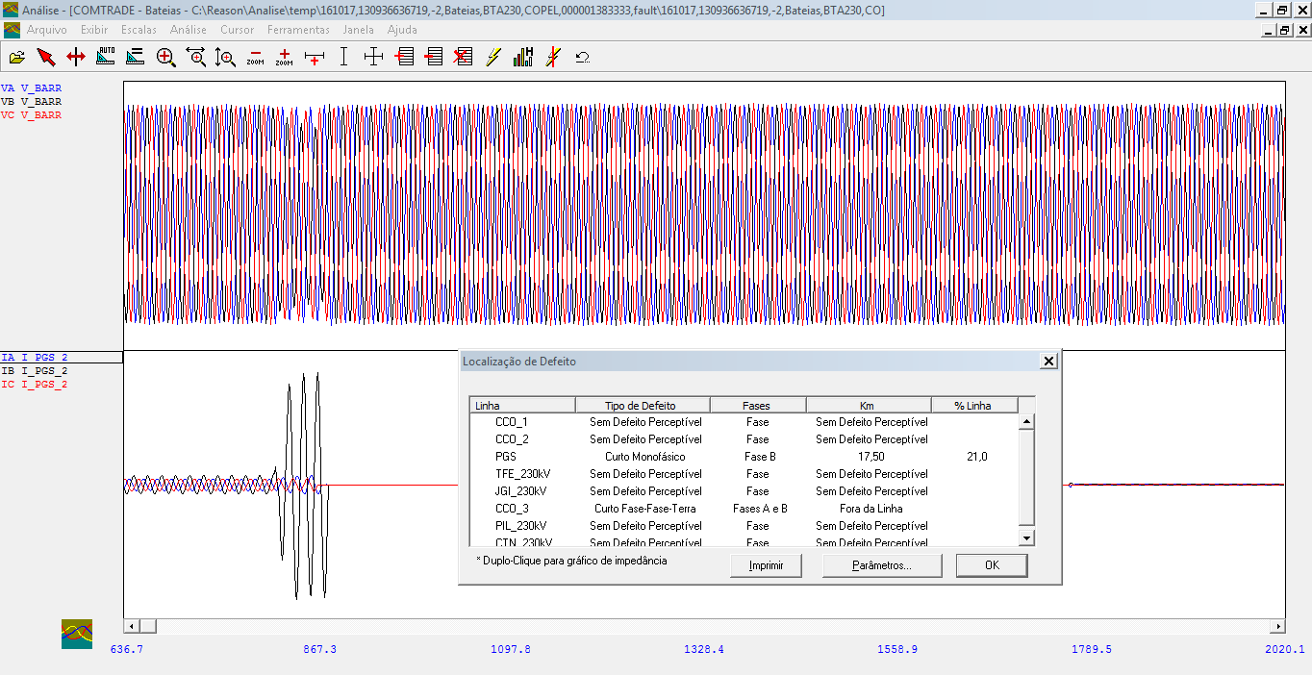
Figure 23 – Fault location by one end method.
Figure 24 below shows the oscillography of the 230 kV BTA circuit of the 230kV PGS substation, phase B the ground, in the 230 kV TL BTA-PGS on 10/17/2016 at 13:09 h showing the contribution of the fault current of 419 A, due to the electrical system of Ponta Grossa Sul 230 kV and Ponta Grossa Norte 230 kV to be electrically radialized by the 230kV BTA side, i.e., the side of 230 kV PGS substation was a week infeed side. The amount of zero sequence current contributes to increase the error of fault location by one end.
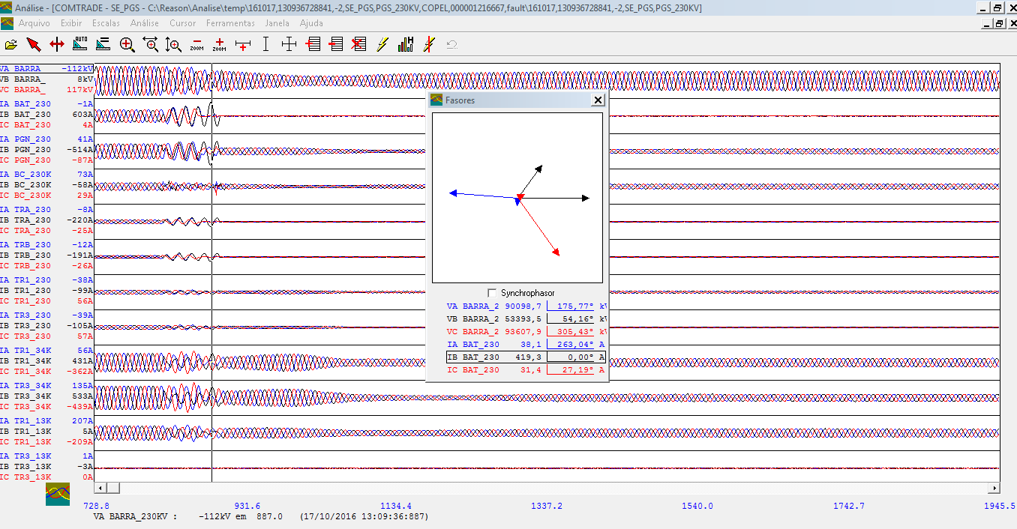
Figura 24 – Circuit 230 kV BTA oscilographyia at 230kV PGS side.
Figure 25 below shows the oscillography of the 230 kV PGS circuit of the 230 kVBTA substation side for a fault of the B phase to the ground in the 230 kV TL BTA/PGS on 10/17/2016 at 13:09 h, showing the contribution of the fault current of 7851 A, due to the electrical system of 230 kV Ponta Grossa Sul and 230 kV Ponta Grossa Norte to be electrically radialized by SE Bateias 230 kV.
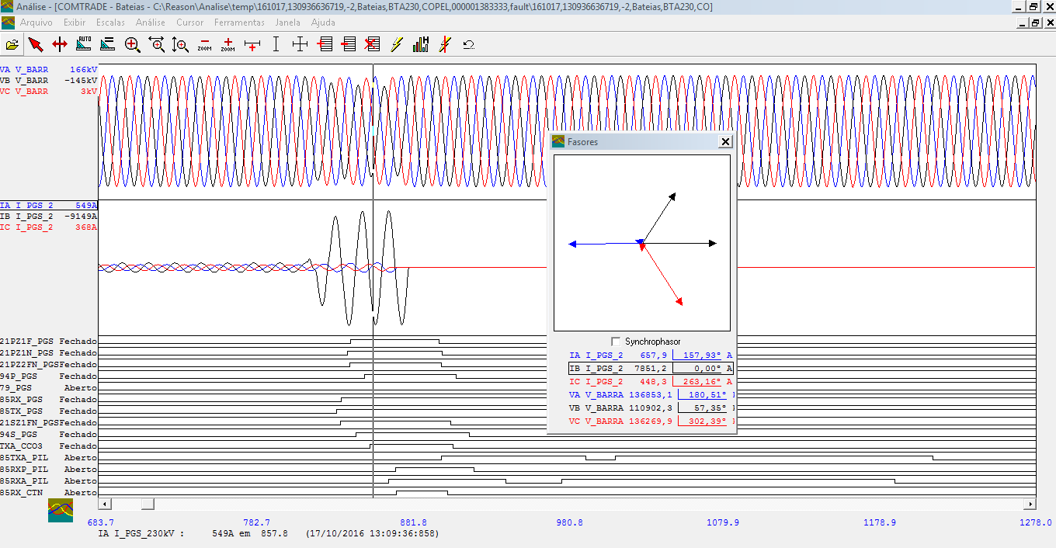
Figura 25 – Circuit 230 kV PGS oscilographyia at 230kV BTA side.
The fault current level on the side of the 230kV BTA substation 230 kV of 7851 @ 57.35A, shows that the fault was almost without fault impedance. According to a report from the Meteorology Institute of Parana Simepar below, atmospheric conditions did not influence the shutdown of the 230 kV TL BTA/PGS.
.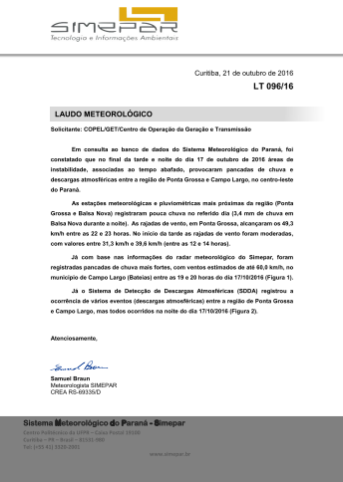
In the oscillography below, figure 26, it is verified that the current of phase B before the fault, is unbalanced, that is, with a leakage current of more than 100 A, and the other phases are 418 A. As the normal operating temperature at 55° C allows a current of up to 439 A and in an emergency at 75 ° allows a current of 583 A, the theoretical operating limit has not been violated. This transmission line has been in operation since 23/10/1965 (CAR 666-611900), being with the arrow compromised by creeping problems.

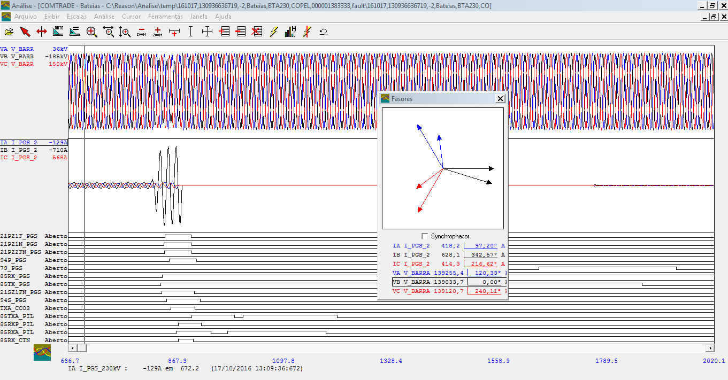
Figura 26 – Circuit 230 kV PGS record at 230kV BTA side.
The figure 27 shows the impedance carteristics values of the 230kV TL BTA/PGS cables measured on line by the PDC.
The calculated values are:
R1 = 8,4 ohms;
X1 = 42,6 ohms;
B1 = 268,6 uS
Comparing the calculated values and those measured by synchrophasors it is possible to verify that the electrical characteristics of the 230 kV TL BTA / PGS cable are the same and there is no error in the calculation of the ampacity of this TL. So it becomes evident that the problem is not electrical, it is mechanical.

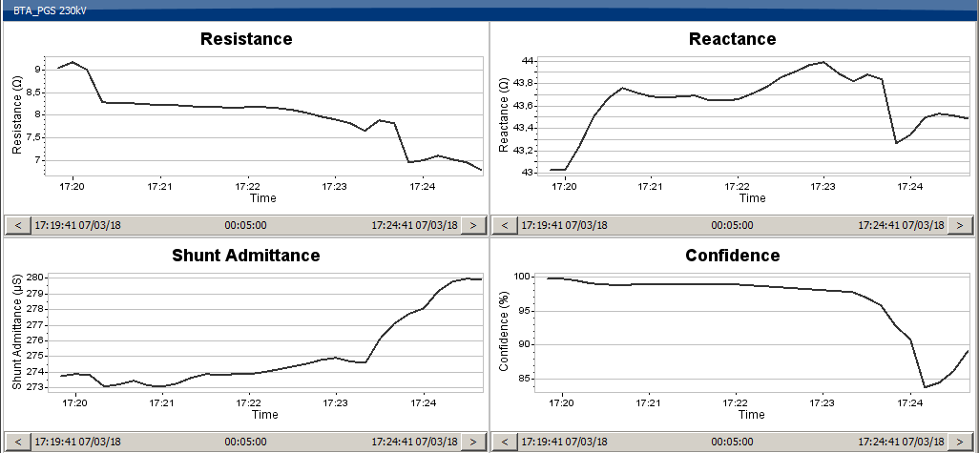
Figura 27 – Impedance carteristics values of the TL 230kV BTA/PGS cables measured on line by the PDC.

Conclusion
Increase of complexity of power system is leading utilities to search for new tools and technology to operate safely and properly their system. This paper presented the analysis of real faults in Copel’s system using current available tools for operators and protection engineers.
Nowadays, in addition to known digital relays oscillography, there are several other tools, such as PMU, TWFL, high-capacity DFRs, that decrease response time and make the work of protection engineers more procedural and less guessing, increasing the quality of fault reports.
Each tool is better targeted for a specific situation in power system operation. As shown above, for fast and precise location of a fault one can use a travelling wave fault locator that will return the correct location of the fault with great accuracy, typically hundreds of meters or less, and reliability compared to methods based on impedance of records from a DFR.
Traditional DFR continues to be used to support the analisis of the performance of the protection system as it has granulatity better than 1ms, and in market there are DFRs with granularity of dozens of microseconds or less, making it easy to pinpoint the start of the fault.
In addition, synchrophasors provide by PMU and supported by a software, embraces a view of interconnected power system that turns the analysis of a fault that spreaded to many substations much faster and easier to understand compared to multiple individual records from DFRs. Also, direct measurement of busbar angle, frequency measurement and voltage module allow a more accurate analysis of the cause of the relay failure. Finally, line parameters calculated by PMUs can be used in the analysis as a tool to conclude if there are electrical or mechanical issues related to a given fault under investigation.
Thus, one can understand that, the more a given utility uses different current tools available to guarantee system performance, the more effective will be the work of the protection engineer. In this paper it was shown that quality of the report of what happened to a given system accurately and in time is increased by combining these different tools.
Brief Biographical Sketch:
Gilmar Francisco Krefta, born in Curitiba, PR. Graduated in Electrical Engineering by UTFPR in 1985. Specialization in Digital Technology in 1998 by UTFPR. He holds a Master's degree in Energy Systems from UFPR in 2008. He was a System Protection Engineer at Copel G & T from 1988 to 2016. He currently works at the Operations Center as an Electrical Studies Engineer at Copel G & T.
Carlos Eduardo Ferreira Pimentel, born in Guarapuava, PR. Graduated in Electrical Engineering from UTFPR in 2011. He has 5 years of experience in the electrical sector and currently serves as an Application Engineer at GE Grid Solutions - Reason Product Line, responsible for engineering projects.
Lucas Barcelos is a Lead Product Manager with GE Grid Solutions, responsible for the Measurement & Networking product line. Lucas earned a BSEE and a Master’s in Systems Automation at UFSC in Brazil. He has 10 years’ experience in the electric industry and is a member of IEEE, Cigre, and is a registered Professional Engineer.
Sergio Luiz Zimath has more than 20 years of experience in the Electric Power Industry leading R&D teams of up to 37 people that developed DFRs, PMUs, GNSS clocks, TW locators, Ethernet switches and software. With more than 65 papers presented and 3 patents, he is member of IEEE, Cigre and a registered Professional Engineer.

