Conference: Fault and Disturbance Conference, April 27-28, 2015 at Georgia Tech

Title: Fault Location Experience using Simulation Software
Authors: Ajmal Saeed (Pacific Gas & Electric), Thanh C. Nguyen (Aspen Inc.)

Abstract
Fault location is one of many important tasks that protection engineers have to perform quickly and accurately. Fast and accurate identification of the line segment where the fault took place reduces line patrol cost, shorten restoration time and improves reliability.

With the availability of microprocessor relays and event recorders at most terminals, engineers have access to a wealth of data about each fault. Many microprocessor relays even provide the estimated fault location. However these estimates are often not accurate because the relay calculations are often done using assumed simplified model of the line without important factors such as variation in source impedance, mutual couplings, and infeeds.

This paper discusses an approach to fault location using recorded event data in combination with fault simulation software. The approach combines automatic iterative software simulation with interactive guidance from engineers to allow more accurate fault location identification.

The paper analyzes application of this fault location approach in several fault cases to show its performance. It discusses when the application of simulation software can provide better results and when an engineer can save time by relying on the location provided by the relay.

PG&E Fault Location Requirements

Pacific Gas & Electric (PG&E) requires every transmission line fault to be analyzed and recorded. All the Transmission faults regardless of customer outage minutes (even zero customers affected) or duration (sustained or momentary) are discussed during the daily outage restoration (ORT) call where all the stakeholders participate. Fault locations and patrol results are discussed. Actions taken to mitigate/repair the damage are discussed.

Protection Engineers remotely connect to the relays, download the relay events, and then analyze them. Relay events provide the oscillography, sequence of events, digital elements, and the approximate fault location. Protection Engineers analyze the event and run the simulation software study to pinpoint the fault location. Once the fault location is determined, the Protection Engineer calls the Operations control center operator to provide fault location with the line name, date, time, PG&E phases involved, location and level of accuracy.

The fault location is also communicated in an email template shown below:

System Protection Fault Location
Line and time of outage: XXX - YYY aaakV line at bbbb
Phase Involved in Fault: PG&E phase c-c. (B-G, B-C-G, A-B-C, etc..)
Fault Location (in miles): X.Y from CCC terminal/bus/switch/junction
Fault Location details: structure xx/yy
Accuracy of Location: +/- xx miles

For multi-terminal lines with several possible locations, all the possible fault locations are listed.

Additionally, protection engineers make sure that all aspects of protection, including pilot protection and reclosing, have functioned properly. If anything is amiss, an action item is created and deficiency is rectified.

With the company emphasis on safety and reliability, line patrols are conducted even for the momentary outages. For difficult terrains, patrols are conducted using helicopters. Fault locations provided by protection engineers are visible at the highest levels and it has become increasingly important to provide fast and accurate fault location response.

Following graphs (See Figure 1 below) show the fault locations done in 2014 according to various categories.

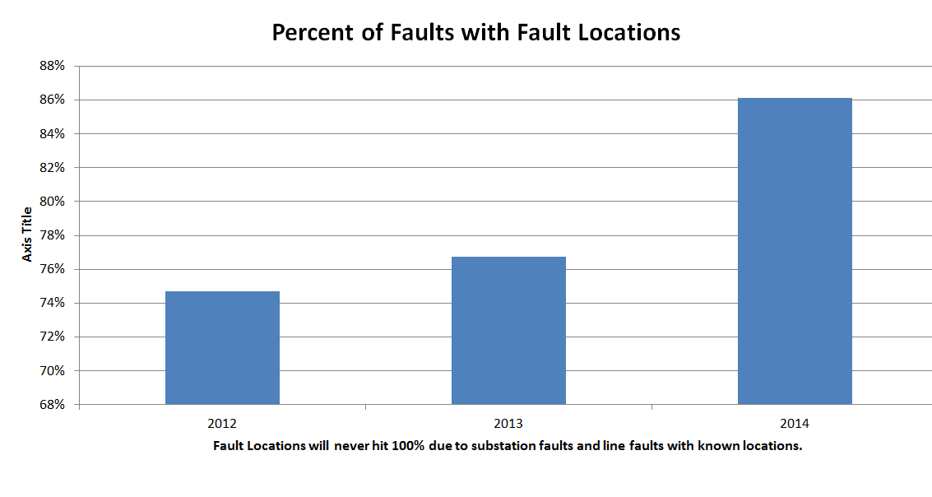 | 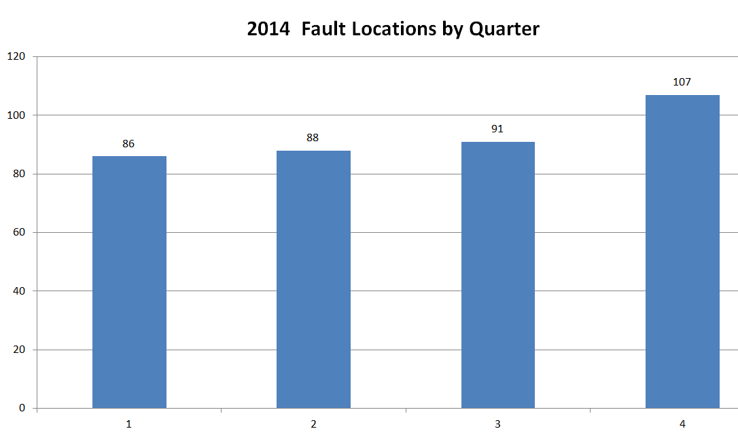
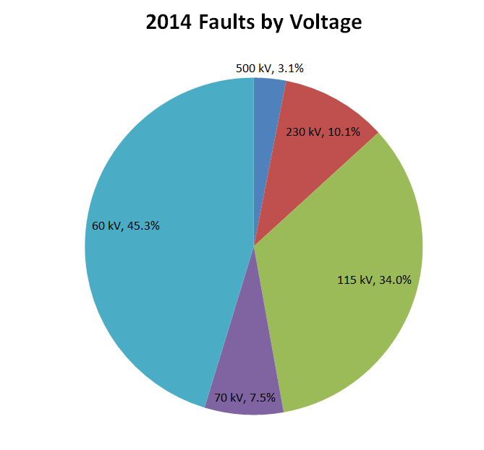 | 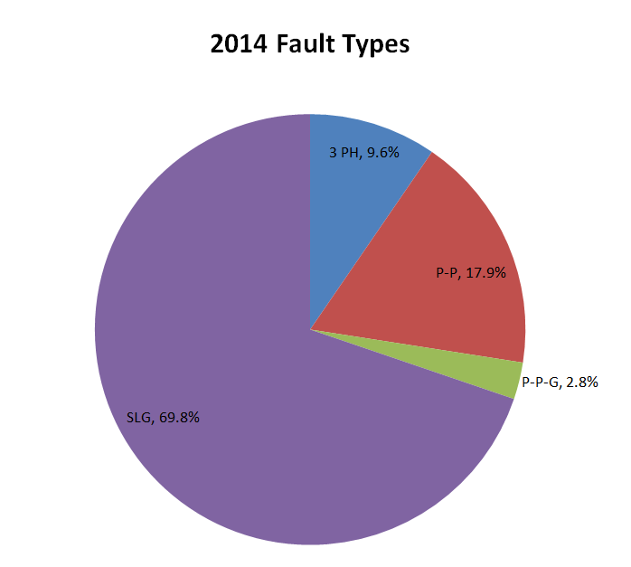
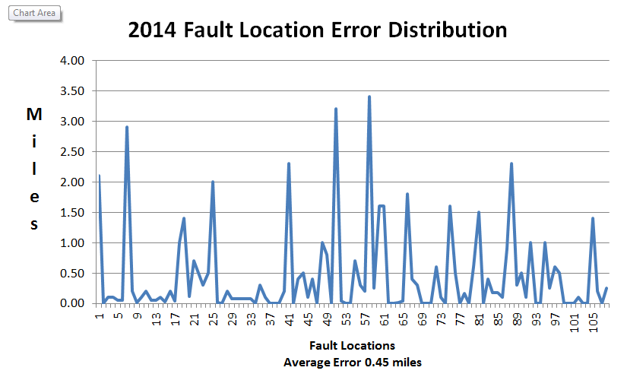 | 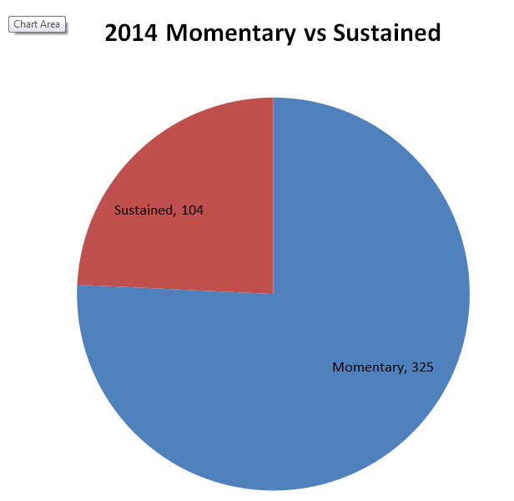

Figure 1: Transmission Fault Locations in 2014 for PG&E

Transmission Line Fault Location Methodology

Except in rare instances where transmission line is equipped with specialized fault location hardware, protection engineers must rely on reading of fault event recording to determine where the fault took place on the line. Fault recording from microprocessor relays include phase voltages and currents seen at the relay location during as well as before the fault. Using a network model that encapsulates relationship between fault voltage and current quantities and fault location on the transmission line, engineers can compute location of the fault from the observed data.

Fault location using line fault model

Figure 2 depicts popular approach to fault location which involves utilization of some form of line fault model, which allows direct calculation of fault location on the line from recorded relay voltages and currents.
Recording:
Bus voltages
Line currents
Line fault model
Distance to fault (Ohm)

Figure 2: Fault Location Using Line Fault Model

Most line fault models output the impedance of line section between relay and fault location in ohms. Using a look up table of impedance vs. line length, the distance in miles from fault to the relay can be computed. Observed fault currents and voltages from one end or both end of the line are used as input for calculation.

Example of single-ended fault location methods that utilize line fault model from published literature:

Simple Reactance Method ^{[1] [2] [3] [4]}
- This method uses the fault current and voltage to determine the line reactance seen by the relay during the fault.
Takagi Method ^{[1] [2] [3] [4]}
- Reduces the effect of load current and uses the line reactance to estimate the fault location.
Modified Takagi Method ^{[1] [2] [3] [4]}
- Eliminates the effect of load current, also reduces the reactance error to estimate the fault location.
Eriksson Method
- This method ^{[4]} uses the fault current and the source impedance parameters to overcome the errors caused by fault resistance, load. Additionally, it estimates the fault resistance.

Many modern microprocessor relays include some implementation of line fault location model that allow distance to fault to be included as part of the relay fault event report.

Despite obvious convenience in application of line fault model in fault location, engineers must always be aware of several areas where the model inherently contains errors:

  - Non-homogeneous conductor information.
  - Infeeds of positive sequence and zero sequence fault currents. PG&E standard distribution transformers are Grounded Wye (High Voltage)-Grounded Wye (Low Voltage)-Delta (Tertiary) and they are source of zero sequence currents.
  - Taps on the line meaning there could be multiple fault locations.
  - Mutual couplings
  - Fault can evolve
  - Fault involving more than on transmission line (cross country faults)

Example of cases where fault location result by relay contain significant error

PG&E 115 kV and 60/70 kV Transmission lines often have taps multiple wire sizes and multiple sources. Most of the standard distribution transformers have delta tertiary winding and are source of zero sequence currents in the event of unbalanced fault. These aspects of PG&E system topology tends to make the relay fault location less accurate.

Significant portion (86.5%) of the faults happened in 2014 on 115 kV and 60/70 kV system and there could be multiple locations of faults that will result in similar relay event records. Relay assumes straight homogeneous conductor path without any taps. If the line is non-homogenous or if there are infeeds, then the linear relationship between the line length and the system impedance does not hold. Infeeds will make the apparent impedance larger than the actual line impedance. Figure 3 below shows a typical 60 kV line with multiple taps and one infeed. It can be seen that the 60 kV line is far from homogeneous line that most of the fault location methods assume.

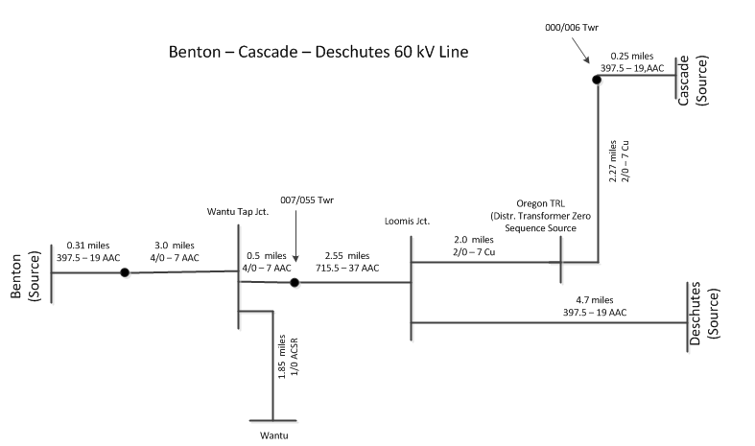
Figure 3: Example of 60 kV line

Fault location using short circuit network model

One way to estimate the fault location on a non-homogenous line is to build a nomograph ^{[1] [2]} to compensate for known errors due to non-homogeneous line. Building a nomograph for a line to come up with the fault location is tedious. Current infeeds like generation on a tap would increase the apparent impedance seen by the relay at the line terminals. Any conductor change would change the impedance / mile of the conductor. The nomograph (Figure 4 below) shows the impedance changes with the generation infeed and change of conductor.

Simulation software allows detailed modeling of the line with multiple infeeds, non-homogenous line sections and mutual couplings. By simulating the fault in the simulation software, there is no need to build a nomograph.

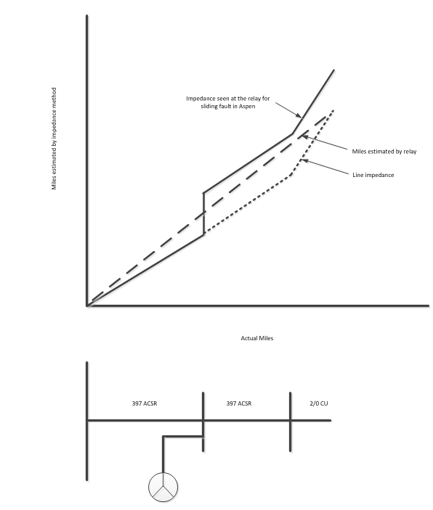
Figure 4: Nomograph of a non-homogenous line

Mutual coupling may increase or decrease the apparent impedance based on the location of the fault and if the fault current on the parallel line is increasing or decreasing the fault current. Relay at one of the line terminal would over-estimate the fault location whereas the relay at the other end would under-estimate the fault location. Nomograph (Figure 5 below) shows the actual impedance versus the impedance seen by the relay.

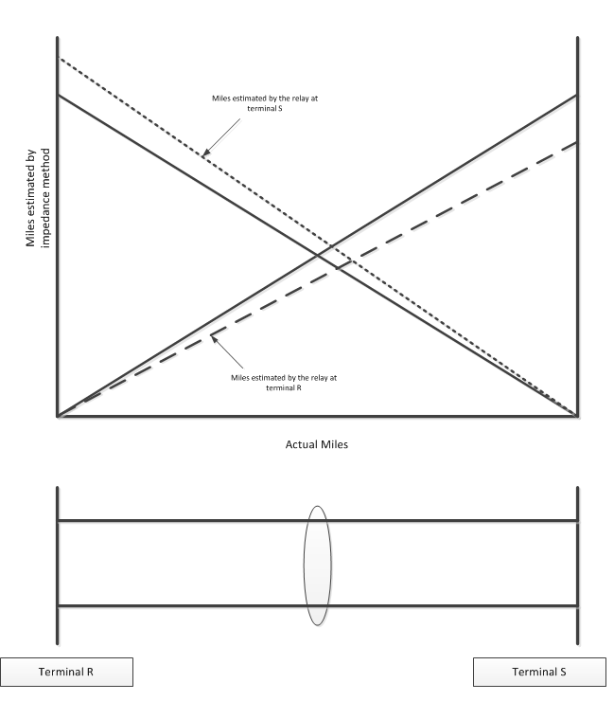

Figure 5: Nomograph of a line with mutual coupling

Takagi method assumes that the fault current has the same angle as the faulted phase ^{[1] [2] [3]}. This can cause error if the conductor is non-homogenous or if the fault current contribution from remote end has a different phase angle than the contribution from the relay end.

When the fault is evolving, relay fault location computation is inconsistent. Protection Engineer sees different fault location estimates from the relay and has to decide which one is accurate.

Sometimes the lightning strikes two lines on the same tower and this can cause cross-country or simultaneous faults. Whereas the relay cannot provide estimated fault location for a cross-country fault, it can be done by applying simultaneous faults using simulation software.

Fault location using fault simulation program

Modern fault simulation programs allow speedy calculation of fault voltages and currents in any fault on a transmission line. By correlating fault quantities from simulation with recorded quantities from relays, the most likely location of fault can be established. This approach is described in Figure 6 below.

Recorded voltages
and currents
Short circuit network solution
Possible faults on line
Simulated voltages and currents
Best match case
Figure 6: Short-circuit network model based fault location

Full scale short circuit network model and computer program are universally available to protection engineer. As a rule, utilities invest substantial effort in maintaining the model and keeping it accurate and up-to-date. Efficiency of modern short circuit program and computer hardware makes it possible to run hundreds of times to seek the best match in very short time (under a minute in most cases).

Key factors that affect accuracy of Short-circuit network model based fault location

- Accuracy of network model
- Accurate representation of pre-fault
- Accurate model of arc resistance

Network model calibration using known fault cases

Protection Engineers rely on the accuracy of network model to set the relays and estimate the fault location. Faults in the system provide a feedback to check the accuracy of the model. On a few occasions, there has been significant difference from the actual fault location. This has prompted the protection engineer to look at the network model and make necessary corrections. Fault location is a useful tool to calibrate the network model.

Direct comparison of simulated and recorded fault values

Protection engineers run short circuit simulation program for fault at various locations and match the fault simulation phasors to the recorded events values download from the relay. Figure 7 below shows the comparison of simulated versus recorded quantities. The quantities include phase and sequence voltages and currents at relay location.

Quite often, good match cannot be found for all the phasor quantities. In these cases the Protection Engineer has to select a key parameter and rely on it for the fault location. The screenshot in figure 7 below shows a case best match found from direct comparison of simulated versus recorded fault phasor quantities.

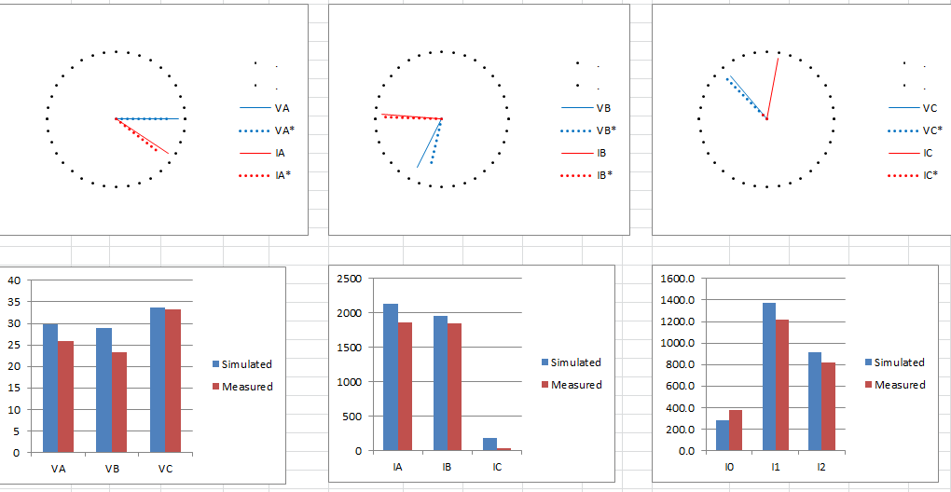

Figure 7: comparison of simulated versus recorded fault voltages and currents

Although the existing method of fault locating using simulation software provides better fault location in most cases, there are some inadequacies in the existing method using simulation software.

How fault location using network model fault simulation can be improved

Many assumptions are also made during the fault simulation:

  - Load current is neglected.
  - Soil resistivity is considered uniform.
  - Conductor resistance for some lines is an assumed value because the old power system models were just reactance based.
  - Arc resistance is estimated and may not be accurate.
  - Clearances may have altered the system connecting generation sources to different buses.

Due to these and other unavoidable inaccuracy of network models and fault solution, direct comparison of voltages and currents phasors does not always yield the best result as shown in the previous section.

Many existing line fault models for fault location are built purposely to cancel out effect of many unknown factors, such as load current, fault resistance, etc. to improve distance to fault result. It’s entirely possible that if we carry out the search for best match among simulated cases using the impedance computed using these methods; we can arrive at much better result.

Recorded voltages
and currents
Simulated voltages and currents
Best match case
Line fault model
Figure 8: Improved Short-circuit network model based fault location
In the current method of fault location, protection engineer identifies the type of fault, simulates the fault on the line and then slides the fault along the line section. Protection Engineers look at the phase currents, sequence currents and the line impedance angle (angle between the voltage and current for the faulted phase). If the line impedance angle for the simulated fault and the recorded fault do not match, then fault resistance is introduced to match the line impedance angle. Fault Location is estimated where the phase currents, sequence currents, and the line impedance angle match. Quite often, all the parameters do not match and then the Protection Engineer has to select a parameter and rely on it for the fault location.
One of the assumptions that the Protection Engineer makes during the simulation is to neglect the load current. Takagi method assumes that load current during the fault stays the same as the pre-fault current. Actual load characteristics are not known but it can be assumed that big percentage of load including motors would continue to draw current during the fault. With the data from the relay, pre-fault currents are known and can be subtracted from the recorded fault current to provide better fault location.

If there is less confidence on the X/R ratio of the conductor model, then it is better to rely on the fault reactance and use the equations from Takagi or modified Takagi method to estimate the fault location. Using the simulation software, the angular difference between the recorded fault current and the simulated fault current seen by the relay can be determined and angular correction required for modified Takagi can be applied to eliminate the reactance error.

The estimate of the fault resistance can be improved by using the Eriksson method. This method uses the source impedance parameters to overcome any reactance error caused by fault resistance and load. It requires the source impedance of the relay end, the remote end, line impedance and fault data. All this information is available in the simulation software and can be used to estimate the fault resistance. Arc resistance is the biggest unknown that can make the fault location difficult.

With the availability of fault data from microprocessor relays and the power system model, Protection Engineers have the tools available to provide much better fault location. By using the simulation software and incorporating the algorithms developed for relay fault location, we can improve the fault location accuracy.

Some methods of fault location rely on source impedance to compensate for the errors introduced by fault resistance. These fault location methods rely on the source impedance value entered into the relay which may not be accurate and can change over time. Fault simulation program can estimate correctly the source impedance and use this value to accurately estimate the fault location.

Protection Engineers can also make use of other information in event report download from relay to improve fault location accuracy. In addition to the oscillography, relay event report show relay elements that picked up and the approximate fault location as calculated using built-in line fault model. By analyzing the event report, protection engineers can specify correct fault type in fault simulation study to pinpoint the fault location.

Two-Ended Methods

Two ended methods use oscillography at both ends of the transmission line to estimate the fault location. Fault data at both ends of the transmission line is used to eliminate the error introduced by fault resistance. It is also used to eliminate the multiple faults location.

Two-ended impedance based fault location algorithms discussed in papers ^{[2,3]} solve simultaneous equations using the negative sequence components for unbalanced faults to compute the fault location. Negative sequence components are not affected by load current, mutual coupling or infeed from zero sequence tapped loads and therefore are used for unbalanced fault location computation. The two-ended impedance based methods are inherently making the assumption that the transmission lines are homogeneous

When relay event data is available from both ends of the transmission line, protection engineers at PG&E measure the ratio of currents (sequence currents or faulted phase current) for faulted line terminals and compare the currents ratio from running the simulation program with the currents ratio from the recorded fault events. Negative sequence current ratio is commonly used for unbalanced faults and positive sequence current ratio is used for three phase balanced faults.

Whereas the two-ended method using the simulation program does not eliminate the fault resistance error completely, it reduces the error and provides better fault location than the single ended method. Also, it eliminates the need to estimate the arc resistance. It should be noted for faults on a tap line the ratio method is not as accurate since the ratio from each of the remote ends is the same over the length of the tap. Simulation program provides advantages over fault location algorithms (that do not run fault simulations) because it takes into account the non-homogeneous line configuration.

Transmission Fault Location Examples

Example: Gold Hill #1 60 kV line fault location (A case of fault location on a non-homogeneous line)

This was a sustained fault on Gold Hill #1 60 kV line. Relay estimated fault location to be 16.64 miles. This location was past the open point on the 60 kV line and did not make sense. By using the fault simulation program, the fault location estimate was revised (about 13.0 miles) and it was found to be close (within 1 mile) to the actual fault location that was 12.5 miles from the substation.

Recorded relay event fault location:

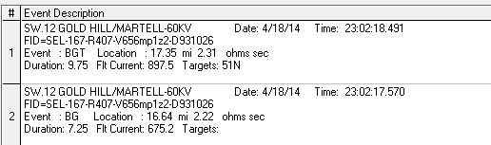

Simulation program phasor comparison:

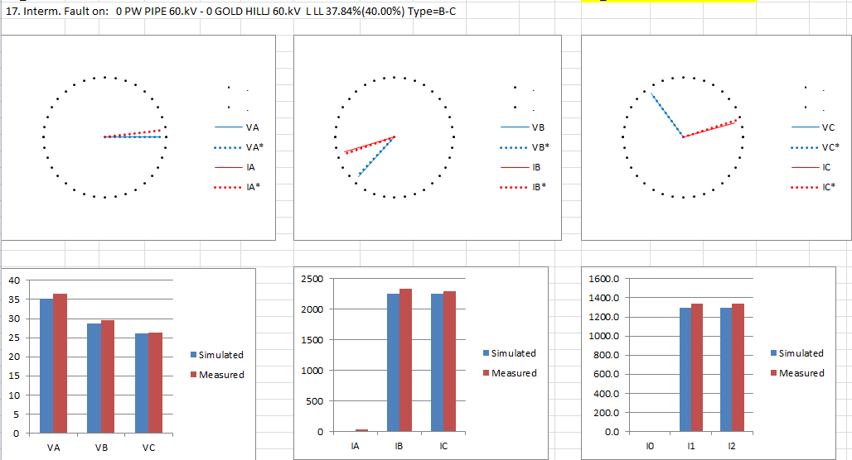
Fault impedance comparison (simulated versus recorded – ohms primary)

Conclusion:

- Gold Hill #1 60 kV Line consists of various line section of 2/0 Cu, 4/0 Cu and 397.5 AAC and simulated fault location provides better fault location than the relay fault location.

Example: East Nicolaus – Wilkin Slough 60 kV line ( A case that identifies the need for model calibration)

Background:

There was a single phase to ground fault in August 2014 on East Nicolaus-Wilkin Slough 60 kV line. Estimated fault location was provided and patrol was conducted, but patrol did not find anything. Couple of months later, similar fault happened with the same fault signature. This time, patrol found avian contact and found the remains of another bird confirming that the previous contact was also caused by avian contact. The actual fault location was 1.5 miles off than the predicted fault location.

Fault currents and voltages match closely with the recorded fault values. Relay reported fault location (1.8 miles from the tap) was close to the fault location estimate using the simulation program (2.0 miles from the tap). Actual fault location was 0.6 miles from the tap.

This was the second case where the fault location is off by 1.5 miles. So, we could use some model correction in this case. The difference between estimated fault location and actual fault location prompted the protection engineer to re-visit the line model.

Simulation program phasor comparison:
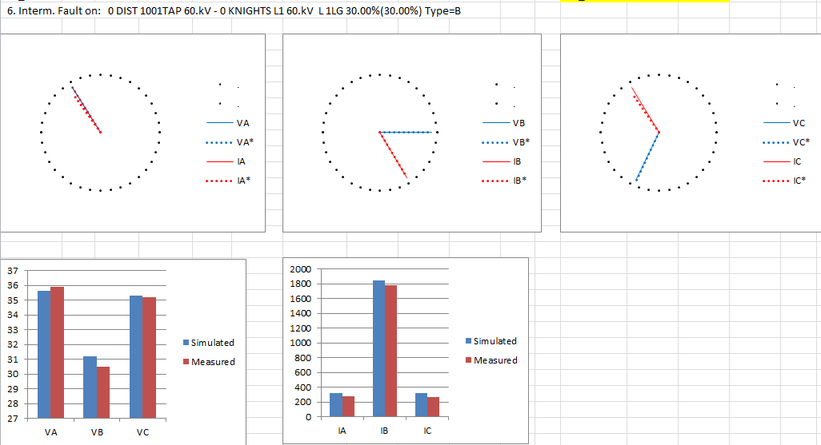

Fault impedance comparison (simulated versus recorded – ohms primary):

Conclusion:
- If the actual fault location is off from the estimated fault location, this could prompt a need for model correction and calibration.

Drum-Deer Creek 60 kV fault (A case where Impedance provides better fault estimate than the simulation fault currents)
Background: This fault was phase-phase fault on a 60 kV line close to Hydro Generation. Protection engineer simulated the fault on the faulted line (Drum-Deer Creek 60kV line) and by comparing the simulated current to the recorded fault current, came up with the fault location estimate. Alternatively, the protection engineer simulated the fault and came up with the fault location estimate by comparing the impedance seen by the relay.
In this case, there is a significant difference in the fault location estimate depending on whether we use fault current or impedance from the simulation program to compare with the measured values from the relay. Since the line is close to Hydro Generation and it is difficult to predict how many units are on, the fault current varies depending on the number of units that are connected to the electric system. The impedance is a more stable parameter to use in this case for predicting the fault location.
Simulation program phasor comparison:
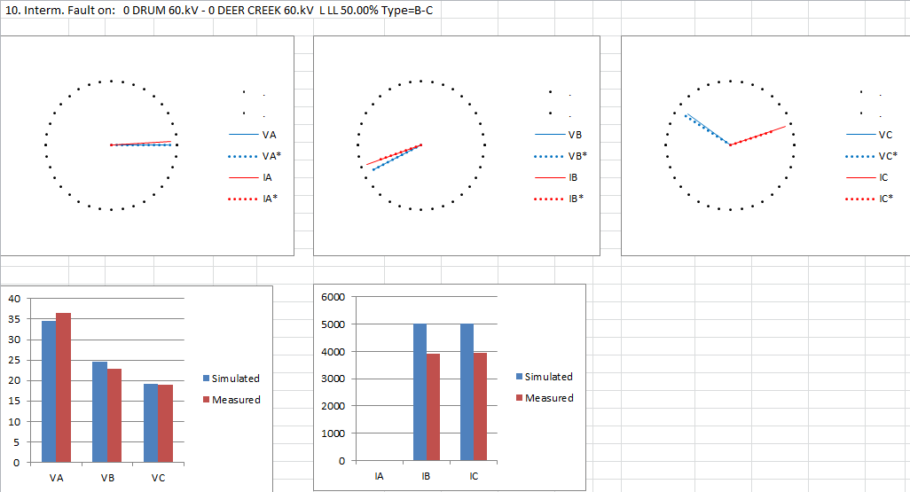
Fault impedance comparison (simulated versus recorded – ohms primary):
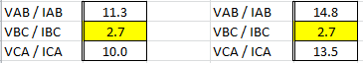

If we rely on just fault currents to estimate the fault location, then the estimate can off. This is shown by the following graphs shown below from the simulation program. The estimated fault location (82% of the 6.3 mile line) is now more than 2 miles different from the one estimated by comparing the impedances.
Simulation program phasor comparison:
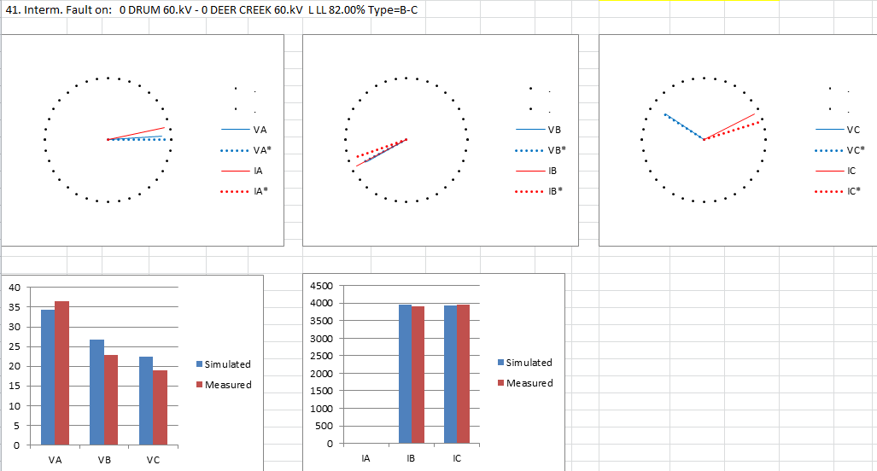
Conclusion:

- The impedance is more stable parameter (compared to fault currents) to use for predicting the fault location especially when the line is close to generation.
Example: Rio Oso-Woodland 115 kV line fault (A case of fault location on a line with infeed)

Background:
There was a momentary fault on Rio Oso-Woodland 115 kV line in the afternoon of September 2014 on a weekend. One hour later, there was another momentary fault on the same line and Protection Engineer was called for the fault location.

Targets at both the line terminals were available but only the line relays at Rio Oso terminals were remotely accessible. There were two possible fault locations that would give same fault currents from Rio Oso. One fault location was near Zamora tap and the other fault location was near the Woodland terminal. Since the relays at Woodland tripped by time overcurrent (no instantaneous flag), the second location (near Woodland line terminal) was ignored and the fault location was estimated at Zamora junction.

Patrol was conducted and avian contact was found near the estimated fault location.

Recorded relay event from Rio Oso substation:
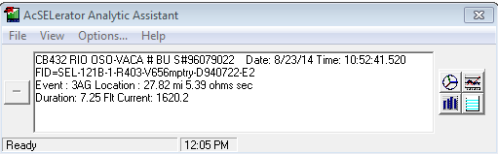

Simulated program phasor comparison:

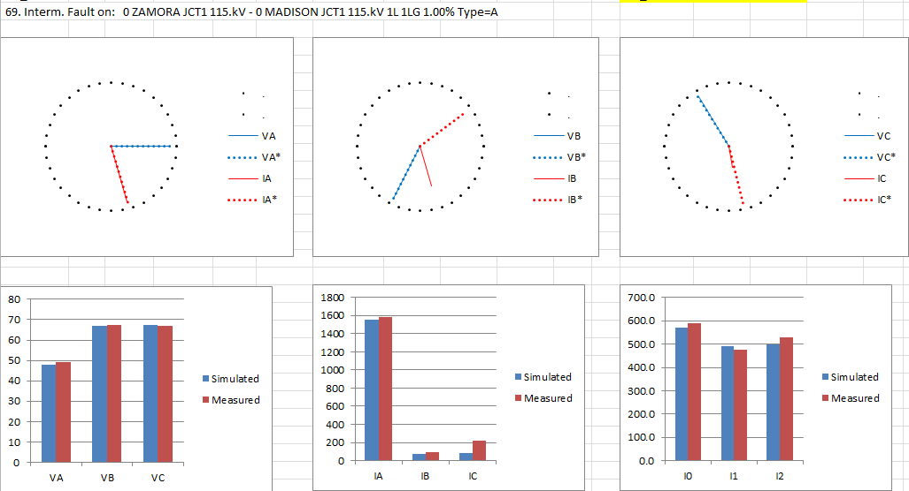

Avian contact was found near 17.5 miles from Woodland substation and 25.3 miles from Rio Oso substation.

Relay events from Rio Oso terminal and relay targets only were available from Woodland.

Conclusion:

- The relay fault location could not be trusted because the line had infeeds throwing off the fault location by the relay.

Example: Vaca-Bahia 230 kV line fault (A case of fault location with Mutual Impedance)

On 11/27/2014, there was lightning strike on Vaca-Bahia 230 kV line and Vaca-Parkway 230 kV lines. The 230 kV lines share the same right of way. Fault location from the relays was communicated through SCADA to the operators indicated that the fault was 24 miles from Vaca Dixon. The actual lightning strike was found to be 26.2 miles from Vaca Dixon.

The fault was simulated in the simulation program and fault location was found to be 24.6 miles from Vaca Dixon end. When the correction was made to eliminate the load current from the fault current, then the estimated fault location came out to be 25.5 miles from Vaca Dixon. This was closer than the fault location estimated by the relay.

Simulated program phasor comparison:
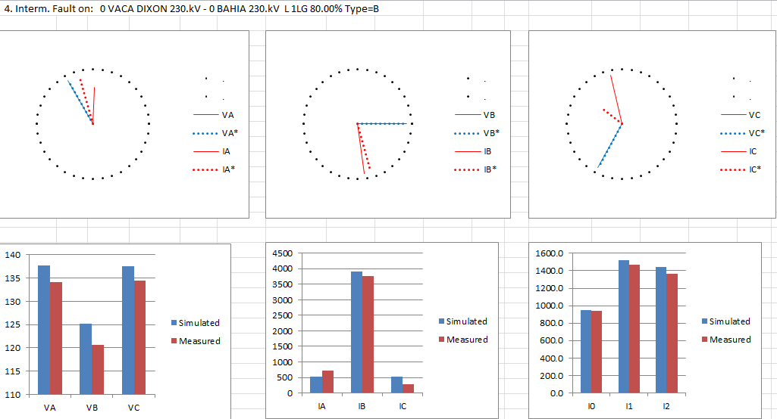

Conclusion:

- When there is mutual coupling with another line, the fault location estimated by the relay can be off.
- When using the simulation program, protection engineer can get better fault location estimate by taking into account the pre-fault current.
Maple Creek-Hoopa 60 kV line fault (A case of fault estimation for high impedance fault)

For a high impedance fault like the one on Maple Creek – Hoopa 60 kV line, the fault angle between voltage and current can get very low). Protection engineer has to estimate the arc resistance before providing the fault location. By introducing the arc resistance to the fault simulation, protection engineer tries to match the simulated fault angle to the measured angle from the fault event. By matching the fault angle and the fault impedance or fault currents, it is possible to get a good estimate of fault location.

In this case, the angle between voltage and current of the faulted phase was almost zero. By estimating very high fault impedance (20 ohms) in the simulation program, it was possible to match the angle between voltage and currents. The estimated fault location was about 1.5 miles (about the same as predicted by the relay) whereas actual fault location was 0.6 miles from the substation. Even with a good estimate of fault resistance, it is difficult to predict the fault location accurately. If you can estimate the fault location within a mile for a high impedance fault, it is a good estimate.

Simulated program phasor comparison:
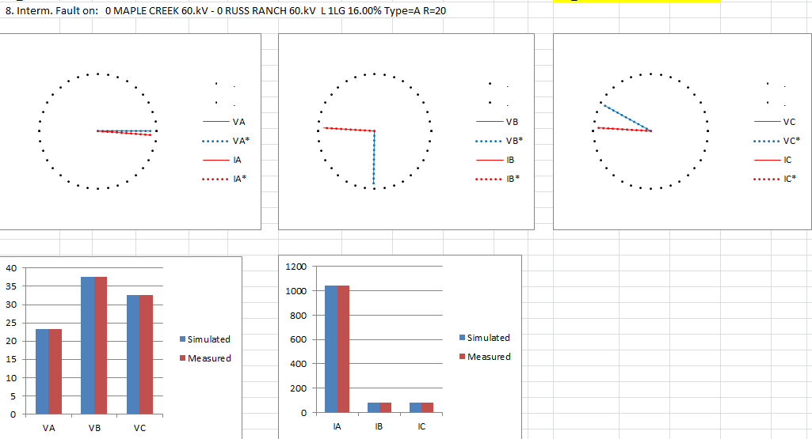

Conclusion:
- It is possible to come up with a good fault location for a high impedance fault using simulation program, if the arc resistance is estimated accurately.
Example – Gualala-Monte Rio 60 kV line fault (A case of evolving fault)

This is an example of phase-phase fault evolving into 3 phase fault. The 60 kV line had 3 taps. Relay tripped by overcurrent element, then reclosed 15 seconds later and then tripped again and locked out.

Relay estimated 81 miles and then 36 miles. Simulated results were close to the actual fault location that was 32 miles from Monte Rio 60 kV substation.

Relay events from Monte Rio CB 22 line relay:
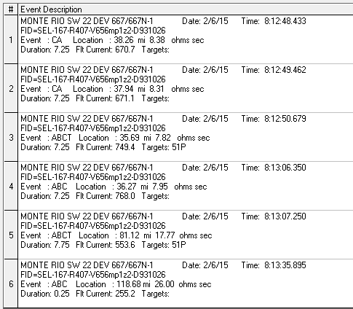

Simulated program phasor comparison:
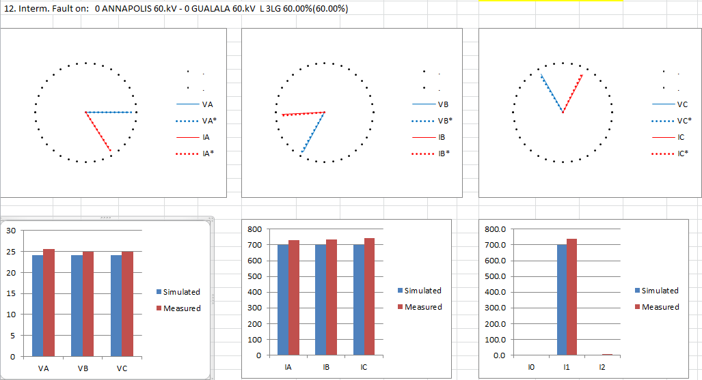

Fault impedance comparison (simulated versus recorded – ohms primary):

Conclusion:

- Relay fault location is not good with the evolving fault. For some line terminals fault location is provided to the operator through SCADA. Operator sees the latest fault location information from the relay and in this case it would have been 81.1 miles for the trip event that would have been way off.

- If you are looking at just the fault currents for estimating the faults, you can go wrong. For a phase-phase fault or 3 phase fault, the impedance provides better estimate than the fault currents.

When to rely on relay fault location

Protection Engineers are often pressed for time to provide good fault location. Whereas it is always recommended to simulate the fault in the simulation program and refine or verify the fault location estimate, there could be cases where protection engineer has to rely on fault location estimate provided by protective relays. In that case following key points can be helpful:

- Relay fault location would be more accurate if the transmission line does not have any taps, does not have strong mutual coupling and is homogenous.
- Relay terminal closest to the fault provides better estimate.
- For an evolving fault with multiple fault location estimates, the lowest fault location relay estimate is more accurate.
- Sometime, the remote communication to the relay is not working and the relay fault location and relay targets are the only information to go by.
- For a line with tapped co-generation, use the second event (after the first reclose) from the relay to report fault location. After the first trip, the co-generation is off-line and source of infeed is removed, resulting in better fault location. If there is no reclosing on the line, then it is not an option.

References:

- IEEE Standards C37.114: IEEE Guide for Determining Fault Location on AC Transmission and Distribution Lines

- Impedance-Based Fault Location Experience by Karl Zimmerman and David Costello, Schweitzer Engineering Laboratories, Inc.

- Impedance-Based Fault Location Techniques for Transmission Lines by Maher M.I.Hashim, Hew Wooi Ping, V.K.Ramachandaramurthy

- Impedance-Based Fault Location in Transmission Networks: Theory and Application by Swagata Das, Surya Santoso, Anish Gaikwad and Mahendra Patel. This work was supported by Electric Power Research Institute, Knoxville, TN, USA.

