IMPLEMENTATION OF ROAD MAP 2012-2015:
DFR/FL FOR acceleration of SYSTEM RECOVERY and enhancement of system stability
IN sumatera POWER SYSTEM
Dhany Harmeidy Barus Eko Yudo Pramono
PLN Indonesia PLN Indonesia
barus@pln.co.id eko.yudo@pln.co.id

Abstract - Indonesia is a big country which has many isolated power system networks. Sumatera power system is one of the main power system networks in Indonesia that supplies electricity for more than 45 million populations in Sumatera Island. To control the network, there are one Inter-Regional Control Center and three Regional Control Centers in the system. To support the system operators, since the March of 2014 all transmission lines in the system have been monitored by Digital Fault Recorder (DFR) and even all backbones of the transmission line are equipped with Fault Locator (FL). It is one of the milestones within Road Map 2012-2015 that has been achieved by special team that was assigned by the management to compile and execute working plan in optimizing Fault Recorders that has started to be installed since the beginning of 2012 in Sumatera power system network.
This paper explains about the implementation of Road Map 2012-2015 of DFR/FL in Sumatera power system network. It describes each milestone of the Road Map, including setting-up master DFR and communication in every Inter (Regional) Control Center, training dispatchers how to operate Master DFR, and setting up three levels of Standard Operation Procedure (SOP) for dispatcher in restoring the system post disturbance based on DFR/FL data and accelerating investigation of fault location at the backbone of the transmission line based on DFR and FL data. The three levels of SOP are designed to, chronologically, assist dispatchers to make correct decision during non-system fault or active/passive system fault occur in the system. The paper also expresses the difficulties faced by the team to determine the most suitable additional DFR/FL to be installed in the system. Furthermore, this paper includes the documentation of wave forms of every type of disturbance in the system to create own fault signatures. It also describes the strategy of the team in combining external DFRs and the internal ones inside numerical relays. The paper also include the upcoming milestone to be achieved which is the possibility of using Phasor Measurement Unit (PMU) feature in DFR for Wide Area Monitoring Systems (WAMS) especially to monitor trend of voltage stability and small signal stability of the system as well as synchronizing islands if partial blackout situation occur in the system. Finally, this paper tells the suggested state-of-the-art future plan of the team to use PMU data as correction to the Real Time State Estimator data for SCADA/EMS Application in every Inter (Regional) Control Center.
Figure 1.1 Hierarchy of Sumatera Control Centers
SCC
NS-LDC
CS-LDC
SS-LDC
Keywords -- Digital Fault Recorder, Fault Locator, Road Map, Control Center, Dispatcher, SOP, PMU, WAMS, State Estimator, SCADA/ EMS.

- Introduction
System Overview
Indonesia is a big country which has many isolated power system networks. Sumatera power system is one of the main power system networks in Indonesia that supplies electricity for more than 45 million populations in Sumatera Island. PLN P3B Sumatera is an operational unit that responsible for Transmission System Operation and Maintenance as well as Load Dispatch Center. Based on 2014 statistics [1], its assets consist of 135 substations and 10,852 kmc transmission lines (T/L). There are 247 transformer units with capacity of 9,555 MVA. Based on the the data, the highest peak load of Sumatera power system is 4.534 MW occurred in October 10, 2014.
To control the network, there are one Inter-Regional and three Regional Control Centers in the system. Sumatera Control Center (SCC), the inter-regional control center, manages inter-regional switching and energy management of 208 generator units with available capacity is about 5,867 MW. The three - Regional Load Dispatch Center (LDC), which are Northern Sumatera LDC (NS-LDC), Central Sumatera LDC (CS-LDC), and Southern Sumatera LDC (SS-LDC), responsible for 150 kV switching in each regional-based. Data communication among all control centers use SCADA system and fiber-optic as media for data tranceiver. Figure 1.1 shows the hierarchy of the control centers.

In system operation point of view, Sumatera system is devided in to 2 sub-systems, which are northen and central-southern sub-system. It caused by small signal stability fenomena between both sub-systems. In 2007 [2], it was the first time to synchronize both sub-systems, several months after completion of T/L that connected both sub-systems. During synchronization phase, there was power swing fenomena that caused tripped of generator units of several power plants in both sub-systems. The fenomena was arising from the long 150kV T/L (about 400km) between two sub-system without existence of any significant loads and generator units. The second attempt was made in mid of 2011. At that time, the synchronization duration lasted longer (about 2 hours) but there was still power swing fenomena and internal alarms showed up in some power plants. The test was made incorporation with R&D Department and local Technical University in Indonesia. The report told that there was quite improvement of system performance caused by the load growth and increasing of generation units close to the interconnection point, but still not secure enough for continuous operation. Furthermore, there was no continuous real time monitoring for small signal fenomena in the control center.

- Road map 2012-2015 : Dfr/Fl For Acceleration Of System Recovery And Enhancement Of System Stability sumatera power system
II.1. Background
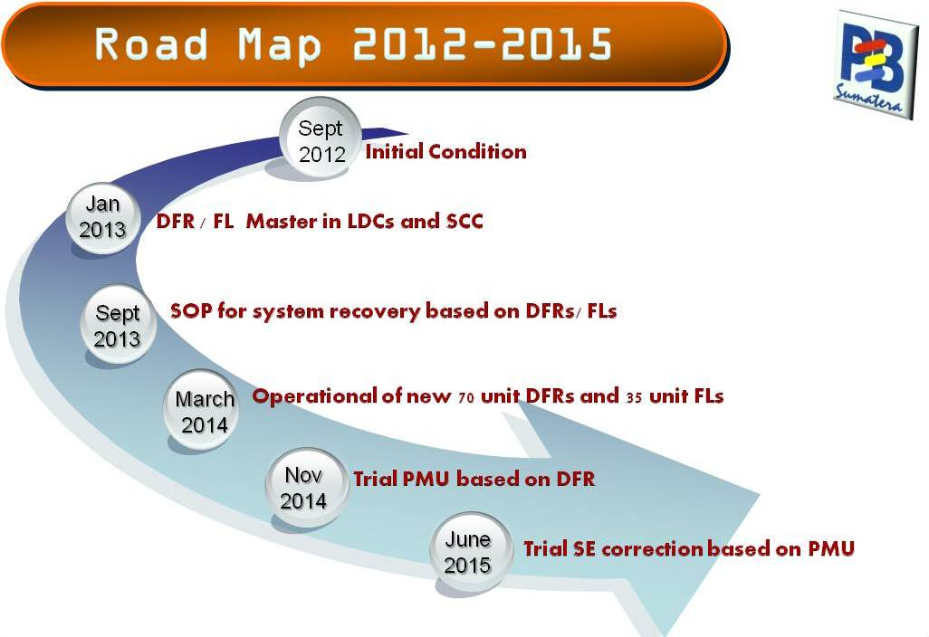
In October 2012 [3], a special team was assigned by the management to compile and execute working plan in optimizing Fault Recorders to fasten restoration time post disturbance. As background, at that time most of the disturbances happened without any comprehensive analysis and evaluation. It caused many recurrent disturbances in the same T/L that reduce significantly system realibility and performance. Furthermore, equipment recovery post disturbance was relatively long, since there was not enough available recorded data to trace the fault. Even since most of T/L topology in Sumatera network were radial and load growth in Sumatera was relatively high (11%), Loss of Load Probability (LOLP) became high.
Figure 2.1. Road Map 2012-2015 : DFR/FL For Acceleration of System Recovery and Enhancement of System Stability Sumatera Power System
In fact, Digital Fault Recorders (DFRs) have been installed in the Sumatera power system since early 2012. Initially, DFRs were designed for protection analysis and evaluation only. Those were installed as supplementary of main equipment and no standard of installation yet. Therefore after the assignment, DFR’s became important and even some Fault Locators (FLs) were then installed in backbone transmission line to fasten the calculation of fault location.
On the other hand, there was no access for dispatchers, as system operator in control center, to the recorded disturbance data and limited protection staffs that had competency to analysis DFR/FL Data as well as maintain the DFRs/FLs.

II.2. Milestones and Action Plan
The team found out that there were 3 factors to be improved in order to have effective usage of DFRs/ FLs for acceleration of system recovery, which are:
- Availability, which define as factor that guarantee DFRs/FLs to record all fault or disturbance in the system and enable to be downloaded from control center.
- Accuracy, which define as factor that guarantee DFRs/ FLs to describe precisely the characteristic of all fault and disturbance including sequence of events and wave form of every phase of voltage and current.
- Competency, which define as factor that guarantee the ability of dispatchers to operate (download, read and analysis recorded data) DFR/FL Master and protection staffs to maintain (troubleshoot, set-up, and calibrate) DFRs/ FLs.
In order to improve the above three factors, the team has designed Road Map from 2012-2015 with action plans for each milestone. There are 6 milestones to guide the team to measure the achivement of the target. The scheme of the Road Map is describe in figure 2.1.

- September 2012 : Initial Condition
Based on figure 2.1, September 2012 is the first Milestone of the road map. The initial conditions were:
- Assignment from the top management to optimatize 49 DFRs and 12 FLs installed in the system to fasten the recovery time.
- Dispatcher had no access to DFR/FL Master.
- Dispatcher had no ability to analysis DFR/FL Data.
- No detailed standards of DFR/FL.

- January 2013 : DFR/FL Master in LDCs and SCC
The action plans to achieve second milestone target from Sept 2012– January 2013 are shown in table 2.1.
Table 2.1. Milestone 2: Constraint, Action Plan, and Target
No | Constraint/ Condition | Action Plan | Realization
1 | Dispatcher cannot access DFR/FL Data in substation | Set-up DFR/FL Master in control center | 7 Nov 2012
2 | There was no communication link from DFR/FL Master in control center to the DFR/FL device | Set-up communication link | 15 Dec 2012
3 | There was no DFR/FL data bay in DFR/FL Master | Update data bay of all substation | 7 Jan 2013

- Sept 2013 : SOP for System Recovery based on DFR/FL
The action plans to achieve third milestone target from January – September 2013 are shown in table 2.2.
Table 2.2. Milestone 3: Constraint, Action Plan, and Target
No | Constraint/ Condition | Action Plan | Realization
1 | Team had no enough knowledge in analyze DFR Data | DFR workshop by expert from TNB | 18-20 March 2013
2 | Dispatcher had no competency to operate DFR Master | Setup material and training for all disptacher | 25 March – 3 May 2013
3 | There was no DFR Master house-keeping in each control center | Setup material and training for new DFR Master house-keeping | 25 March – 3 May 2013
4 | There was no SOP of DFR Master Operation and Maintenance | Setup SOP of DFR Master O/M for dispatcher and house-keeping | 25 March – 3 May 2013
5 | There was no standard IP for DFR device | Standardize IP for Equipment in substation including DFRs and FLs | April – July 2013
6 | There was no standard wiring and naming for analog and digital input/ sensors | Standardize wiring and naming for analog and digital input/ sensor | April – July 2013
7 | No external DFR installed for Power Transformer | Optimize internal DFR in Numerical Relay for Power Transformer | April – July 2013
8 | There is no SOP for Equipment restoration post disturbance | Compile SOP for Equipment restoration post disturbance Level 1-3 | April –July 2013
9 | There is no SOP for Equipment restoration post disturbance | Start implementing SOP for Equipment restoration post disturbance Level 1 | May 2013
10 | There is no documentation of fault type and source | Conduct documentation of every fault happened to make own fault signature | May 2013 – now

- March 2014 : Operational of new 70 unit DFRs and 35 unit FLs
The action plans to achieve fourth milestone target from February 2013 – March 2014 are shown in table 2.3.
Table 2.3. Milestone 4: Constraint, Action Plan, and Target
No | Constraint/ Condition | Action Plan | Realization
1 | There was no priority list of T/L bays needed to equipped with DFRs and FLs | Compile list of minimum T/L bays needed to equipped with DFRs and FLs | Feb – March 2013
2 | No procurement documents of new DFRs and FLs | Compile procurement documents of new DFRs and FLs | April – June 2013
3 | Procurement for new 35 FLs device | Monitor procurement process, installation, and training | July 2013 – January 2014
4 | Procurement for new 70 DFRs device | Monitor procurement process, installation, and training | July 2013 – March 2014

- November 2014 : Trial PMU based on DFR
The action plans to achieve fifth milestone target from March – November 2014 are shown in table 2.4.
Table 2.4. Milestone 5: Constraint, Action Plan, and Target
No | Constraint/ Condition | Action Plan | Realization
1 | Low reliability of data link communication from Local DFR to DFR Master | Coordinate with IT Department to install dedicated router | April – June 2014
2 | Local DFR device support IEEE Std C37.118 protocol for Synchrophasors | Trial Basic Synchrophasors software | July – October 2014
3 | Limited feature in basic Synchrophasors software | Trial WAMS Application based on DFR data | November 2014 - now

- June 2014 : Trial SE correction based on PMU
The action plans to achieve sixth milestone target from January – June 2015 are shown in table 2.5.
Table 2.5. Milestone 6: Constraint, Action Plan, and Target
No | Constraint/ Condition | Action Plan | Target
1 | No references related SE Data Correction of existing SCADA/ EMS from PMU Data | Coordinate with SCADA/ EMS manufacture | January – April 2015
2 | No experiences in connecting PMU Data to Real Time SE Data Correction | Trial Real Time SE Data Correction based on PMU Data | June 2015 -

- Phases of implementation
III.1. Phase 1 (September 2012 - January 2013)
During phase 1, Road Map was not established yet and there was no team to monitor the activities. Protection staffs were dominantly involved in setting-up DFR Master, data bays, and communication link. There was no significant constraint in achiving target of Milestone 2.

III.2. Phase 2 (January - September 2013)
Phase 2 was the most difficult and important stage of all. In this stage the construction of team was done. Embryo of the team was formed in February 2013. In the first meeting of the team, there was a Focus Group Discussion (FGD) using Root Caused Problem Solving (RCPS) and and fishbone analysis. The team started to describe the big picture of problems and constraints in the existing system. Draft of the road map was created as proposed solution to those problems. Furthermore, to enhance insight of the team about fault and disturbance analysis, the team invited expert from TNB, Malaysian National electricity utility, to lead an in-house workshop. As information, at that time TNB had experience about 17 years in using DFR for dispatcher. A week after the workshop, the action plans of the road map was finalized and became the workplan of the team.
As explained previously in II.2, there are 3 factors that determine the success of DFR/FL for Dispatcher, which are: availability, accuracy, and competency.
Most of the details about availability factor will be explained in Phase 3 where team planned to procure new DFRs and FLs in order to monitor disturbance recorded data for all T/L in the system. But for monitoring power transformer disturbance data, the team has decided to use internal DFR in numerical relays that installed at incoming transformer bays (low voltage side). As information, at the end of 2012 all power transformers were equipped with numerical relay that has internal DFR feature. For the purpose of equipment recovery, internal DFR is adequate for disturbance recorded data of power transformer since system fault or non-system fault, active or passive faut can be clearly founded out from the internal DFR. It reduced much cost to procure dedicated external DFR for each 247 power transformers in the system.
In term of accuracy factors, standard communication link, equipment IP, and DFR/FL peripherals were compiled by the team to become guidance. Furthermore, the team set comprehensive standard wiring and naming for all analog and digital input/ sensor of DFR/FL. Practically, It has reduced misleading information from recorded data post disturbance and help dispatchers to analysis the disturbance and take correct action to fasten system recovery.
For competency factor, started with the needed of DFR/FL training for dispatcher as background, it was concluded that a dedicated team was needed to set-up the material and make sure dispatchers has enough competency to analysis DFR/FL data in reducing recovery time. In coorporation with training center, the team conducted 3 kinds of DFR/FL training, which are: DFR/FL for Dispatcher, Maintenance of Local DFR/FL, and Troubleshooting of Local DFR/FL. Since there was no DFR Master house-keeping in each control center, team conducted in-house training for 12 offline staffs that projected to maintain DFR/FL Master in each control center. Standard Operation Procedure (SOP) in operating and maintaining DFR/FL for dispatcher and house-keeping were compiled by the team.
With new insight after the in-house workshop, the SOP was compiled. It was designed to be 3 levels of implementation, considering the competency of dispatcher, which are:
- Level 1 : May 2013 – December 2013, dispatcher operate DFR/FL Master and the result become comparison to the investigation result of local protection staff.
- Level 2 : January 2014 – June 2014, dispatcher operate DFR/FL Master and the result of non-system and temporary fault, become recomendation to restore tripped equipment.
- Level 3 : July 2014 – now , dispatcher operate DFR/FL Master and the result of non-system, temporary fault, and system fault passive become recommendation to restore tripped equipment.
In Level 1, disptacher was asked to learn and get used to DFR/FL Master. To accelerate dispatcher in mastering DFR/FL operation, during daily morning operation briefing, there was always discussion among dispatchers and operation staffs regarding fault analysis based on DFR/FL data if there was transmission fault happen in the system day before. The important output during this level is dispatcher get used to DFR/FL and even able to suggest fault location based of analysis of DFR data record. Several times, dispatchers direct accurate distance of the fault location from the installed DFR, especially for fault caused by lightning strike and phase to phase fault. It is usefull since only backbones of T/L equipped with FL devices.
In level 2, for non-system fault caused by protection relay malfunction, dispatcher suggests local protection staff to block the mulfunction relay before normalize the faulty equipment. Implementation this level in the real time condition, especially for non-system fault in T/L, will reduce recovery time of the tripped T/L and as the result, it will increase availability of T/L.
In level 3, the team expects dispatchers will have enough ability and experience in operating DFR/FL Master. Addition of system fault passive analysis will reinforce reccomendation from dispatcher and as result reduce recovery time post disturbance significantly.
Since May 2013, all recorded data of DFRs have been collected as documentation to make own fault signature of the waveforms in Sumatera grid. As the first step, the team classified the waveforms in to 2 big groups which are : system and non-system fault. Then System fault can be devided as : high impedance and solid to ground fault. Solid to ground can be devide as : lightning strike and non-lightning strike fault. Detailed classification and sample of the waveforms can be seen in Apendix 1.

III.3. Phase 3 (February 2013 – March 2014)
In Phase 3, all of the action plans were done to procure new DFRs/FLs in order to monitor all T/L by DFRs and backbones by FLs. Tabel 3.1 shows the number of installed vs required DFRs/ FLs.

Table 3.1. Installed vs Required DFRs/FLs in April 2013
Regional | DFRs |  | FLs
 | Installed | Req | Installed | Req
Northern Sumatera | 13 | 29 | 3 | 8
Southern Sumatera | 14 | 12 | 3 | 10
Southern Sumatera | 22 | 29 | 6 | 17
Sumatera | 49 | 70 | 12 | 35

Table 3.1 shows that there were 70 (60%) of DFRs dan 35 (70%) of FLs needed to be procured in order to monitor all transmission lines (T/L) using DFRs and all T/L backbone using FLs.
The next step was to determine the most suitable new DFRs and FLs to be procured in the system. It was quite tricky task to do since many vendors offered their own products with interesting high-tech feature but no guaranty can compatible to the existing ones. Then team decided to compile a proposed procurement documents for the new DFRs and FLs that required compatibility DFRs/FLs firmware and user interface. Other important condition for new DFR to be fulfilled was supporting IEEE Std. C37.118 protocol for synchrophasors. After submit procurement document to the auction committee, the team monitor the procurement process. During that period, there was a “beauty contest” phase among the bidders to prove the ability of their product. The open auction process saved about 30% cost compare to the previous procurement without reduce any technical requirement aspects. By the end of March 2014, all new 70 DFRs and 35 FLs were installed and ready to use.

III.4. Phase 4 (March - November 2014)
In this phase, the team tried to explore all features in the new DFRs/FLs. The new and most interesting one is the capability of DFRs in monitoring real time stability parameters of all substations in the system with exactly the same time frame. The new DFR device support IEEE Std. C37.118 protocol for synchrophasor purpose [4]. It is wellknown as Phase Measurement Unit (PMU). Initially, it could not be done smoothly. New device became the suspect. But after a joint investigation with the vendor, we noted that the bottleneck caused by low reliability of data link communication from local DFR to the DFR Master in every control center. After coordination with IT department, the team decided to install dedicated router for disturbance recording device in every substation. Previously there was only one router for all devices in every substation including office purpose. It cause bottleneck in data traffic from and in to the substation. With the new dedicated router, synchrophasor feature could run properly.
Initially, the team used basic synchrophasors software that included in the contract. It can show only maximum three PMU devices and no historical data. The team needed about 4 months to explore and calibrate DFR device and peripherals to produce stable and realible PMU Data. Thereafter, the team planned to explore enhance capability of PMU Device. Since the limitation of basic synchrophasors software, vendor offered trial enhanced PMU Data acquisition application that support Wide Area Monitoring System (WAMS) based on DFR Data. The application has 2 main features which are [5]:
- Basic feature: visualization of Voltage, Current, Frequency, Phasor, Power.
- Enhance feature: power oscilation detection, islanding detector and synchronization, voltage stability, phase angle difference.
The features are very useful for system stability assessment of Sumatera Grid since some stability fenomena occurs in the system, which are:
- Small Signal Stability: as explained previously in I. (System Overview), there is small signal stability (power swing) problem between northen and central-southern sub-system.
- Voltage Stability: Voltage collapse fenomena between central and southern part of Sumatera. Cheap generation from southern part can not be optimally transferred to the central part caused by undervoltage problem along 504kmc 275kV construction T/L but 150kV in operation. By using real time PV Curve in the backbone T/Ls, dispatcher can have proper information for tricky situation, such as not optimizing cheap generation in the southern part for congestion of the T/L.
- Frequency and power angle Stability : there is a present of new 2x220MW coal steam power plant in northen sub-system while existing system stiffness only about 100 MW/Hz. Real time frequency and power angle monitoring will help dispatcher to monitor the fenomena as well as historical data for post disturbance analysis and evaluation.
- Islanding detector and synchronization: Synchronizing remotely northens and central-southern sub-system will be possible with this application. For many radial topologies in Sumatera Grid, any large disturbances may cause islanding operation. This application may enable dispatcher to detect islands and remotely synchronize islands.
Detailed figures of the application can be seen in appendix 2.

III.5. Phase 5 (January - June 2015)
In this phase, the team will try to seek references related State Estimator (SE) Data Correction of existing SCADA/EMS from PMU Data. The team will coordinate with SCADA/EMS manufacture of each control center. If possible, the team will try to connect PMU Data Application to SCADA/EMS database. For this task, thea team will also follow updated scientific papers that discuss related topic.

- Impact of Implementation
Since the DFR/FL Road Map has been approved by the top of management, the implementation of all action plans become resposibility of all stakeholders. The Maintenance Units have to maintain all DFRs/FLs while System Operation Department will deliver post fault report based on DFR/FL data. Engineering Department will compile equipment specification based on team standard while Finance Department needs to prepare budget for new DFR/FL procurement. As coordinator, the team is in charge to monitor and make sure that all activities firmly on the right track.
Regarding population of DFRs/FLs, in March 2014, all T/L are monitored by DFRs and all backbones by FLs. All Power Transformer are monitored by internal DFR in numerical relays. Even most interface application of numerical relays can be accessed remotely by protection staffs. It will help dispatcher immensely to accelerate system recovery. After mid 2014, recurrent disturbances decreased significantly since fault location could soon found and then climb up inspection were done immediately to fix the problems.
Currently, DFRs/ FLs have an important role to be determinant in every disturbance verification meeting among operational units. Previously, there were many “ghost disturbances” for unclear evidence on site. It caused many hidden failures in the system that at certain time may cause large disturbance even blackout. With the existence of DFRs/FLs there is always explanation for most disturbances occurred in the Sumatera grid, whether system or non system fault, high or solid to ground fault, lightning strike or not.
Even though in trial phase, PMU feature in DFRs has given positive impact to enhance system stability in Sumatera Grid. It enlarges confident for dispatcher in real time operation.

- Conclusion And Lesson Learned
  - Implementation of DFR/FL Road Map will add immensely availability of the transmission equipments and competency of dispatchers and maintenance staffs.
  - Implementation of DFR/FL Road Map needs full commitment of the top management and good cooperation from all stakeholders.
  - Creative strategy of DFRs/FLs installation and monitoring will optimize the existence of all disturbance data recording devices such as DFR device, FL device, numerical relays, and data concentrator.
  - There are still wide possibilities to develop capability of DFR device to improve the system performance such as real time monitoring and Wide Area Monitoring System (WAMS) using PMU based on DFR device. In the future, SE Data Correction is one of state of the art feature of DFR device.

Acknowledgment
The authors would like to thank all those individuals who reviewed and made comments to drafts of this paper. The authors would also like to thank all of those people who contribute significantly in the DFR/FL Team, especially Eko Yudo Pramono, Bambang Budiarto, Dispriansyah, Faisal Lubis, Hartoyo Carnatha, Andi Murniaty, and William Ondang.
References
[1] PT. PLN (Persero) P3B Sumatera, “PT PLN (Persero) P3B Sumatera Statistics 2014”, 2015.
[2] PT PLN (Persero) P3B Sumatera, “Final Report of Small Signal Stability Assessment in Sumatera Grid 2007-2011“, 2012.
[3] PT PLN (Persero) P3B Sumatera, “Progress Report of Road Map DFR/FL Team P3B Sumatera”, 2014.
[4] Qualitrol, “IDM+ , Functional Specification and User Guide”, 2013.
[5] Elpros, “WAProtector , Functional Specification and User Guide”, 2014.
Biographies
Dhany Barus was born in Medan, Indonesia, in 1976. He received the B.S. degree in electrical engineering from Institute Technology of Bandung, Indonesia, the M.Sc. degree in electrical power system engineering from the same university in 1998 and 2001, respectively.
From 1998 to 2002, he was a Researcher at Institute Technology of Bandung, Indonesia. Since 2002, he works for PLN, National Electricity Company in Indonesia. Currently, he is Manager of Northern Sumatera Load Dispatch Center, P3B Sumatera in Medan. His research interests include power systems planning, operations, protection, and simulation.

Eko Yudo Pramono was born in Jakarta, Indonesia, in 1970. He received the B.S. degree in electrical engineering from Brawijaya University, Indonesia in 1992, the M.Sc. degree in electrical engineering from Bandung Institute of Technology, Indonesia in 2007.
Since 1994, he has been working in PLN (National Electricity Company) Indonesia. Currently, he is General Manager of PLN P3B Sumatera. His research interests include system protection, power system operations, and lightning system protection.

Appendix 1.

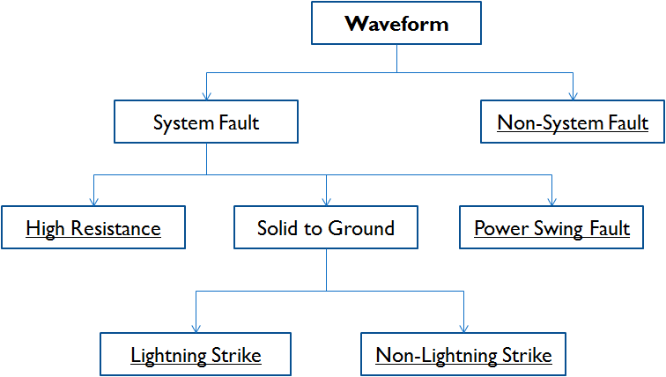

Figure A.1.1 Finger print clasification of fault waveform

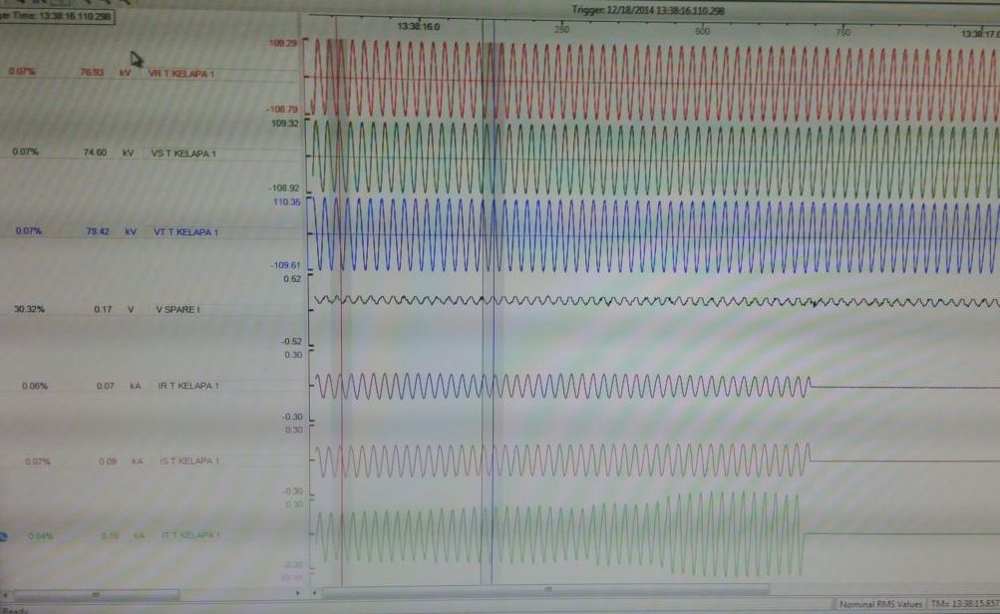
Figure A.1.2 High Impedance Fault Waveform

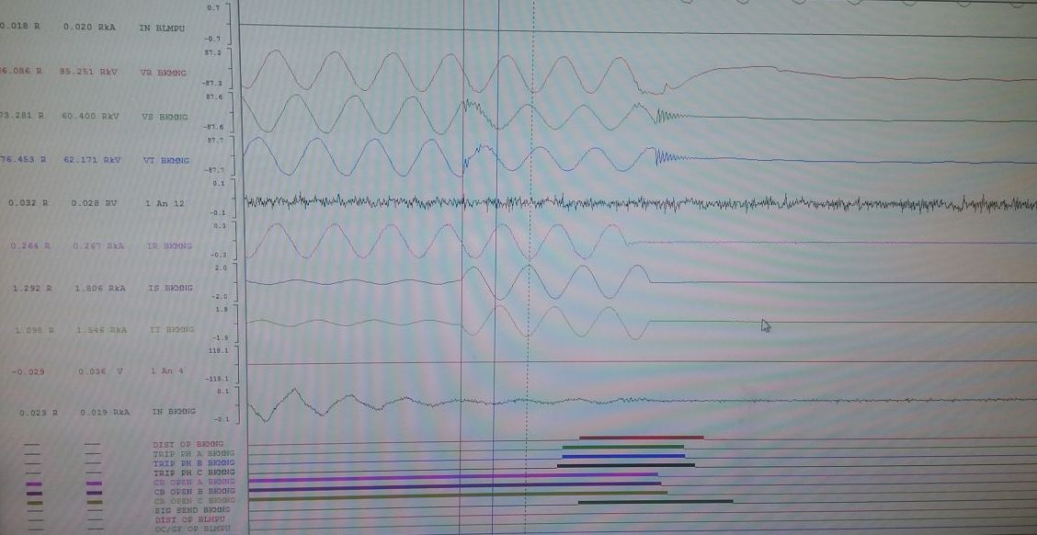
Figure A.1.3 Lightning Strike Fault Waveform

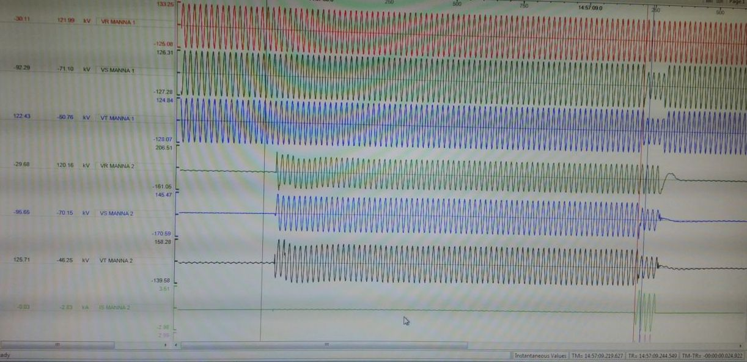
Figure A.1.4 Non - Lightning Strike Fault Waveform

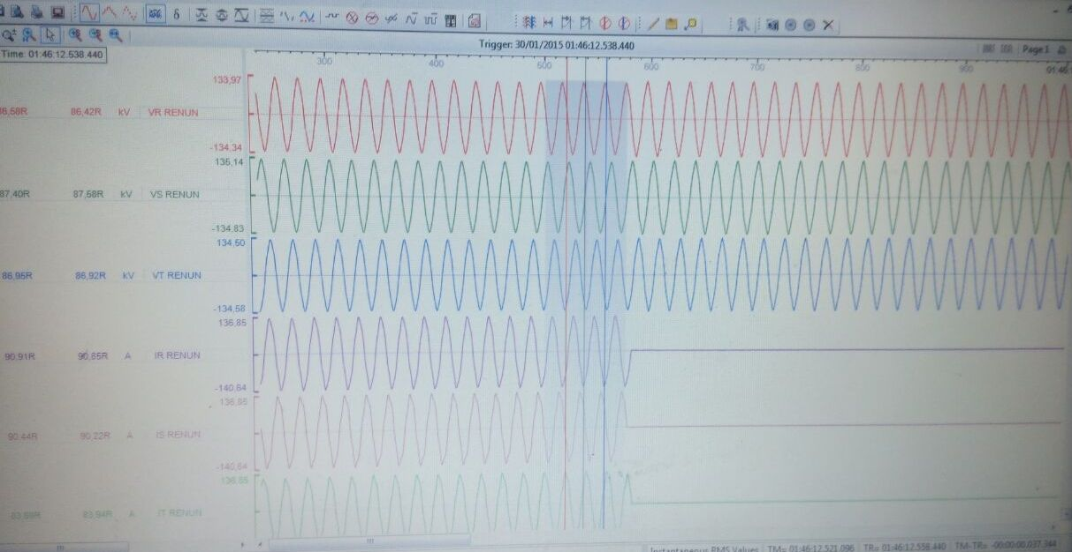
Figure A.1.5 Non-System Fault Waveform

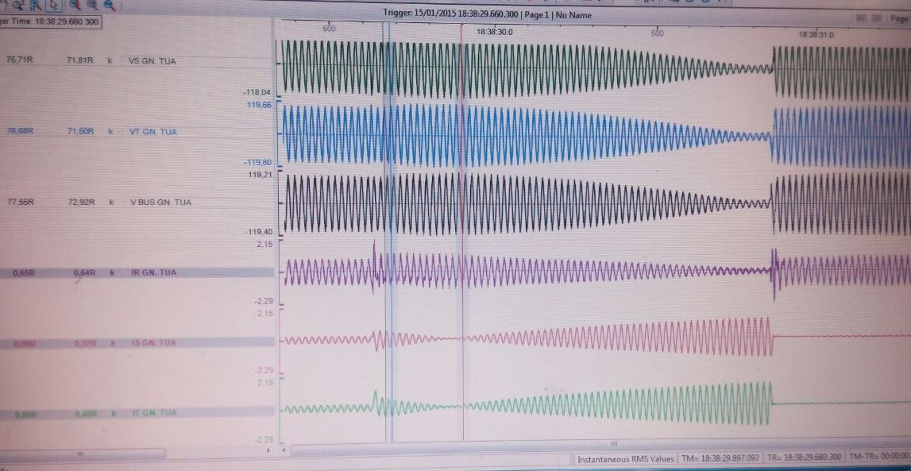
Figure A.1.6 Power Swing Fault Waveform

Appendix 2.

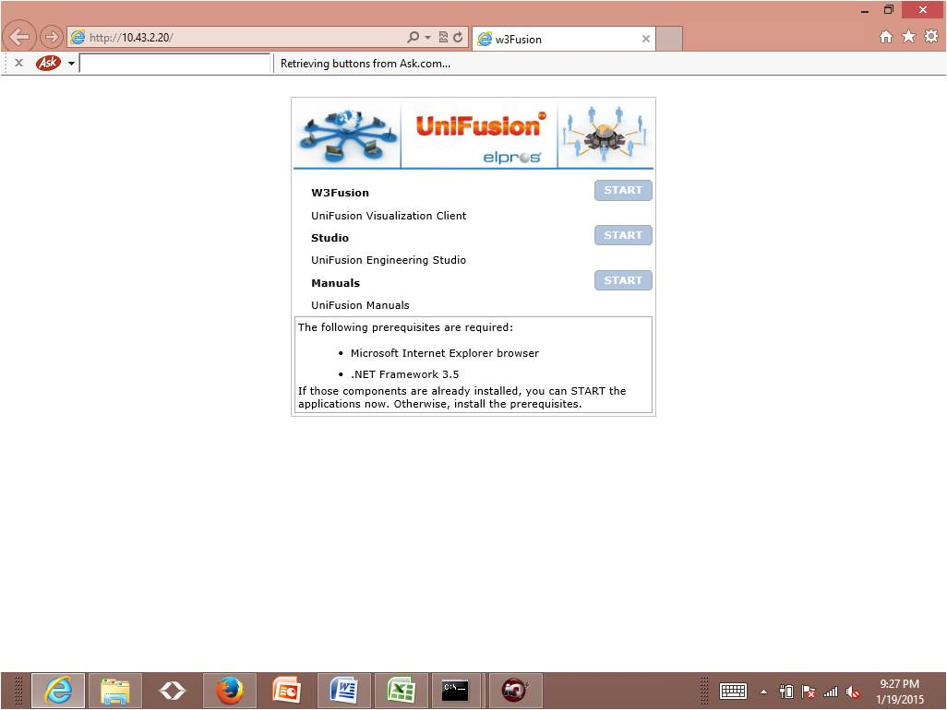
Figure A.2.1 Elpros Display from browser

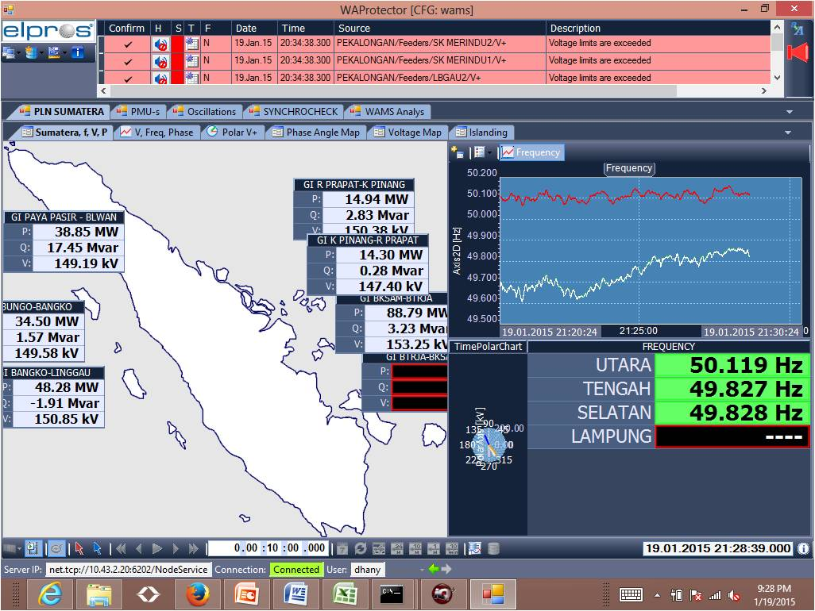
Figure A.2.2 Sumatera Grid Phasor Map

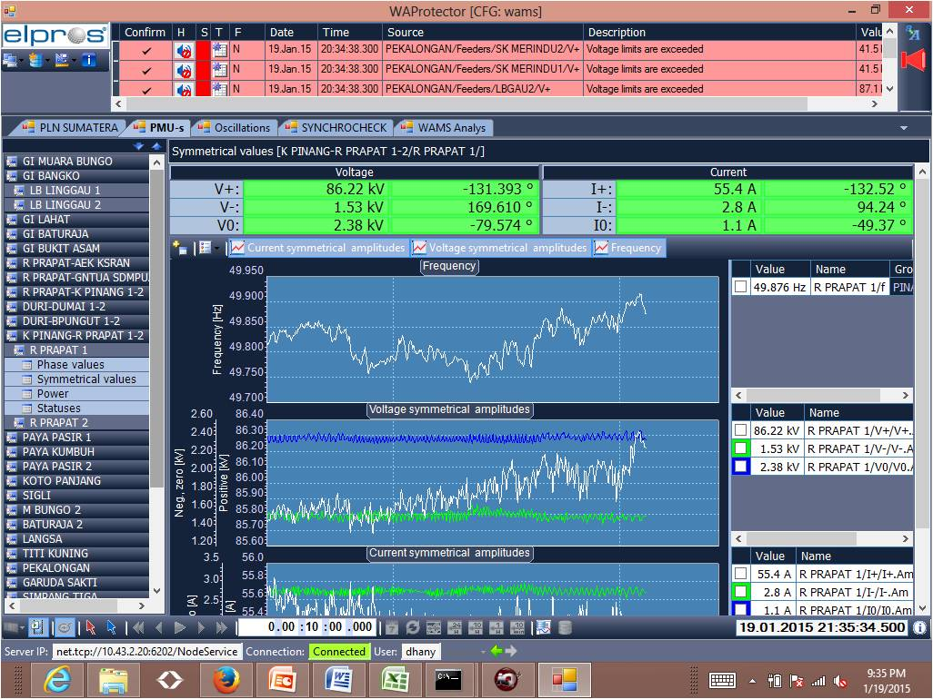
Figure A.2.3 Visualization of Phasor

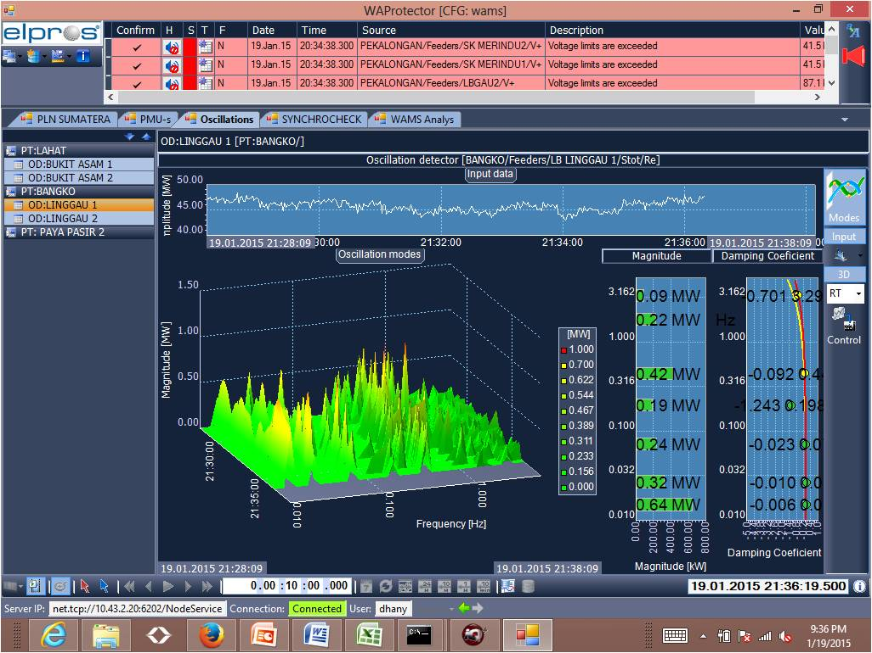
Figure A.2.4 Visualization of Oscillation

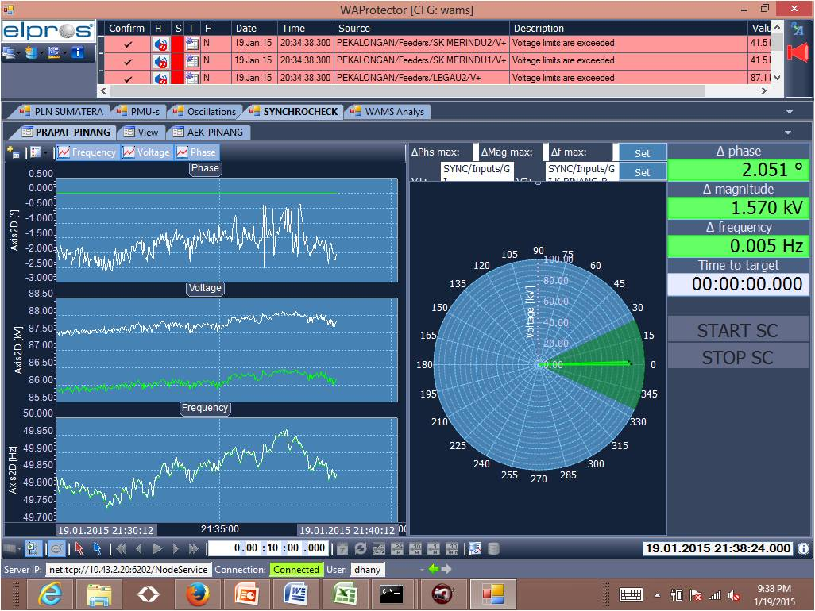
Figure A.2.5 Visualization of Synchro Check

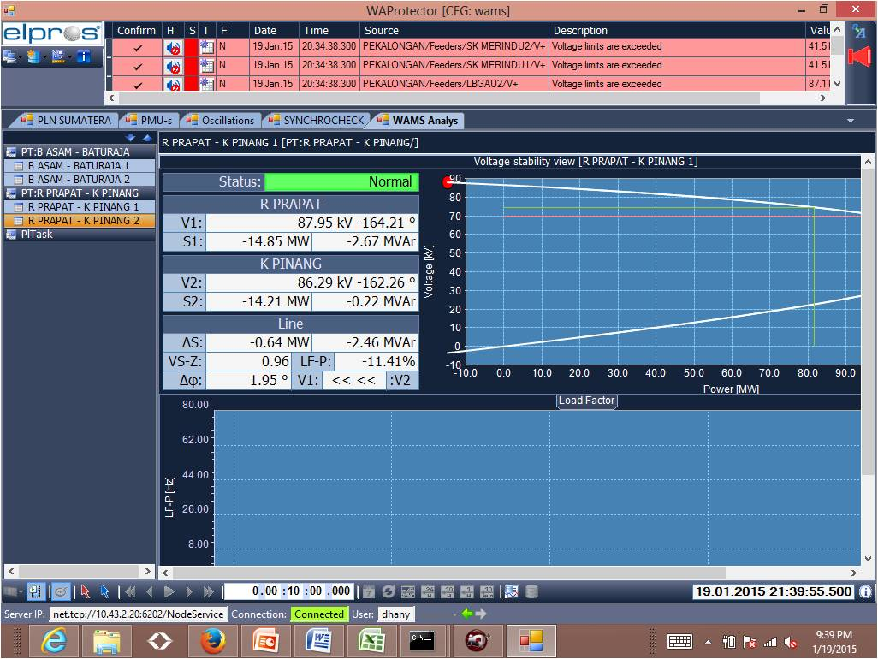
Figure A.2.6 Visualization of Voltage Stability (PV Curve)

