TVA’s Transmission Voltage Unbalance Evaluation

Georgia Tech
2018 Fault and Disturbance Analysis Conference

JBR, JAMES ROSSMAN, TLL, THEO LAUGHNER, AMM, ANTHONY MURPHY, DEM, DAVID MARLER, GLK, GARY KOBET
Tennessee Valley Authority
United States

SUMMARY

This paper presents transmission level voltage unbalance as measured by two primary methods across the Tennessee Valley Authority (TVA) Transmission system. It also discusses the recent focus on distribution voltage control. Three standards mentioning voltage unbalance (VUB) are discussed as well as TVA's operations, limits, and limitations on voltage balancing. An example of equipment malfunction creating voltage unbalance is discussed. A team was formed to address voltage unbalance concerns and this team made a number of measurements across the TVA system. The team determined the average transmission system unbalance delivered to customer sites to be 0.59% (method 1) and 0.64% (method 2). In 2014, TVA transmission adopted a 161-kV-level VUB maximum limit for distributor service delivery of 1.4% (IEC 61000-3-13 methodology). One area in NE Tennessee experienced levels above this new delivery limit of 1.4% VUB during high system loading. To reduce this VUB in NE Tennessee, TVA initiated a capital project to transpose critical 500-kV lines which are known to operate above their surge impedance loading level creating VUB between phases.

KEYWORDS

Voltage Unbalance, SCADA, DFR, Motor Heating, Motor Protection, Surge Impedance Loading.
Introduction

Voltage unbalance between phases creates problems for three-phase motor operations with increased motor heating and differences between motor phase currents. If high levels of voltage unbalance are undetected, then the motor may become damaged or shorten the motor’s expected lifespan. Ideally, motor protection schemes should detect the condition and shut down the motor to protect the motor from the voltage unbalance condition. Commercial and industrial consumers do not want their equipment damaged or periodically shut down, and expect utility delivery voltages to be sufficiently balanced to not create operational problems.

The Tennessee Valley Authority (TVA) is primarily a generation and transmission entity and their customers are 154 distributors of TVA power plus 58 directly-served customers (primarily large industrial facilities). In late 2011, TVA received inquiries related to transmission-level unbalance between phase voltages and in response formed a Voltage Unbalance Team (VUT) to evaluate this issue.

The VUT evaluated measurements from 22 historical SCADA sites (method 1) as well as setting up 52 digital fault recorders (DFR) [1][2] to take simultaneous measurements (method 2) in April 2012. The two methods showed the average line-to-line voltage unbalance from 0.59% (SCADA method) to 0.64% (DFR method) across the TVA system. The VUT members also determined that some locations showed higher levels with the DFR method showing a two standard deviation value of 1.41%.

Trends In Distribution Operations

Recent trends in distribution system operations are challenging utility engineers to look for differences in line-to-line voltages. Better monitoring is available for distribution engineers as well as economic incentives to encourage them to better control voltage swings.

Increased Monitoring
In the last few years, grid modernization projects including installation of SCADA systems have enabled utilities to record parameters from the substation level, across distribution feeders, down to smart revenue meters at end-use sites. Consequently, the ability to identify differences between phase voltages has enhanced significantly in recent years.

Distributor inquiries related to transmission voltage differences often referred to the maximum differences between phase voltages over the nominal voltage as the means to calculate relative unbalance. For example, three voltages of 13.2-kV, 13.2-kV and 13.0-kV may be reported to TVA as a 1.5% unbalance. Later in this paper we will show the ANSI C84.1 definition of this unbalance is significantly different.

Another factor in identifying unbalance is the accuracy of the recording devices and the length of time between device calibrations. When reporting values of a few percent, both of these factors can create significant errors from the true voltage unbalance. The key is to understand the limitations of the measurement devices and to correctly apply standard definitions for unbalance.

Distribution Voltage Control
Distribution engineers have looked for opportunities to reduce costs and electrical energy losses through advanced voltage control of the distribution system. Historically, distribution engineers have designed systems to ensure adequate service voltage during extreme loading conditions. Typically, the service voltage for customers at the end of the feeder has dictated the operational system constraints during maximum system loading. Conversely, the service voltage for customers at the beginning of the feeder has dictated the operational system constraints during minimum system loading.

TVA has a project called Conservation Voltage Regulation (CVR) [3] with a strategy for reducing energy consumption through voltage optimization. For participating distributors, TVA promotes continuous distribution feeder operation in the lower half of the ANSI C84.1 standard voltage range as a way to reduce energy. Voltage regulation is accomplished by deploying CVR systems using End-Of-Line Voltage Monitoring, Advanced Metering Infrastructure (AMI) or Volt-VAR Optimization [3].

Standards

ANSI C84.1
The American National Standard for Electric Power Systems and Equipment, ANSI C84.1-2011[4], defines voltage unbalance in its Annex C as follows:
Per C.3 - Percent voltage unbalance = 100 x (maximum deviation from average V) / (average V)

Reworking the previous example, three voltages of 13.2-kV, 13.2-kV and 13.0-kV actually are 1.0% unbalanced. The reason for the reduction of this value is that the measurement of deviation is from the average value of the three voltages.

Annex C states that 98% of electrical utilities operate less than 3% voltage unbalance and 66% operate less than 1% voltage unbalance. Furthermore, ANSI C84.1 Recommendation C.2 states - Electric supply systems should be designed to limit the maximum voltage unbalance to 3 percent when measured at the electric-utility revenue meter under no-load conditions. This national standard is focused on end-use equipment not on transmission.

NEMA MG 1
The National Equipment Manufacturers Association, NEMA MG 1, Motors and Generators [5], discusses the impact of unbalanced voltages in section 14.3 titled Effects of Unbalanced Voltages on the Performance of Polyphase Induction Motors. Figure 14.1 in section 14.3 shows the de-rating recommended versus voltage unbalance and contains a recommendation to not operate a motor above 5% voltage unbalance. Interpreting Figure 14.1[5], motors need to be de-rated to approximately 99% of nameplate at 1% unbalance, 97.5% of nameplate at 1.5% unbalance, 95% of nameplate at 2% unbalance, 88% of nameplate at 3% unbalance, 82% of nameplate at 4% unbalance, and 76% of nameplate at 5% unbalance.

IEC 61000-3-13
While the NEMA and ANSI standards are primarily concerned with end use equipment, the IEC standard has defined an alternative method of voltage unbalance measurement and also specifies limits. IEC 61000-3-13 defines the voltage unbalance factor to be the modulus of the negative-sequence to the positive-sequence components of the voltage at fundamental frequency, expressed as a percentage. Further, the IEC method suggests differing limits based on voltage class. Table 2 within the standard proposes a planning limit of 1.8% for voltages from 1kV to 35kV, 1.4% for voltages from 35kV to 230kV, and 0.8% for voltages above 230kV. The limits are based on 95% probability levels using statistical distributions. In March 2014, TVA’s Transmission & Power Supply organization adopted the 1.4% IEC’s 61000-3-13 upper limit (161-kV/230-kV only) levels for service delivery to distributors of TVA power.

TVA Phase Voltage Measurements

Voltage Unbalance Team
TVA staff received a number of inquiries from distributors related to voltage unbalance in 2011 and early 2012. These concerns were primarily from distributors located in the East Tennessee Area. To address these concerns the TVA transmission planning group formed a Voltage Unbalance Team (VUT).

TVA Voltage Unbalance Measurement Equipment
The VUT determined that there were two systems available for data. First, TVA SCADA system collects phase voltage data routinely and this was reviewed over 4 seasons. Second, it was found that digital fault recorders (DFRs) could be triggered at a given time/date for simultaneous snapshot of key busses in the TVA system. Voltage calibration of the two systems is critical in this assessment of TVA voltage unbalance. Calibration drift between phases could easily influence unbalance readings that were less than 1 percent. It was reasoned that high voltage unbalance readings might be due to instrumentation errors and not to actual voltage unbalance.

TVA SCADA-Data Voltage Unbalance Measurements
TVA staff evaluated 22 sites over four seasonal periods for voltage unbalance. The average voltage unbalance for these periods was 0.59%. During lighter system loading conditions the unbalance was higher than during periods of higher system loading, suggesting that end-use motor balancing plus generation balancing contribute to reducing voltage unbalance. The East TVA area averaged 0.73% which is slightly higher than 0.59% over the four study periods. In 2014, the NE area was determined to have high VUB levels. The corrective actions for this location are discussed in the next section of this report.

TVA DFR-Data Voltage Unbalance Measurements
On Sunday 4/1/2012 at 2:00 am, DFR units recorded a snapshot of phase voltages at 52 locations (see Figure 1) across TVA. This date/time was chosen for low transmission system loading and deemed the worse-case condition for voltage unbalance. The average unbalance for the 52 sites was 0.64%, as shown by the lower straight line in Figure 2.

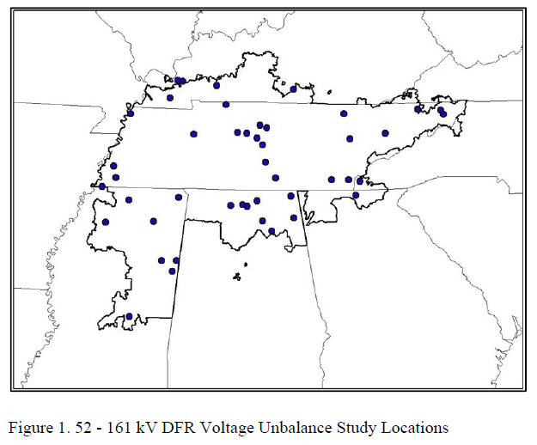 | 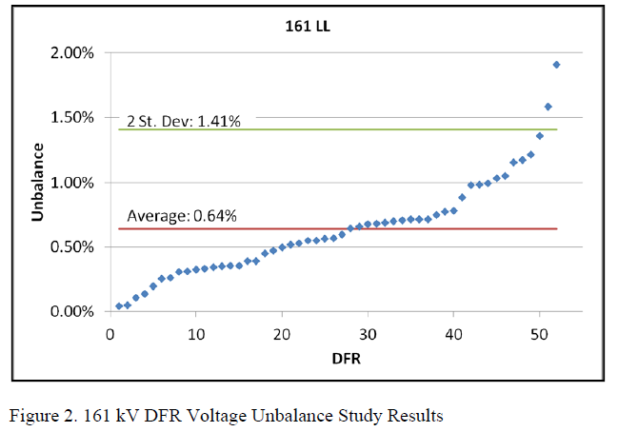

TVA’s measurements were made under low and peak loading conditions. As ANSI C84.1 states, the distributor-level service measurements are made at the meter point without any customer load influencing the measurements. As a result, it is difficult to compare end-use, distribution-level and transmission-level voltage unbalance measurements. This is why TVA adopted the IEC 61000-3-13 methodology.

TVA Voltage Balancing

Limitations of TVA Phase Voltage Adjustment
All TVA equipment corrects for voltage by adjusting the three-phase voltages simultaneously. These include three-phase capacitor banks, three-phase reactors, load tap-changers on 500-kV to 161-kV transformer banks operated in a three-phase manner, and VAR support from localized generation equipment.

Distribution systems tend to service single-phase loads so unbalances can occur. Transmission systems tend to service bulk distribution delivery points with the expectation that the three-phase load current will be balanced. Therefore, TVA did not incorporate individual phase adjustment in the planning and operating of the bulk transmission system. The one exception to transmission-level phase adjustment is generation. Like three-phase motors, generators tend to balance out slight voltage unbalances although the voltage unbalances tend to create extra heating. However, TVA has no known issues with voltage unbalance at generation sites

Transmission system line operation may generate unbalance voltages if the lines are long without line transpositions. However, TVA’s average 500 kV line length is approximately 50 miles and both the 161-kV and 500-kV systems have only a few line transpositions. In 2014, the VUT identified a pocket of delivery points (figure 3) in NE Tennessee occasionally running above 1.4% VUB. It was determined that the 500-kV lines in the NE corridor were experiencing high flows exceeding 1000-MW (above the surge impedance loading level – see figure 4). These transmission lines are horizontally configured and when highly loaded the voltages between phases separate in magnitude and phase angle. To correct this issue, a capital project was initiated to transpose multiple 500-kV lines in the NE area allowing for high line loading without undue voltage unbalance between phases.

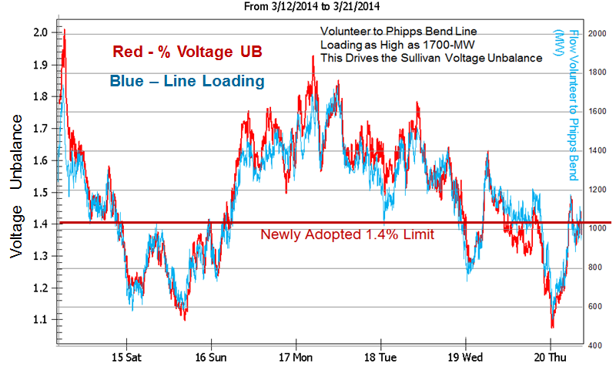
Figure 4 - 500-kV Line MW Flow and %VUB

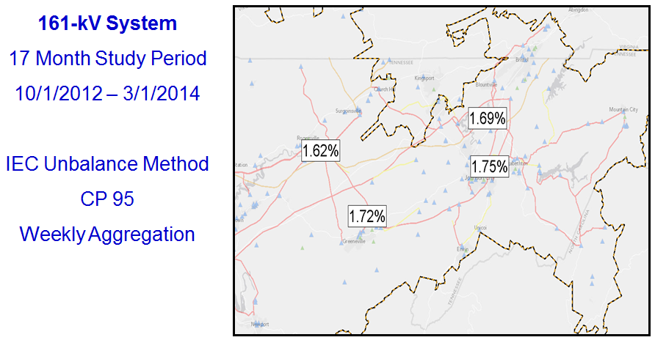

Figure 3 - NE Area VUB- Sites Over 1.4%

TVA distributor delivery points are at 161-kV (or below) and these lines tend to be short. Also, TVA has installed many switching stations at interconnection line locations making the line segments even shorter. Once the corrections to the NE corridor were made, the VUT determined that transmission voltages are not significantly unbalanced due to TVA line configuration. In other words TVA 161-kV service to distributors normally remains below the IEC 6100-3-13 1.4% VUB.

TVA Sensing for Voltage Unbalance Conditions
Most voltage concerns from customers relate to delivery of either high or low three-phase average voltage. Frequently these are during on-peak or off-peak loading conditions and can occur anywhere across the TVA delivery area. VUB complaints are far less frequent and tend to be localized at locations where service delivery conditions are unusual. This was the case with the NE Tennessee customers listed previously.

Voltage unbalance detection schemes are used as part of equipment protection systems. For example, on large capacitor banks if the unit reaches a certain level of current unbalance the protective relaying will trip the bank. Also, for load tap changers (LTCs) the programmable controller detecting tap movement will signal system operations if tap changers become unbalanced. Capacitor bank operations and transformer bank tap operations are the most significant sources of TVA phase voltage unbalance.

TVA Example Where Voltage Unbalance Occurred Due to Equipment Malfunction
On July 23, 2012, TVA manually operated LTCs on a large transformer bank. This bank consists of three large single-phase 500-161-kV transformers with the three transformer LTCs operated together. One transformer lowered its tap setting two positions lower than the other two transformers. This created a 1.5% unbalance condition. The programmable logic controller monitoring this operation did not receive a signal from a defective micro-switch and so the TVA SCADA system did not detect the voltage unbalance.

A nearby large industry noticed the unbalance and quickly reported the condition to TVA. It should be noted that none of the industrial equipment tripped off-line but it was apparent from unbalanced motor currents that a voltage unbalance existed. Actions were immediately taken to correct the unbalanced voltage condition. This example is supplied to show that transmission-level unbalances can occur due to equipment malfunction.

Conclusion

Distributors of TVA power noticed voltage unbalances and their concerns led to TVA forming the VUT. Measurements were evaluated using both SCADA data and DFR data to quantify voltage unbalance across the TVA system. It was found that voltage unbalance is generally higher during lightly loaded system conditions than during peak system conditions. The one exception to this was in the NE Tennessee area with high power flows exceeding the 500-kV line surge impedance loading level. TVA determined key 500-kV lines needed transpositions and a capital project was initiated to allow these key lines to run at higher loading without creating VUB issues.

Increased attention to voltage unbalance arises from increased focus on voltage levels by distributors. It was found that a number of distributors were not using the correct definition for voltage unbalance. This paper references ANSI C84.1 and NEMA MG 1 and their discussions on voltage unbalance.

Utilities typically have limited ability to balance voltages at the transmission level. Faulty equipment can create problems and an example of this is presented. Generators and end-use motors appear to help reduce voltage unbalance and this is the primary reason for unbalance to be less during periods with higher loads.

Measurements using data from monitoring equipment readily available to most transmission system operators found that the average voltage unbalance is less than 1 percent across TVA. ANSI C84.1 notes that 66% of utilities operate at 1 percent or below, but this is an end-use standard and TVA operations are at the transmission level. For this reason, in 2014 TVA adopted the IEC 6100-3-13 transmission-level 1.4% VUB as a target to move towards corrective action.

BIBLIOGRAPHY

[1] NERC Standard PRC-002-1, Define Regional Disturbance Monitoring and Reporting Requirements, www.nerc.com.
[2] NERC Standard PRC-018-1, Disturbance Monitoring Equipment Installation and Data Reporting, www.nerc.com.
[3] TVA Project Overview, “EPA Clean Air Agreement, Conservation Voltage Regulation”, August.19, 2011.
[4] American National Standard, Electric Power Systems and Equipment - Voltage Ratings (60 Hertz), ANSI C84.1-2011.
[5] National Electrical Manufacturers Association, NEMA MG 1 - Motors and Generators, 2009, Revision 1 - 2010.
[6] IEC 61000-3-13, Electromagnetic compatibility (EMC) – Limits – Assessment of emission limits for the connection of unbalanced installations to MV, HV and EHV power systems

